Electrician
Position Description

1. POSITION SUMMARY

Job Title: | Electrician
Position No: | 10015.000
Department: | Infrastructure & Operations
Reports to: | Works Engineer – Water & Wastewater
Band and Level: | Administrative/Technical/Trades Band 2, Level 2
Grade: | 38
Updated: | September 2018

2. OVERVIEW
The Electrician’s primary responsibility is to maintain all electrical aspects of Council’s water and wastewater pump stations and treatment plants, including radio telemetry systems. The secondary responsibility is to maintain all electrical aspects of Council’s other buildings.
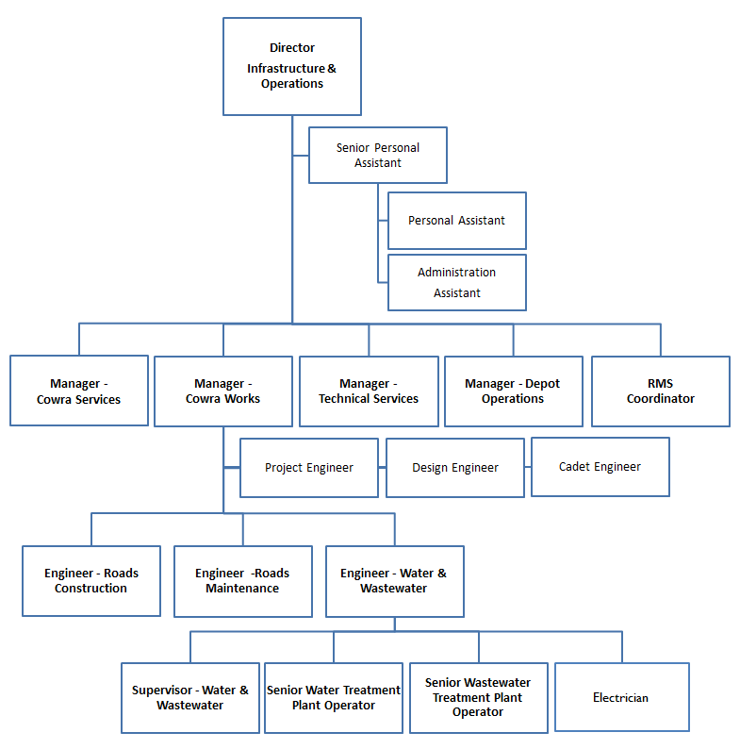

3. RESPONSIBILITIES AND DUTIES

The duties and responsibilities listed here are considered essential to achieving the primary objectives of this job. These duties will be undertaken in such a manner that will enable the section to operate in an effective and efficient manner and within budgetary constraints.

- Maintain Council’s water collection and distribution pump stations
- Maintain Council’s wastewater collection and distribution pump stations
- Maintain electrical components of Council’s water treatment plant
- Maintain electrical components of Council’s wastewater treatment plant
- Maintain Council’s remote monitoring network (telemetry) of water and wastewater systems
- Provide assistance in the planning, installation and commissioning of new electrical facilities within the water and wastewater systems
- Supervise staff as required
- Participate in Council’s on-call roster to respond to after hours events
- Maintain a sound knowledge of current legislation, standards, policies and guidelines relevant to area of responsibility and ensure that activities comply with relevant legislation, standards and policies.
- Communicate known problems/issues, including but not limited to: hazards, risks, incidents, accidents and near misses in a timely manner to direct supervisor.
- Perform allocated duties utilising initiative, making positive contributions to work quality, productivity, and to work to a timetable, in a cost effective manner.
- Other duties that may arise at the direction of the Works Engineer – Water and Wastewater that are consistent with the level of competencies of the position and in line with the principles of multi-skilling.

4. KNOWLEDGE, SKILLS AND ABILITIES

- Authority and accountability: Responsibility as a trainer/co-ordinator for the operation of a small section which uses staff and other resources, or the position completes tasks requiring specialised technical/administrative skills.
- Judgement and problem solving: Skills to solve problems which require assessment of options with freedom within procedural limits in changing the way work is done or in the delegation of work. Assistance may be readily available from others in solving problems.
- Specialist knowledge and skills: Positions will have specialised knowledge in a number of advanced skill areas relating to the more complex elements of the job.
- Management skills: May require skills in supervising a team of staff, to motivate and monitor performance against work outcomes.
- Interpersonal skills: In addition to interpersonal skills in managing others, the position may involve explaining issues/policy to the public or others and reconcile different points of view.
- Qualifications and experience: Thorough working knowledge and experience of all work procedures for the application of technical/trades or administrative skills, based upon suitable certificate or post-certificate-level qualifications.

5. WORK, HEALTH & SAFETY RESPONSIBILITIES

All employees are responsible for Work Health and Safety (WHS) for Council and their duties include:
- Complying with Council’s WHS policies and procedures.
- Working with due diligence and consideration to safeguard their own health and safety and the health and safety of others.
- Reporting any potential hazards, incidents or injuries to their Supervisor and Human Resources within 48 hours.
- Participating in any applicable WHS consultation arrangements.
- Complying with any Return to Work Plan if injured and supporting rehabilitation in the workplace.
- Correctly using all personal protective equipment.
- Complying with emergency and evacuation procedures and site rules if applicable.

6. PHYSICAL DEMANDS

The physical demands described here are representative of those that must be met by an employee to successfully perform the essential functions of this job.

While performing the required indoor duties of this job, the employee is regularly required to sit and use hands to input data and write. The employee is frequently required to talk or hear in person and on the telephone. The employee is occasionally required to stand, walk, and occasionally lift items up to 15kg. Specific vision abilities required by this job include close vision and the ability to adjust focus.

While performing the required outdoor duties of this job, the employee is regularly required to use hands to finger, handle or feel; reach with hands and arms; climb or balance; stoop, kneel, crouch or crawl; and talk or hear. The employee frequently is required to stand, walk, run and smell. The employee is regularly required to sit. The employee may be occasionally required to lift and/or move up to 25kg. Specific vision abilities required by this job include close vision, distance vision, colour vision, peripheral vision, depth perception and ability to adjust focus. The employee may be required to climb into/onto mobile plant items.

7. CONDITIONS OF EMPLOYMENT

Hours
Council’s outdoor staff work a 38 hour week on the basis of a nine day fortnight. Some variation in work hours may be required from time to time to ensure the efficient undertaking of the position.

Performance Appraisal
A performance appraisal will be undertaken on an annual basis utilising performance indicators and include formulation of a career path and training plan.

Policies and Procedures
The employee who occupies this position must comply with Council's Code of Conduct and all other policies and procedures that affect his or her employment.

All other conditions of employment are in accordance with the Local Government (State) Award.

8. ACKNOWLEDGEMENT

I, ......................................................................................... (Print Name) acknowledge that I have read and understand the duties, responsibilities and requirements of this position.

Sign: ……………………………………… Date: ………………………..

This is not a static document. Management reserves the right to review and amend this Position Description in consultation with the position holder as the need arises.

