Management Accountant
Position Description

1. POSITION SUMMARY

Job Title: | Management Accountant
Position No: | 1425.000
Department: | Corporate Services
Reports to: | Manager – Finance
Band and Level: | Professional/Specialist Band 3, Level 3
Grade: | 43
Updated: | August 2018

2. OVERVIEW

The primary responsibility of the Management Accountant is control and oversight of Council’s financial sub-systems and to provide effective and efficient accounting support to the finance division, in particular the Manager – Finance and Director – Corporate Services.

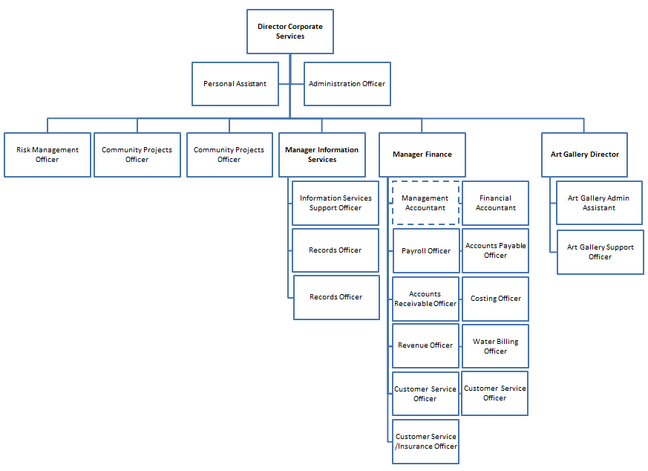
3. RESPONSIBILITIES AND DUTIES

The duties and responsibilities listed here are considered essential to achieving the primary objectives of this job. These duties will be undertaken in such a manner that will enable the section to operate in an effective and efficient manner and within budgetary constraints.

- Coordinate and oversee Accounts Payable, Accounts Receivable and Payroll functions.
- Coordinate and oversee Plant function - ensuring timely data/rate entry.
- Coordinate and oversee Inventory function - ensuring timely data entry and scheduled stock takes (Depot 3 per year & Quarries 4 per year).
- Weekly reconciliation of Council’s bank accounts.
- Oversee Council’s subsidiary ledgers and ensure monthly reconciliations are performed.
- Perform daily cash receipting review.
- Perform expenditure review and act as co-signatory for cheque and electronic fund transfers.
- Investment of Council funds with various Fund Managers and the preparation of monthly investment report (including reconciliation of funds invested with general ledger).
- Maintain the structure and content of Council’s General Ledger (e.g. creating/maintenance of job numbers, processing of journal entries).
- Preparation / submission of Council’s Annual Fringe Benefits Tax return.
- Reconciling and accounting for Council’s loan borrowings.
- Maintenance of Council’s S94 database (including reconciliation to general ledger).
- Assist in grant applications, the provision of acquittal information and maintenance of Grands/Subsidies database.
- Monthly reconciliation of ATO integrated account.
- Coordinate production and review of monthly plant purchases register.
- Coordinate calculation and submission of monthly diesel fuel grant application.
- Submit monthly Business Activity Statement.
- Monthly reconciliation and clearing of general ledger suspense accounts.
- Provide monthly private works report - quote to actual cost.
- Preparation of Special Schedule 7 -Report on Infrastructure Assets.
- Purchasing - monthly compliance testing and expediting of outstanding orders.
- Keep abreast with and implement any Australian Accounting Standards and Accounting Code amendments as required.
- Other duties that may arise at the direction of the Manager - Finance that are consistent with the level of competencies of the position and in line with the principles of multi-skilling.
- Act in accordance with Council’s Code of Conduct, Anti-Discrimination Policy and other policies as advised.
- Maintain a sound knowledge of current legislation, standards, policies and guidelines relevant to area of responsibility, and ensures that activities comply with relevant legislation, standards and policies.
- Communicate known problems/issues, including but not limited to: hazards, risks, incidents, accidents and near misses in a timely manner to direct supervisor.
- Perform allocated duties utilising initiative, making positive contributions to work quality, productivity, and to work to a timetable, in a cost effective manner.
- Other duties that may arise at the direction of the Manager - Finance that are consistent with the level of competencies of the position and in line with the principles of multi-skilling.

4. KNOWLEDGE, SKILLS AND ABILITIES

- Authority and accountability:
Provides a professional advisory role to people within or outside the employer. Such advice may commit the employer and have significant impact upon external parties dealing with the employer. The position may manage several major projects or sections within a department of the employer.

- Judgement and problem solving:
Positions have a high level of independence in solving problems and using judgement. Problems can be multi-faceted requiring detailed analysis of available options to solve operational, technical or service problems.

- Specialist knowledge and skills:
The skills and knowledge to resolve problems where a number of complex alternatives need to be addressed.

- Management skills:
May be required to manage staff, resolve operational problems and participate in a management team to resolve key problems.

- Interpersonal skills:
Interpersonal skills in leading and motivating staff may be required. Persuasive skills are used in seeking agreement and discussing issues to resolve problems with people at all levels. Communication skills are required to enable provision of key advice both within and outside the employer and to liaise with external bodies.

- Qualifications and experience:
Tertiary qualifications combined with a high level of practical experience and an in-depth knowledge of work.

5. WORK, HEALTH & SAFETY RESPONSIBILITIES

All employees are responsible for Work Health and Safety (WHS) for Council and their duties include:
- Complying with Council’s WHS policies and procedures.
- Working with due diligence and consideration to safeguard their own health and safety and the health and safety of others.
- Reporting any potential hazards, incidents or injuries to their Supervisor and Human Resources within 48 hours.
- Participating in any applicable WHS consultation arrangements.
- Complying with any Return to Work Plan if injured and supporting rehabilitation in the workplace.
- Correctly using all personal protective equipment.
- Complying with emergency and evacuation procedures and site rules if applicable.

6. PHYSICAL DEMANDS

The physical demands described here are representative of those that must be met by an employee to successfully perform the essential functions of this job.

While performing the required indoor duties of this job, the employee is regularly required to sit and use hands to input data and write. The employee is frequently required to talk or hear in person and on the telephone. The employee is occasionally required to stand, walk, and occasionally lift items up to 15kg. Specific vision abilities required by this job include close vision and the ability to adjust focus.

7. CONDITIONS OF EMPLOYMENT

Hours
Council’s indoor staff work a 35 hour week in the basis of a nine day fortnight. Some variation in work hours may be required from time to time to ensure the efficient undertaking of the position.

Performance Appraisal
A performance appraisal will be undertaken on an annual basis utilising performance indicators and include formulation of a career path and training plan.

Policies and Procedures
The employee who occupies this position must comply with Council's Code of Conduct and all other policies and procedures that affect his or her employment.

All other conditions of employment are in accordance with the Local Government (State) Award.

8. ACKNOWLEDGEMENT

I, ......................................................................................... (Print Name) acknowledge that I have read and understand the duties, responsibilities and requirements of this position.

Sign: ……………………………………… Date: ………………………..

This is not a static document. Management reserves the right to review and amend this Position Description in consultation with the position holder as the need arises.

