POSITION DESCRIPTION
Position Details
Position Title | Pool Lifeguard - Casual
Position Number | 1770
Band/Level | Band 1 Level 2 | Last Update | 26 October 2015
Overview
Department: Community Growth

The Community Growth department manages community services, culture and sporting facilities and services, economic development and commercial enterprises as well as corporate business operations. The divisions managed by this department include: Library and Community, Culture, Property & Economic Development, Corporate Business Services.

Service Unit: Culture

Culture Service Unit develops and manages Council‘s Cultural assets and programs whilst providing high quality customer focus and service delivery. Cultural assets and programming include theatres, art gallery, leisure centres, beaches, sporting ovals and amenities, parks, playgrounds, foreshores and natural reserves.

Role Dimensions

Authority and Accountability
- The jobholder works within detailed written or oral instructions or procedures or under supervision.
- Decisions affect own work only.
- The work of the job holder influences the external environment by meeting basic standards of service.
- The jobholder complies with operational requirements in cooperation with or under the supervision of other employees. Other employees or members of the public may be affected by the employee’s acts or omissions.
- Has little or no responsibility for budget development.
- Look for ways to save costs. Be conscious of budget constraints and be aware of cost implications of own actions within own work area

Direct Reports
- Nil.

Designated Position in accordance with s449 of the Local Government Act
- No.

Corporate requirements
- Implement Integrated Management System (IMS) policies and procedures to ensure commitment in promoting and practicing work, health, safety and environment protection;
- Communicate and support Council’s outcomes and strategic objectives and act in a manner consistent with the corporate values;
- Maintain awareness and compliance with Central Coast Council’s Code of Conduct and Policies, including the EEO Policy, Anti-Bullying and Harassment Policy, and the relevant risk management protocols;
- Knowledge and compliance with appropriate legislation and codes;
- Commitment to continuous improvement and willingness to undertake;
- Work flexibly to meet the demands of the organisation.

Position Requirements

As a Casual Pool Lifeguard at Central Coast Council you will be expected to:
- Behave ethically, honestly and professionally and actively reports misconduct, conflicts of interest and inappropriate/illegal actions;
- Be committed to completing work activities effectively;
- Be open to the input of others and works to understand their perspectives;
- Be adaptable, flexible and focussed when dealing with change;
- Show respect, courtesy and fairness when dealing with customers and keeps them informed about all services and seeks feedback to ensure their needs are met;
- Work as a supportive and cooperative team member, shares information and acknowledges others’ efforts;
- Be able to respond to conflict without inflaming the situation and knows when to refer to a supervisor for assistance and/or withdraw from a conflict situation;
- Understand team objectives and how their work relates to the team’s success and contribute to the development and achievement of team goals and work;
- Identify issues that may impact on task completion and provides appropriate solutions;
- Follow safe work practices for self and alerts others and escalate when required;
- Apply basic checking and quality control processes when practising procurement and contract management.
- Plan and deliver tasks on schedule and seek help when required;
- Ensure team members understand how their role and tasks align to business objectives and affect overall performance;
- Ensure team members understand and inform customers about decisions and processes;
- Accommodate changing priorities and respond flexibly to uncertainty and ambiguity.

As the Casual Ocean Lifeguard at Central Coast Council you will also be expected to:
- Ensure the public's safety and health at all times;
- Monitor swimming pool water quality;
- Ensure centre is clean and safe;
- Supervise of patrons in the pool hall;
- Liaise and communicate with customers at the Centre;
- Assist with event/ programme set-up requirements.

Essential Criteria (Generic)
- A customer service ethos and a demonstrated customer-centric approach to service provision;
- Demonstrated High quality problem solving skills and a demonstrated ability to effectively adjust plans and schedules;
- Ability to communicate effectively both verbally and in writing with staff and the public;
- Proven ability to work effectively as part of a team.

Essential Criteria (Specific)
- Current Applied First Aid Certificate (HLT FA 311A) OR Provide First Aid Certificate (HLTAID 003);
- Current RLSSA Pool Lifeguard Certificate;
- Demonstrated previous experience working in an aquatic/ leisure facility or equivalent;
- Ability and willingness to work across the spread of operating hours from 4am to 10pm Monday to Sunday;
- Please provide your Working with Children Check Clearance Number or Application Number as per Child Protection (Working with Children) Regulation 2013 and provide your Date of Birth for the purpose of verification;
- Demonstrated ability to embrace change and commitment to work across multiple work locations.

Capability Framework that Underpins this Position
Council has adapted the NSW Public Sector Capability Framework for all positions. The Framework describes 16 capabilities across four core groups: 1- Personal Attributes, 2 - Relationships, 3 - Results and 4- Business Enablers. A further 4 capabilities within the People Management group are for employees who manage people.

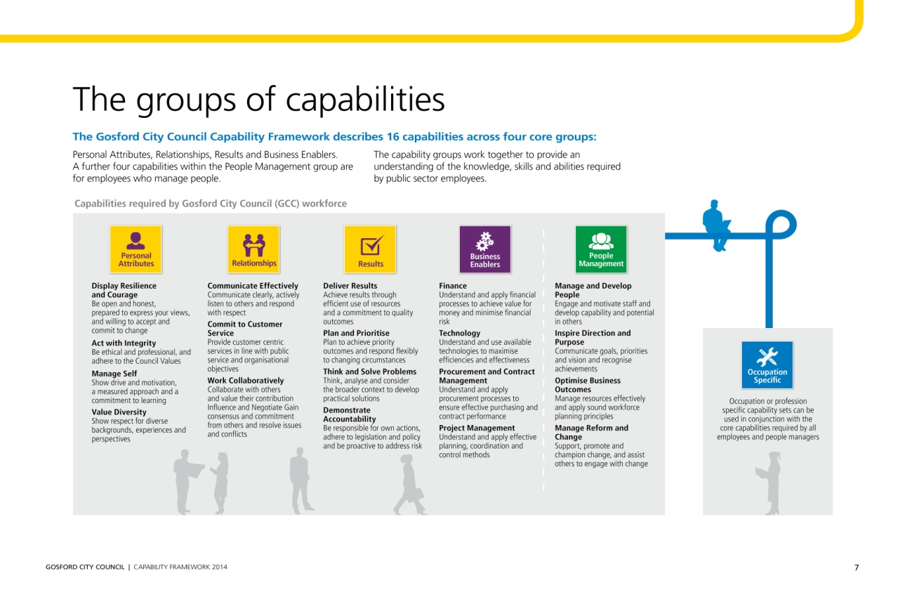

The level of capabilities for this role has been identified ranging between Foundational and Intermediate against the five capability core groups outlined above. Refer to the attached supplement for the descriptors relating to these capabilities.

Overview of Your Job Position:

Coordinator Leisure & Beaches
Supervisor:

Immediate
Supervisor:

Pools & Lifeguard
Team Leader

Duty Lifeguard
This Position
Casual Lifeguard
Lifeguards
Part Time
Others Reporting to
Same Supervisor:

© State of New South Wales (Public Service Commission) 2013

