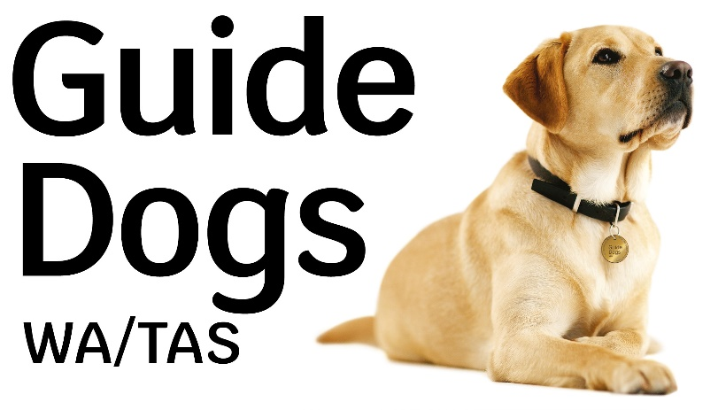

Job Description
Position: Team Leader - Marketing and Communications
Division: Engagement and Development
Reports To: Manager Engagement and Development
Direct Reports: Marketing and Communications Coordinator and Marketing Officers
Level: 7
Agreement: VisAbility Limited Enterprise Agreement 2018 - 2021

Purpose:
This role manages the engagement, marketing and brand strategy of the Guide Dogs WA and Guide Dogs Tasmania brands. The position involves coordinating a range of high-quality outputs including content creation, marketing campaigns, media relations, graphic design, digital marketing and social media management.

Our Vision
Inclusion and independence for all.

Our Values
Be there for everyone.
Trust and be trustworthy.
Collaborate and be innovative.

Our Purpose
To give everyone living with vision loss the support and confidence they need to thrive in the community.

We Aspire To
- Create a positive environment through our interactions with others
- Promote honesty by having moral and ethical principles
- Practice decision making with confidence
- Build trust through personal leadership
- Embrace change and be solution focused

We Strive To
- Continually pursue excellence and use best practice procedures
- Always act with respect and dignity toward others
- Engage in honourable conduct
- Be accountable for our actions
- Act professionally in all situations, especially when publicly representing our organisation
- Achieve our personal and work goals
- Take a proactive approach to coaching, learning and sharing knowledge

Key responsibilities and accountabilities
- In liaison with the Manager Engagement and Development, develop and implement the Guide Dogs WA and Guide Dogs Tasmania marketing strategies and communications plans.
- Strategic development of writing and production of marketing and promotional material for donor and supporter directed communications.
- Strategic development of writing and production of marketing and promotional material to promote Guide Dog program awareness and educate the community within the relevant state.
- Provide leadership and direct line management to team members.
- Contribute to the recruitment, induction and professional development of staff as required.
- Coordinate the digital marketing strategy for Guide Dogs WA and Guide Dogs Tasmania including the website, eDMs, social media and web articles, as well as analytics and online advertising.
- Measure and report to Manager Engagement and Development on digital and social media strategy.
- Create, maintain and strengthen the Guide Dogs WA and Guide Dogs Tasmania brands in all forms of media in accessible formats (online, print, academic).
- Create and curate engaging content including photography, video and graphics in line with strategy and content plan.
- Coordinate and support the development of all Guide Dogs WA and Guide Dogs Tasmania marketing collateral materials in line with accessibility guidelines.
- With the Manager Engagement and Development, oversee implementation of brand strategy and style guide.
- Identify, develop, and coordinate media strategy, including the development of press releases, case studies and speaking proposals as required.
- Coordinate the design of marketing material and promotional literature for all Guide Dogs WA and Guide Dogs Tasmania initiatives.
- Work with the fundraising team to produce donor centred material as required by the Fundraising staff.
- Research media coverage and track competitor activity by keeping abreast of market changes and the marketing mix used by competitors. to identify effective promotional methods
- In liaison with the Manager Engagement and Development, review achievements and issues, and set goals on regular basis to ensure strategic and operational objectives are being met.
- Assist in the preparation of reports for the Manager Engagement and Development.
- Actively seek information from VisAbility’s Process Mapping System and contribute to the creation and ongoing improvement of VisAbility’s processes through providing input, feedback and suggestions.
- Other duties as required by the Manager Engagement and Development.

Skills and attributes required

Essential:
- Bachelor’s degree, preferably in marketing, public relations, journalism or a related communications field.
- 5 years minimum marketing, communications, media or public relations experience. Experience working across various forms of publications.
- Previous experience managing fundraising and marketing programs.
- Proven ability in developing and implementing successful marketing strategies leading to improved operational outcomes.
- Proven ability to motivate and lead a team and deliver results through leadership.
- Sound ability to make decisions and solve problems though research, reflection, analysis and rigorous evaluation.
- Exemplary written and oral communication skills.
- Proven ability to successfully manage large scale projects
- Experience in managing communications programs focused on community engagement and donors.
- Exceptional organisation skills and attention to detail to support working to tight deadlines.
- Proven ability to establish and maintain relationships with key internal and external stakeholders.
- Ability to travel independently as required for events or off-site meetings.

Desirable:
- Print house and graphic design experience and/or exposure preferred
- Experience in/exposure to direct marketing principles and programs
- Knowledge of WCAG2.0 website development accessibility guidelines.
- Previous experience in website development.
- Valid “C” or “E” class driver’s license.

