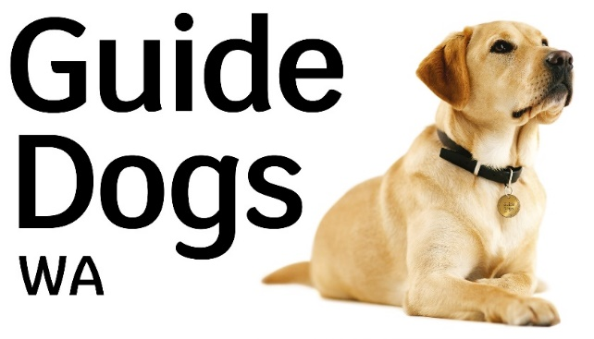

Job Description
Position: Program Manager - Guide Dog Services WA
Division: Guide Dog Services
Reports To: Manager - Guide Dog Services WA/TAS
Direct Reports: Guide Dog Mobility Instructors, Guide Dog Trainers, Puppy Raising Coordinator, Facility Dog Trainer, Liaison Officer
Level: 8
Agreement: VisAbility Limited Enterprise Agreement 2018 - 2021

Position Summary:
This position is responsible for providing the day to day management of the guide dog services department in WA, along with technical leadership, expertise and training of staff.
The key focus comprises; delivery, development and evaluation of Guide and Assistance Dog Services, implementation of a Functional Business Plan ensuring a focused strategy on program structure, consolidation, expenditure, program development, KPI’s, evolution and growth. Employee management and development, monitoring program and staff KPI’s, development of effective operational systems; and promoting interconnectedness and strong collaboration between departments and programs are integral to this role.

Our Vision
Inclusion and independence for all.

Our Values
Be there for everyone.
Trust and be trustworthy.
Collaborate and be innovative.

Our Purpose
To give everyone living with vision loss the support and confidence they need to thrive in the community.

Key responsibilities and accountabilities
TECHNICAL
- Provide technical expertise, advice, training, coaching and leadership of the Guide Dog WA and Assistance dog WA services team.
- In collaboration with other members of the Guide Dog Mobility and Puppy Raising team, monitor and support the intake, assessment and matching of dogs.
- Evaluate the quality (i.e. adhering to International Guide Dog Federation - IGDF – standards and ADI standards) and responsiveness of Guide and Assistance Dog services ensuring their effectiveness and their relevance to the client population.
- Undertake IGDF and ADI standard reviews and contribute towards service development and continuous improvement.
- Ensure the team assess Guide Dogs and Assistance Dogs to the standard determined by Guide Dogs WA and based on International Guide Dog Federation and Assistance Dogs International Standards.
- Provide professional recommendations regarding suitable career for dogs in the program to the Manager Guide Dogs Services WA/Tasmania
- Develop and maintain a Functional Business Plan in line with Guide Dogs WA broader strategic priorities.
- Maintain current knowledge of trends and developments in relation to Guide Dog services, training techniques, practices, policies and legislation.
- Develop processes and documents associated with the WA Guide Dog and Assistance dog training program ensuring they are relevant and up to date at all times.
- Ensure accurate and timely recording of data on the Client Management System within required timeframes
LEADERSHIP and PLANNING
- Lead and support direct reporting staff in accordance with their JDs and expected performance KPI’s.
- Work strategically with the Manager - Guide Dog Services WA/Tasmania to investigate, grow and develop programs and services, securing future funding streams.
- Contribute to the planning, development and delivery of Guide Dogs WA services to metropolitan and regional clients, as required and within available resources.
- In conjunction with other GDWA/VisAbility programs, assist with information provision on the Guide Dog program to external parties, clients and staff, as required.
- Work in close liaison with the fundraising department to maximise the profile of Guide Dogs in the Western Australian community.
- Act as an ambassador for Guide dogs by publicly supporting GDWA/VisAbility’s strategic direction. Represent GDWA at relevant promotional events.
- Ensure team compliance with organisational policies and procedures.
- Ensure safe work practices are adhered to at all times.
- Report to Manager any issues relating to or impacting service provision.
- Other duties as reasonably directed by Manager.

Skills and attributes required

Essential:
- Relevant qualifications in Vet Science, Vet Nursing or Allied Health.
- Proven team management, coaching and mentoring skills.
- Demonstrated highly developed interpersonal skills.
- Up-to-date knowledge of Guide Dog Mobility theory and practices, and knowledge of community resources relevant to people with vision impairment.
- Superior planning and organising skills, coupled with stress tolerance skills.
- Sound knowledge of current philosophy, policies and legislation relevant to Guide Dogs and Assistance Dogs.
- Ability to manage the physical demands and inherent requirements of the job and complete the tasks and duties as stated.
- Ability to work well within a team as well as independently.
- Awareness of the personal impact of disability and loss of vision for an individual.
- Effective communication skills both oral and written.
- Demonstrated knowledge and expertise in use of Microsoft Office programs and client management systems.
- NDIS Clearance and National Police Clearance.
- Valid Driver’s Licence.

Desirable:
- Recognised qualification in Guide Dog Mobility Training
- Broad base of experience in one or more IGDF accredited organisations.
- Understanding of NDIS practices and requirements in relation to client services.
- Effective public presentation skills.

