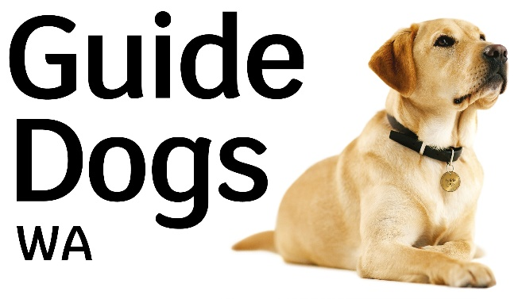

Job Description
Position: Guide Dog Mobility Instructor
Division: Guide Dog Services
Reports To: Program Manager Guide Dog Services WA
Direct Reports: Nil
Level: 5/6/7
Agreement: VisAbility Limited Enterprise Agreement 2018 - 2021

Position Summary:
This position is responsible to provide professional guide dog mobility services to clients with vision loss to enable them to travel independently, safely and efficiently. The role involves assessing, training and matching dogs to eligible clients and conducting client training programs to develop effective working units.
This position may also provide services on the assistance dog and facility dog programs.

Our Vision
Inclusion and independence for all.

Our Values
Be there for everyone.
Trust and be trustworthy.
Collaborate and be innovative.

Our Purpose
To give everyone living with vision loss the support and confidence they need to thrive in the community.

Key responsibilities and accountabilities
- Assess and train Guide Dogs to the standard determined by Guide Dogs WA and based on International Guide Dog Federation standards.
- In collaboration with other members of the Guide Dog Team, match Guide Dogs to clients.
- Develop, document and conduct Guide Dog Client Training Programs, both centre-based and domiciliary.
- Refer Guide Dogs for veterinary examination, as required.
- Maintain current knowledge of trends and developments in relation to Guide Dog services, training techniques, practices, policies and legislation.
- Contribute to the planning, development and delivery of Guide Dogs WA services to metropolitan and regional clients, as required and within available resources.
- Advocate on behalf of clients in relation to issues of access and equity.
- In conjunction with other VisAbility Programs, assist with information provision on the Guide Dog program to clients and staff, as required.
- Ensure accurate and timely recording of data on the Client Management System within required timeframes
- Actively seek information from the organisations Process Mapping System and contribute to the creation and ongoing improvement of the organisation’s processes through providing input, feedback and suggestions.
- Collaborate with other departments to achieve organisational objectives.
- Comply with organisational policies and procedures.
- Ensure safe work practices are adhered to at all times
- Meet individual Key Performance Indicators (KPIs).
- Act as an ambassador for Guide dogs, promoting good public image and supporting the organisation’s strategic direction
- Other duties as reasonably directed by Manager.

Skills and attributes required

Essential:
- Recognised qualification in Guide Dog Mobility Training
- Up-to-date knowledge of Guide Dog Mobility theory and practices, and knowledge of community resources relevant to people with vision impairment
- Superior planning and organising skills, coupled with stress tolerance skills
- Sound knowledge of current philosophy, policies and legislation relevant to Guide Dogs
- Ability to manage the physical demands and inherent requirements of the job and complete the tasks and duties as stated
- Ability to work well within a team, as well as independently, assuming responsibility for nominated tasks
- Awareness of the personal impact of disability and loss of vision for an individual
- Effective communication skills both oral and written
- Demonstrated knowledge and expertise in use of Microsoft Office programs.
- Current National Police Clearance Certificate.
- Valid Driver’s Licence.

Desirable:
- Effective public presentation skills.
- Broad base of experience in one or more IGDF accredited organisations.
- Background in teaching or training adults and children

