**How to complete your employee referral nomination form**



**Personal Details**

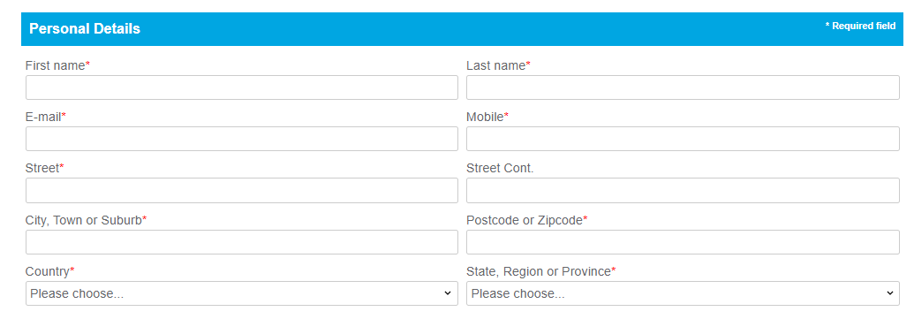

**Questions**

