Position Description
Early Childhood Teacher

About Council
Georges River Council is a leading, people-focused organisation with approximately 600 staff members. Our people are working to make the Georges River area an accessible, green, diverse and innovative community and economy. We are dedicated to providing vibrant public places, sustaining and developing a thriving creative culture, helping protect our natural environment, and making our suburbs more liveable.

Our organisation is made up of a committed, talented, and diverse workforce. Our vision, mission and values underpin all that we do to successfully achieve our Community Strategic Plan (CSP) and implement our Delivery and Operational Plans.

Mission, Vision and Values
Mission: A leading people-focused organisation delivering outstanding results for our community
and city.
Vision: Naturally connected to place, community
and Country.

Values:
To find out more please visit georgesriver.nsw.gov.au/Council/Careers

Child Protection
At Georges River Council we are committed to putting children first and championing child safety within our community. We actively advocate for the rights of children and young people and will uphold our commitment as a child safe organisation.

EEO
Georges River Council wants to build a workplace free from discrimination and harassment. It is the responsibility of all employees to ensure that they treat all colleagues and customers with respect and professionalism without regard to non-relevant criteria or distinctions.

Workplace Health and Safety
‘There is always time to work safely’. We all have a responsibility for Workplace Health and Safety.
All employees must observe safe work practices and operating procedures and comply with the requirements of the WHS legislation and Council’s Policies and Procedures relating to Workplace Health and Safety.

Conditions of employment
Conditions of employment are in accordance with Council’s Code of Conduct, as specified in the employment contract.

Otherwise, employment at Georges River Council is governed by Council policies, procedures and the Local Government (State) Award 2023.

About the directorate
Community and Culture
The Community and Culture directorate works in partnership with the community to ensure it is social and culturally connected. Our teams provide diverse and vibrant programs, service and facilities that bring together communities, deliver cultural and creative engagement opportunities and support the informational needs of our community.

- Community and Early Learning Services
- Cultural Engagement and Library Services
- City Life

About the position
Title
Early Childhood Teacher

Position number
4000XX
Directorate
Community and Culture

Business unit
Community and Early Learning Services

Reports to
Coordinator Early Learning Services

Direct reports
Nil

Classification/grade
13

Child protection tier
Tier 1 - Working directly with children

Position purpose

The Early Childhood Teacher, is expected to be an active, engaged, leader as part of a team which provides high quality early childhood education and care to the community.

This includes:
- Developing strong relationships with children, staff and families.
- To provide leadership and promote a cooperative team approach.
- To develop and implement, in consultation with parents and staff a high quality program that meets the individual needs of children.
- To prepare and maintain documentation that relates to children’s development, educational program, and compliance with legislative requirements.
- Implementing the policies and associated procedures of the organisation at all times.
- Working with other staff towards continuous improvement in all areas of the service’s operations.

Direct reports/Organisational structure
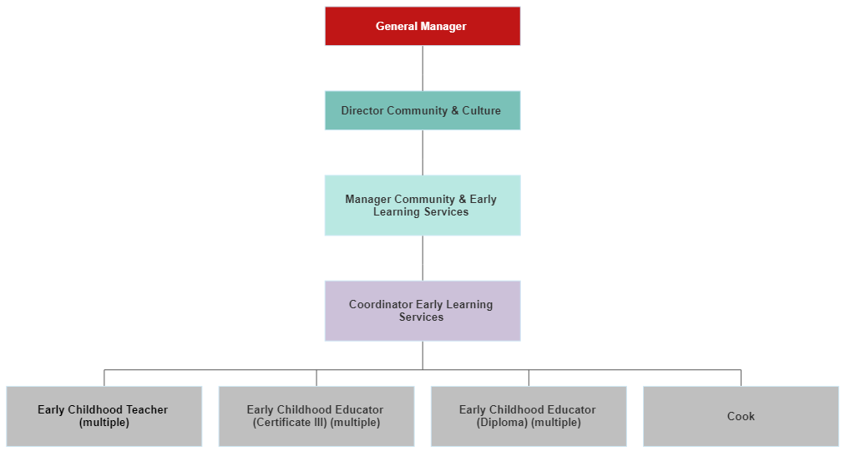

Key accountabilites
General Responsibilities
  - Lead, guide and support a team which provides high quality early childhood education and care, Working in accordance with the requirements of the Children (Education and Care Services National Law Application) Bill 2010, Education and Care Services National Regulations and the National Quality Standard for Early Education and Care.
  - Working in accordance with the Code of Ethics of the Early Childhood Australia.
  - Developing and implementing the services’ philosophy in undertaking all other duties.
  - Working in accordance with the policies and associated procedures of the organisation.
  - Facilitating the implementation of contemporary, research based practices at the service.
  - Providing ongoing support and assistance to other staff in all areas of service operation.
  - Providing ongoing support and assistance to the centre coordinator and any other associated organisation.

Responsibilities as per the National Regulations
  - As required, to act as the Nominated or Certified Supervisor of the early childhood education and care service.

Responsibilities as per the National Quality Standard
  - Develop and deliver an Educational program and practice.
  - Monitor and Plan for individual training requirements. Attend in-service training, conferences, webinars as appropriate and share your knowledge with centre and department staff.
  - Ensure you are an accredited Early Childhood Teacher, maintaining your records in the NSW Education Standards Authority Portal.
  - Assume the role of Responsible Person, taking on responsibility of being in day to day charge of the centres operations.
  - Understand what is required to be reported in the ACECQA portal and ensure all incidents are reported within 24 hours of the incident occurring.
  - Be actively involved in reviewing centres policies and procedures.
  - Where possible, assume the role of Educational Leader at the service, guiding curriculum decision making, unpacking the themes of Exceeding, mentoring other staff on their programming approach.
  - Ensure to implement the service statement of philosophy and that it guides the pedagogy.
  - Develop programs which reflect the Early Years Learning Framework (EYLF) and teaching decisions.
  - Ensure curriculum decision making contributes to each child’s learning and assist children to enhance their connection with community, wellbeing, confidence as learners and effectiveness as communicators.
  - Support children in developing the goals of the EYLF:
- A strong sense of their identity.
- Connections with their world.
- A strong sense of wellbeing.
- Confidence and involvement in their learning.
- Effective communication skills.
  - Guide the implementation of a play based learning environment responsive to children’s interests, strengths and abilities.
  - Plan and implement incursions and excursions that are relevant extensions of the centres program including developing the accompanying risk assessment.
  - Lead and guide the planning, implementation, evaluation and reflection of education and care programs which reflect the emerging skills and interests of children.
  - Implement intentional teaching strategies to scaffold and guide children’s interests and learning.
  - Assist with the implementation of daily routines and use routine times as opportunities for learning.
  - Plan children’s learning and the documentation of this so as to make their learning visible.
  - Maintain ongoing records of the children’s development and records of children’s assessments connected to learning outcomes.
  - Engage in critical reflection and evaluation of children’s learning to be used as a primary source of future planning.
  - Advocate and support thinking and discussions on curriculum considerations relating to inclusion and the community of Aboriginal and Torres Strait Islander, culturally and linguistically diverse families.
  - Mentor and teach educators through observations, guided discussions and recommendations for professional development on curriculum practices.
  - Use informational technology to support and extend children’s learning.
  - Be aware of funding available and structure of support available to assist children with additional needs.
  - Role model appropriate interactions and behaviours with children, staff and families.
  - Contribute to the centres Quality Improvement Plan and its implementation of projects.
  - Contribute to and implement the centres Inclusion support plans and Reconciliation Action Plans.
  - Make recommendations and advocate for difficult and complex matters such as significant program changes, policy changes and long established procedures.
  - Oversee the progress and competencies of trainee staff and students and the centre.
  - Peer review your colleagues summative assessments and observations, providing constructive feedback.

Children’s Health and Safety
  - Ensure each child’s health and wellbeing needs are supported.
  - Ensure that children are safe and adequately supervised at all times.
  - Ensure potential supervision risks are reported to other educators and the centre coordinator.
  - Take responsibility for the protection and rights of children attending the service.
  - Ensure that the environment is safe, supportive, stimulating and educational for children.
  - Respond positively and consistently to children’s additional needs/requirements – diet/allergies, developmental etc.
  - Ensure a high standard of hygiene is maintained in compliance with procedures and policies.
  - Administer first aid and medication in compliance with procedures and policies.
  - Ensure to keep accurate and detailed records of injury/accident/trauma and medication forms.
  - Become familiar with all policies regarding health and safety at the service.
  - Support children’s individual wellbeing and comfort in sleep, rest and relaxation.
  - Assist to ensure the service’s child protection policy is implemented.
  - Inform the centre coordinator of any allegations or convictions of a child protection nature against any other employees, of which you become aware.
  - Ensure that you are implementing the centres Munch and Move policies and incorporating physical activity into the centres programming.
  - Understand your obligation as a mandatory reporter and be up to date with current reporting guidelines.
  - Develop risk assessments for the centre as requested by Nominated Supervisor
  - Develop risk assessments for all excursions planned for your room.
  - Ensure all safety checks are carried out daily and all emergency evacuation drills are completed.

Performance criteria/expectations/measurements
Performance expectations for this position are as agreed and outlined in the position description and in Council’s Performance Excellence Program.

What we’re looking for
Knowledge, Skills and Qualifications

  - Current Working with Children Check, with at least 6 months until expiry.
  - NSW Department of Education and Communities approved Early Childhood Education and Care Qualification. ACECQA approved or recognised teaching qualification (i.e. either a Bachelor of Teaching or Education or equivalent).
  - Current First Aid, Anaphylaxis and Asthma Management Certificates, with at least 6 months until expiry.
  - NESA accredited teacher in the categories of either: Graduate, Proficient, Highly accomplished or lead.
  - NSW Department of Education and Communities approved Child Protection Training Certificate.
  - Food Handling and Preparation Training or Certification.
  - Sound communication skills and ability to relate well to children, parents, staff, volunteers and the community.
  - Understanding of Work Health and Safety Requirements.
  - The ability to develop, document and implement an educational program for children.
  - Knowledge and understanding of all current legislation governing early childhood education and care, including the National Quality Framework.
  - The ability to lead, support, motivate and mentor staff.
  - Demonstrated ability or willingness to work as a member of a multi-disciplinary team.

Other Desirable Attributes

  - Demonstrated experience working with groups of children aged 0-5 years in a Childcare Centre setting (or similar).
  - Demonstrated experience or willingness to act as a Nominated Supervisor or Educational Leader.
  - Demonstrated ability or willingness to develop partnerships with all stakeholders who are from diverse backgrounds (children, family members, co-workers, other Council employees, volunteers, students and community members).
  - Demonstrated ability or willingness to prioritise and meet study and work commitments and/or deadlines.
  - Ability to speak a relevant community language e.g. Arabic, Cantonese, Mandarin, Greek.

