Role: Home Care Package (HCP) Care Manager
Task Description  - The HCP Care Manager role is aimed towards supporting clients to remain independent at home and within the community.  - The HCP Care Manager will assist clients to remain independent by coordinating necessary services (in-house or externally), managing client budgets and overseeing the client’s care plans.  - Within the role, HCP Care Manager’s will liaise with client’s services, treatment providers, ACAT (Aged Care Assessment Team).  - The HCP Care Manager facilitates both face-to-face meetings / assessments with clients, as well as engage in remote-based communication (phone / email). Report writing / case noting is also a significant component of the role.  - Greater than 50% of role would be undertaken at a computer workstation (office or home-based).  - Clients consist of people with disadvantaged / homeless backgrounds and clients typically have physical, psychological, emotional or behavioural issues. These are assessed prior to referral to Wintringham. Clients are then categorised as level 1 or 2 (low care), 3 or 4 (high care) on the ANZAF legislation guide.  - HCP Care Managers can be exposed to client’s with escalating behaviour, resulting in physical or verbal abuse.  - HCP Care Managers manage a case load of 19-31 clients (depending on whether percentage of level 1, 2, 3 or 4 client’s).  - The HCP Care Manager may travel up to 1 hour (one-way) to attend face-to-face meetings with clients  Modification Options  - Reduction in face-to-face visits if erratic client behaviour a concern or have two HCP Care Managers attend |  | Body Map  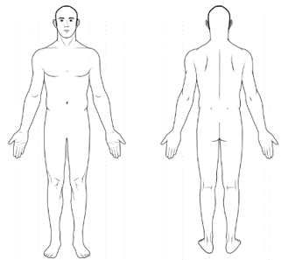
 |  | Demands Category
 |  | Physical Demand |  | Emotional Demand
 |  | Cognitive Demand |  | Role Demand

Photos
 | 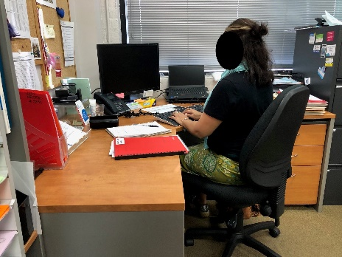
Writing at workstation | Typing at workstation |  | Backpack with laptop
 |  |  | 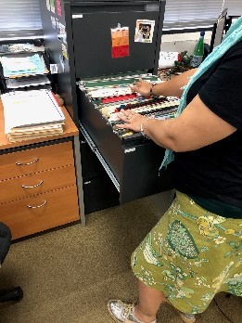
Client ‘red’ book | Client manila folder |  | Filing cabinet to access records

Job Activity | Frequency |  |  | Comments
 | O  <33% | F  33-66% | C  >66%

Physical Demands
Neck movement:
Trunk movement:
Shoulder movement: |  |  |  | Not required to work above shoulder height
Elbow movement:
Hand movement: |  |  |  | Writing and typing
Foot movement: |  |  |  | Driving, attending client’s homes
Standing:
Sitting: |  |  |  | Driving, completing computer-based tasks
Walking:
Squatting / kneeling:
Lifting:
Average weight: 1-2kg |  |  |  | ‘Red’ book, client folder(s)
Maximum weight: 5kg |  |  |  | Wheelchair, 4-wheel walker / frame
Climbing / stairs: |  |  |  | Within community / client residence
Push / pull (clothing bins, Ladders): |  |  |  | Client in wheelchair (as required)
Sensory: hearing, touch, sight

Psychological Demands
Reading comprehension
Oral comprehension
Oral expression
Writing |  |  |  | Writing during meetings and phone calls
Numerical reasoning
Critical thinking
Attention to detail
Judgment and decision making |  |  |  | May be required to make time sensitive decisions
Active listening
Memory |  |  |  | Required to recall information of 19-31 clients
Concentration

Emotional Demands
Social perceptiveness
Stress tolerance |  |  |  | HCP Care Manager are confronted with difficult circumstances that can induce significant psychological stress
Persuasion
Dealing with stakeholders
Resolving conflicts & negotiating with others
Deal with unpleasant or angry people |  |  |  | HCP Care Manager’s may be exposed to verbal abuse on a weekly basis
Work with work group or team |  |  |  | Mainly work independently, however, monthly team meetings and team audits

Role Demands
Adaptability and flexibility
Time pressure |  |  |  | Circumstances may occur that require urgent actioning
Time management
Coordinate and lead others |  |  |  | Coordinating services for clients
Impact of decisions on co-workers or company results

Key Definitions
Term | Definitions
Physical Demands
Sedentary Work | Manual handling involving < 5kg occasionally or < 1kg frequently to lift, carry, push, pull or otherwise move objects. Sedentary work involves sitting most of the time, but may involve walking or standing for brief period of time. Jobs are Sedentary if walking and standing are required only occasionally and all other Sedentary criteria are met. Sedentary work may involve repetitive action (i.e. typing).
Light Work | Manual handling < 10kg of force occasionally, or < 5kg of force frequently, or a negligible amount of force constantly to move objects. Physical demand requirements are in excess of those for Sedentary work. Even though the weight lifted may be only a negligible amount, a job should be rated as Light Work:  When it requires walking or standing to a significant degree: or  When it requires sitting most of the time but entails pushing or pulling of arm or leg controls  When the job requires working at a production rate pace entailing the constant pushing or pulling of materials even though the weight of those materials is negligible
Medium Work | Manual handling 10kg to 25kg occasionally, or 5kg to 10kg frequently, or up to 5kg constantly to move objects. Physical demand requirements are in excess of those for Light Work.
Heavy Work | Manual handling 25 to 50kg occasionally, or 10 to 25kg frequently, or 5 to 10kg constantly to move objects. Physical demand requirements are in excess of those required for medium work.
Psychological Demands
Lowest | Cognitive:  < 3 cognitive demands in the frequent or constant on the frequency rating and / or < 5 occasional ratings | Emotional:  < 3 emotional demands in the frequent or constant on the frequency rating | Role:  < 2 role demands in the frequent or constant on the frequency rating
Light | Cognitive:  Between 3 & 5 cognitive demands in the frequent or constant on the frequency rating and / or between 6-7 occasional ratings | Emotional:  Between 3 & 4 emotional demands in the frequent or constant on the frequency rating | Role:  2 role demands in the frequent or constant on the frequency rating
Medium | Cognitive:  Between 6 & 8 cognitive demands in the frequent or constant on the frequency rating and / or 8-10 occasional ratings | Emotional:  Between 5 & 6 emotional demands in the frequent or constant on the frequency rating | Role:  3-4 role demands in the frequent or constant on the frequency rating
High | Cognitive:  >8 cognitive demands in the frequent or constant on the frequency rating and / or 11 plus occasional ratings | Emotional:  > 6 emotional demands in the frequent or constant on the frequency rating | Role:  5 role demands in the frequent or constant on the frequency rating

