POSITION DESCRIPTION
Chronic Disease Nurse

Reports to: | Chronic Disease Team Leader | Division: | Nurses
Award: | Nurse Award 2010 | Classification: | Registered Nurse Level 2, Pay Point 1 - Registered Nurse Level 2, Pay Point 4
BRAMS Classification: | Registered Nurse Level 1 – Registered Nurse Level 4 | Direct Reports: | Nil
Approved by: | Chief Executive Officer | Date approved: | 4 July 2022

ORGANISATIONAL CONTEXT
The Broome Regional Aboriginal Medical Service (BRAMS) is an Aboriginal Community Controlled Health Service which has been caring for the Broome community for more than 40 years. When we first opened our doors in 1978, BRAMS was the first remote Aboriginal Medical Service in Western Australia.
BRAMS provides comprehensive, holistic and culturally responsive primary health care, social and emotional wellbeing services, and NDIS support to Aboriginal people living in Broome. BRAMS delivers more than 40,000 of occasions of service each year. BRAMS delivers services in accordance with our Model of Care.
Our Vision
Healthy People – Strong Community – Bright Future
Our Mission
Provide holistic and culturally responsive health and wellbeing services for Aboriginal and Torres Strait Islander People. That means making our Mob healthy.

POSITION PURPOSE
The Chronic Disease Nurse works collaboratively with clients, General Practitioners, Aboriginal Health Workers and external health providers, to provide responsive multidisciplinary care services for Aboriginal and Torres Strait Islander people with chronic diseases to optimise health outcomes.

KEY RESULT AREAS | MAIN DUTIES
Service Delivery | In partnership with the General Practitioner and Aboriginal Health Worker, oversee the case management of clients with complex care needs and coordinating appropriate service delivery including but not limited to:  - Ensuring all patients with chronic disease are receiving timely reviews and follow ups.  - Provide a high standard of contemporary chronic disease care and clinical management of chronic disease patients.  - Creating and maintaining recall lists for clients including adult health checks, development and follow up of GP Management Plans and Team Care Arrangements.  - Ensure Chronic Disease Patients have a completed 715 health check and complete as scheduled.  - Coordinating Chronic Disease Clinics.  - Facilitating the referral of patients to specialist appointments including PATS arrangements.  - Analysing client data and making recommendations for ongoing care to General Practitioners.  - Work closely with visiting medical specialists and allied health providers to ensure that interventions are appropriately documented and acted upon.  - Facilitate and accompany clients where appropriate in accessing Telehealth services.
Education and Promotion of Health Literacy | Health promotion and disease prevention education to enable clients to understand and manage their health conditions including but not limited to:  - Facilitate self-management and provide education for individual clients re their condition(s), care plan, goals and support engagement with BRAMS.  - Deliver health promotional and education to individuals and community group to increase awareness and prevention of chronic conditions and promote healthy lifestyle choices.  - Provide clinical leadership to the multidisciplinary team in all areas of chronic disease prevention and management.
Administration and Compliance | Maintain records in accordance with organisational policies including but not limited to:  - Maintain secure and accurate client information on the MMEX system.  - Actively participate in Continuous Improvement activities, including data collection and cleansing.  - Adherence to the BRAMS IAHP annual work plan that includes Key Performance Indicators.  - Ensure respectful and active participation in team meetings, staff meeting and community activities as practicable.  - Adhere to all BRAMS policies and procedures as appropriate to the role.  - Foster and promote a collaborative team environment within the workplace.  - Proactively investigate new perspectives, attitudes and behaviours and take steps to evaluate and improve your own and organisational performance.
Stakeholder Engagement | Maintain and establish networks with relevant organisations.  - Comply with and contribute to continuous improvement of all BRAMS policies, procedures and processes.  - Contribute to achieving BRAMS Quality Objectives.  - Participate in internal and external audits.  - Utilise BRAMS’ QMS System (LOGIQC) to its full capacity.
Quality Management System | Contribute to effective team performance which ensures BRAMS continues to deliver the best service to community in line with program specific accreditations and ISO 9001 standards including but not limited to:  - Comply with and contribute to continuous improvement of all BRAMS policies, procedures and processes.  - Contribute to achieving BRAMS Quality Objectives.  - Participate in internal and external audits.  - Utilise BRAMS’ QMS System (LOGIQC) to its full capacity.
The duties outlined in this Position Description are not exhaustive and are only an indication of the work of the role. BRAMS reserves the right to vary the Position Description.

KEY PERFORMANCE INDICATORS
The employee will be required to participate in the development of an individual workplan which will include key result areas associated with their position and a requirement to demonstrate appropriate behaviours which reflect a commitment to BRAMS values and strategic directions.

KEY RELATIONSHIPS
Internal
CEO | The CEO may make day-to-day requests for support and information from the Chronic Disease Nurse relating to the Chronic Disease programs.
Practice Manager | The Chronic Disease Nurse may receive guidance and direction from the Practice Manager.
Chronic Disease Team Leader | The Chronic Disease Team leader is the first point of contact for the overall direction of work.
Employees, Team Leaders and Managers | Build effective relationships across the organisation.
External
External Stakeholders | The Chronic Disease Nurse will develop and maintain strong links with external stakeholders in the delivery of clinical services and to support the best outcomes for consumers.

WORKFORCE CAPABILITY FRAMEWORK
BRAMS is operating in a rapidly changing environment which requires our workforce to build capabilities and quality to enable - and drive - sector reforms, particularly the Closing the Gap initiative. These stages of work can be thought of as ‘domains’, and are intended to be consistent with BRAMS’ Model of Care. Each domain comprises several capabilities that enable BRAMS staff to achieve the objectives of that stage of work. These domains and capabilities combine to form the capability framework for BRAMS.
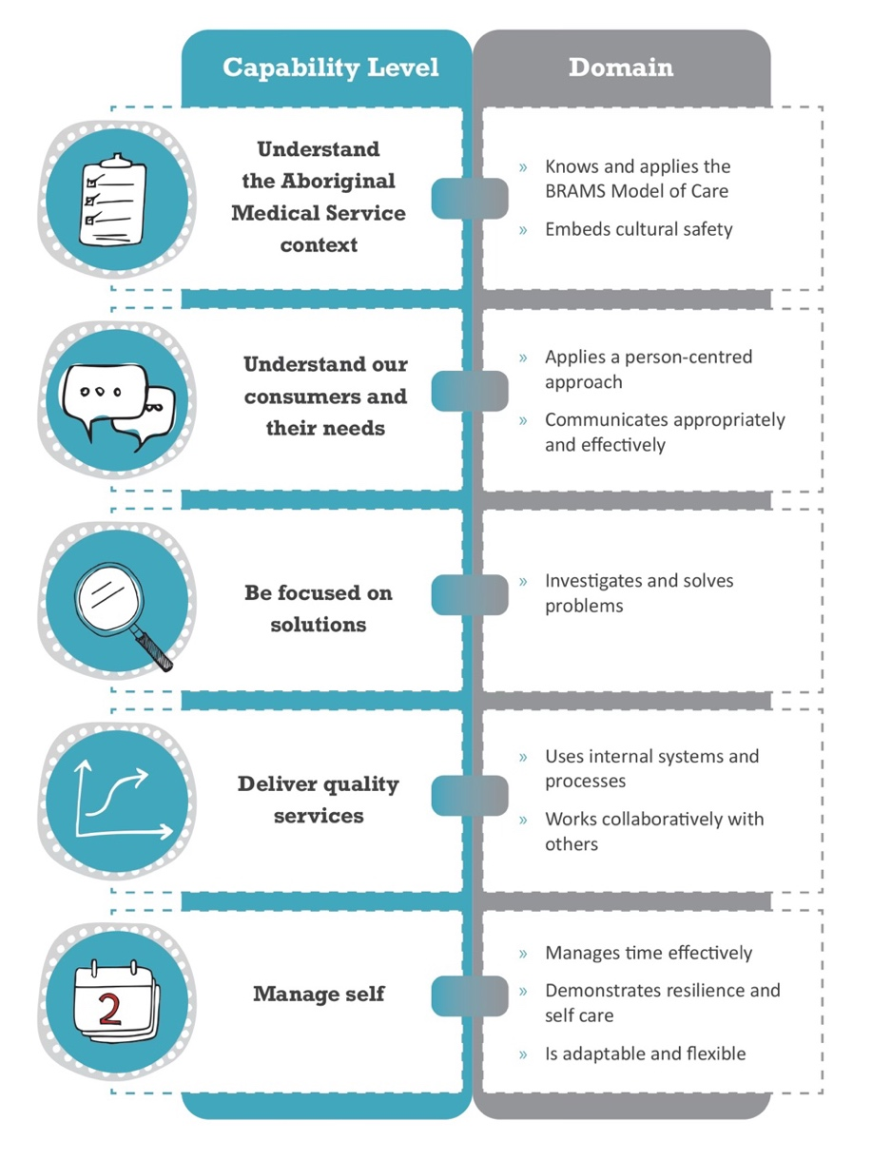

CAPABILITY LEVELS FOR THE POSITION
Capability levels for the position are as follows and reflect a progressive increase in complexity and skill:
Foundational > Established > Leading
CAPABILITY |  | DOMAIN | LEVEL
 | Understand the Aboriginal Medical Service context | Knows and applies the BRAMS Model of Care | FOUNDATIONAL
 |  | Embeds cultural safety | FOUNDATIONAL
 | Understands our consumers and their needs | Applies a person-centred approach | FOUNDATIONAL
 |  | Communicates appropriately and effectively | FOUNDATIONAL
 | Be focused on solutions | Investigates and solves problems | FOUNDATIONAL
 | Deliver quality service | Uses internal systems and processes | FOUNDATIONAL
 |  | Works collaboratively with others | FOUNDATIONAL
 | Manage self | Manages time effectively | FOUNDATIONAL
 |  | Demonstrates resilience and self-care | FOUNDATIONAL
 |  | Is adaptable and flexible | FOUNDATIONAL

BRAMS MODEL OF CARE
The BRAMS Model of Care is an expression of our collective goals of delivering high quality comprehensive health and wellbeing for Aboriginal people. Our Model of Care is defined in the figure below.
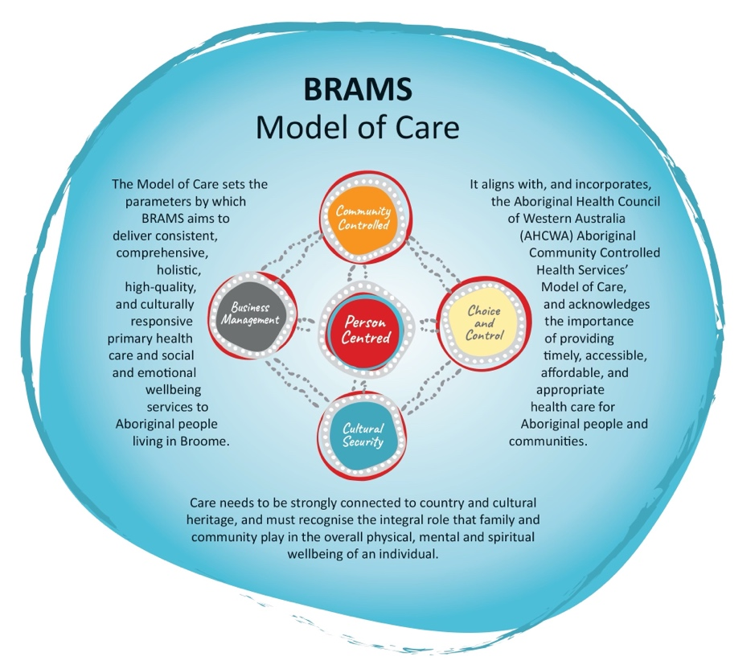

VALUES
The values of BRAMS are used to indicate the type of conduct required by our employees and the conduct that our consumers can expect from our service:
- Respect: Treat one another and others with respect.
- Integrity: Be truthful, honest and ethical in our dealing with one another and others.
- Accountability: Take responsibility for what we do and the decisions we make.
- Quality: Provide high quality services that meet the expectations of our clients and the community.

EMPLOYMENT SCREENING
Employees are required to demonstrate that they have undergone appropriate employment screening in accordance with BRAMS Employment Screening Policy. The following checks will be required for this role:
 | National Police Check |  | Pre-Employment Medical Assessment
 | Working with Children Check |  | National Disability Insurance Service Check
 | AHPRA Verification Check |  | Drivers Licence Verification Check
 | Passenger Transport Driver Check |  | COVID-19 Vaccination

SELECTION CRITERIA
Candidates for the position of Aged and Disability Case Manager must address the following selection criteria:
Essential Criteria
- AHPRA Registered Health Professional.
- Must hold and maintain a current Australian issued Driver’s Licence.
- Must be vaccinated against COVID-19

Desirable
- Qualifications in Public Health or Chronic Disease Management.
- Previous experience within an Aboriginal and Torres Strait Islander Community Controlled Health Service.
- Demonstrated high level of interpersonal, verbal and written skills to facilitate effective communication with individuals and groups.
- Ability to work with a wide variety of professionals and as part of a wider team.
- A demonstrated capacity for self-management, participative decision making, effective teamwork and the capacity to build respectful relationships with clients in a primary health care setting.
- Sound understanding of primary health care, clinical understanding of chronic diseases and demonstrated case management experience.

ROLE ACCEPTANCE
I have read and understood the responsibilities associated with this role the organisational context and the values of BRAMS as outlined within this document.
Employee Signature: | Date:

