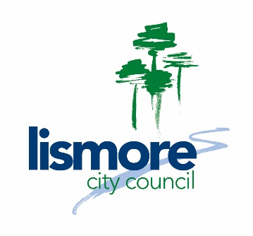

POSITION DESCRIPTION – Trainees (parks)

Our Values:

Position title: Trainee – Parks & Recreation (Horticulture)

Job code: 2001

Name: Vacant

Section: Parks & Recreation - Works

Position reports to: Team Leader - Gardens

Band and level: Band 1 Level 1

Salary grade: Local Government (State) Award Based Salary for Trainees

Staff management: Nil

Budget responsibility: Nil

Primary function:

The primary function of this traineeship is to learn the fundamentals of urban horticulture whilst assisting the Parks & Recreation section maintain its gardens and grass/turf areas. The role will include general gardening, weeding, pesticide spraying, mowing and edging among many other tasks.

Person description:

- The right person for this role will be self-motivated, proactive, observant and aware
- They will be a team player
- They will embody Council’s values

Responsibilities and duties:

The Trainee is responsible for making every effort to acquire skills and knowledge needed to successfully complete the traineeship by:
- Accepting instruction and training in the vocation assigned to the traineeship
- Attending scheduled training delivered by the registered training organisation
- Completing all assignments and other assessment tasks set by the registered training organisation
- Maintaining the competency record book or work evidence guide issued by the registered training organisation
Responsibilities and duties (cont):

- Notifying and discussing with their supervisor any concerns or attendance requirements at work and the registered training organisation
- Notifying State Training Services if there are any changes to your personal details, or if there are any concerns about completing the traineeship
- Cooperating and communicating with the supervisor and team
- Working safely and following instructions

Entry level requirements:

- Interest and commitment in learning horticulture, parks and recreation.
- Work in an environment where there is a high demand for manual labouring tasks
- Literacy and numeracy skills to enable the trainee to complete the training requirements of the vocation with the registered training organisation
- Work as per the Be, Do, Know model

Qualifications and experience:

- White Card – Work Safely in the Construction Industry or willingness to obtain prior to commencement
- An ability to gain a drivers licence within the term of the traineeship

Corporate responsibilities:

In 2010 our organisation established a framework for the future through our Reconciliation Action Plan. Council commits to building relationships, demonstrating respect and providing opportunities for a supportive working environment for an increasing number of Aboriginal and Torres Strait Islander employees.

We are continually striving to improve every aspect of our business. Our vision for reconciliation is that our community walks together towards a shared future, acknowledging through actions and words the histories, cultures and contributions of Aboriginal and Torres Strait Islander community members

Lismore City Council will ensure all the trainees have access to a Mentor and any support services to facilitate a successful completion of the traineeship program

Skills STEPS:

Step 1. Successfully complete 1st year of traineeship, TAFE training and on the job training.

Step 2. Successfully complete 2nd year of traineeship, TAFE training and on the job training.

