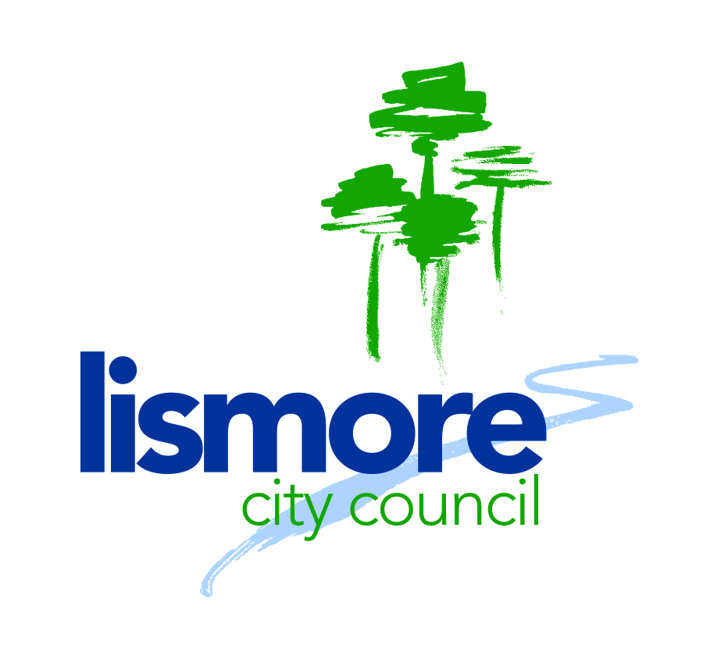
POSITION DESCRIPTION

Our Values

Position title: Waste and Services Education Officer

Position code: 1486

Name: Vacant

Section: Commercial Services

Position reports to: Business Project Coordinator

Band and level: Band 3 Level 2

Salary grade: 14

Staff management: Nil

Budget responsibility: Yes

Primary function of the role:
Reporting to Business Project Coordinator the Waste and Services Education Officer is responsible for the delivery of waste education projects and services and also contribute to the development, delivery and evaluation education, marketing and awareness activities identified within the Commercial Services Program.

The position is responsible for:

- Deliver waste education projects and services in accordance with approved project plans.
- Provide technical advice to facilitate the development of education programs to reduce waste to landfill and reduce contamination in the organics bin and recycling service, across all sectors of the community.
- Promote the activities of the Commercial Services Program to the community.

This position is part of a multi-skilled team and is required to flexible and agile. From time to time, this role may be required to support more than one department as the need arises and provide support across the organisation as directed.

Person Description
The right person for this role will:
- Be accepting of new ideas and embrace change
- Be outcome focused
- Be open minded in sharing information and knowledge freely
- Be flexible and agile to work across different business areas
- Have a drive for improvement
- Have personal integrity and take responsibility
- Have a genuine customer service focus
- Have the ability to prioritise and schedule work and meet deadlines
- Have excellent time management and organisational skills
- They will embody Council’s values.

The Commercial Services Education Project Officer:
- Has the skills, capability and willingness to analyse problems, evaluate alternatives with a focus on collaborative problem solving.
- Ensures projects and resourcing plans are aligned to accountabilities and responsibilities.
- Engages and consults by means of well-developed oral and written communication skills, with the capability to influence, listen to others, put forward ideas and encourage the views of others.
- Leads their team to achieve excellence through service delivery benchmarks and is committed to the implementation of continued improvement processes; and
- Is accountable for the financial, legal, physical and human resources for the team within agreed budgets, timeframes and reporting standards.

Key responsibilities and performance goals:

 | Responsibilities | Accountability
Work Health and Safety | Manage and monitor work health and safety responsibilities, ensure compliance with the legislation and regulations that govern the operations within the Program area and assist others in the team to implement the relevant policies, procedures and processes. | - Foster a culture of safety and behaviour based on safety principles.
Best Practice and Benchmarking | Develop best practice education programs for waste and recycling.  Establish and monitor waste education behaviour benchmarks.  Monitor projects, processes, standards and service delivery benchmarks. | - Assist to identify and implement improvements to education programs.  - Monitor and review community and industry benchmarks to meet strategic objectives
Governance and Risk | Ensure risks to the delivery of projects are identified and managed | - Project risks are identified on the corporate risk register with appropriate mitigation strategies  - Comply with Council’s Procurement Guidelines and processes  - Ensure that all corporate records are fully and accurately captured and maintained, to comply with legislative requirements and business needs
Customer driven service delivery | Build and maintain relationships with key stakeholders and customers (internal and external) related to program service delivery. | - Provide a high level of customer service to manage the expectations of internal and external customers in the resolution of their issues  - Drive a customer service approach in all interactions  - Enhance your knowledge base.  - Use social research to better understand community knowledge and motivations to improve participation in education and marketing programs.  - Participate in community consultation programs and foster partnerships for positive outcomes.  - Expand partnerships and network activities to enhance the reach and delivery of quality programs.
Finance | Create and manage financial and physical resources within agreed budgets, timeframes and reporting standards | - Services are delivered to the established benchmarks within the agreed budget tolerances and timeframes.  - Monitor and report monthly in accordance with Council standards and expectations, including trend analysis and dashboard reporting  - Identification and sourcing of external funding to maximise service delivery.
People | Leader:  Coach, mentor, empower, develop and lead a cohesive and high performing customer centred, results driven team. | - Demonstrate accountable, affiliative and constructive behaviours in all interactions  - Foster an engaged and empowered workforce. Embrace continuous improvement principles to improve delivery of services to Council customers.  - Commitment to fostering and participating in a positive team environment.  - Be flexible and adaptable to the changing needs of the team.  - Participate and contribute.  - Be available to take on other roles as required (e.g. in leave periods).
Drive Innovation | Create a culture that inspires people to generate innovative solutions that optimise revenue to Lismore City Council. | - Facilitate the identification, analysis and implementation of improvement initiatives for waste and recycling education projects  - In collaboration with Managers, implement, monitor and report on improvement initiatives
Communication and Consultation | High level of written, verbal and interpersonal communication skills that inspires confidence in your team and the audience you are communicating with. | - Coordinate marketing and community education to maximise the promotion of business activities  - Provide clear concise information.  - Maintain high level skills in the operation of computer applications such as word processing, spreadsheets, databases  - Draft correspondence, complex and detailed business cases, proposals, submissions, general business documents  - Preparation of project related documentation and initiatives including consultation with key stakeholders, risk management, status updates and discussion papers.  - Preparation of strategy, policy, procedure and process documentation  - Implement high level conflict resolution and negation skills.  - Participate in community consultation programs and foster partnerships for positive outcomes.  - Expand partnerships and network activities to enhance the reach and delivery of quality programs.

Entry Level Qualifications:
Skills and Experience

Qualifications, certificates and licences
- Degree qualification in Education, Public Relations, Communications or Marketing or a related discipline; or equivalent relevant industry experience.
- Demonstrated experience in implementing and delivering community education and environmental programs that incorporate education for sustainability.
- Highly developed interpersonal skills including liaising with a wide range of stakeholders.
- Highly developed computer literacy particularly within a Microsoft based and electronic record keeping environment.
- Experience preparing reports, work schedules and evaluating outcomes.
- Possession of a current Class C driver’s licence.

Experience, skills and knowledge
- Sound knowledge of techniques used in Education for Environment and community awareness raising.
- Ability to develop, implement and evaluate high quality education programs that engage and motivate target audiences.
- Ability to utilise a range of media for promotional and educational uses.
- Highly developed written and oral communication skills, particularly the presentation of scientific and complex information to influence and motivate change within the community.
- Ability to interpret social and other research to optimise the success of education programmes.
- Ability to write grant applications and associated reports.
- Ability to research and analyse complex issues and provide appropriate options and solutions to the Commercial Services management team.
- Ability to communicate effectively and to a high standard across all levels of Council and with a range of community groups and stakeholders.
- Self-motivated and with strong initiative to achieve positive environmental and social outcomes.
- Ability to work in a team environment and deliver quality outcomes.
- Ability to use graphic arts programs.
- An up-to-date understanding of the internet and the ability to use the same to communicate various Council issues, activities and initiatives.
- Demonstrated extensive experience and ability to deliver services aligned to the business activities of the team.
- Demonstrated experience leading behavioural change in an established team and inspiring people to drive engagement, change and accountability.
- Proven high degree of personal integrity, emotional intelligence, flexibility and comfort working with ambiguity while driving towards clarity and solutions.
- Ability to lead the team in the development of competitive advantage and solutions to business problems and opportunities.
- Demonstrated skills in the planning, development and delivery of projects
- Demonstrated experience in preparing successful grant submissions
- Sound business planning, organisational, financial, and high-level report writing and administrative skills.
- Ability to create an environment in which innovative, efficient and effective ways to meet customers’ needs are generated by colleagues and other organisational stakeholders.
- Demonstrated experience in the delivery of effective high-level customer service
- Demonstrated experience in working collaboratively with peers to ensure consistency in the achievement of organisation objectives (multi-skilling, information and resource sharing).
- Demonstrated ability to work both independently and in a team fostering an environment based on teamwork and cooperation.
- Demonstrated computer literacy, including word processing, excel and maintaining corporate records including Council information management software (such as Authority, Content Manager and BIS).
- Demonstrated commitment to ethics, probity and transparency in decision making.
- Thorough understanding of and commitment to equal employment opportunity and work health and safety principles.

Skills STEPS

STEP 1

Review education plans and make recommendations regarding changes and further development

Exhibit effective communication with the community and create a positive public image

Continually update waste and other Commercial Services Businesses website sections

Use business technology

Develop, implement and promote effective communication techniques

STEP 2

- Develop a waste education plan
- Coordinate the production of brochure and marketing materials
- Develop waste and recycling education programs

STEP 3

- Implement waste and recycling education programs
- Develop a database of waste, organics and recycling statistics
- Provide advisory service to customers
- Maintain waste management website
- Provide educational advice to the Commercial Services team
- Manage finances within budget

STEP 4

- Maintain the schools waste education program
- Provide input into the waste management strategy
- Write project briefs and funding submissions
- Conduct research for the development and evaluation of education programs

