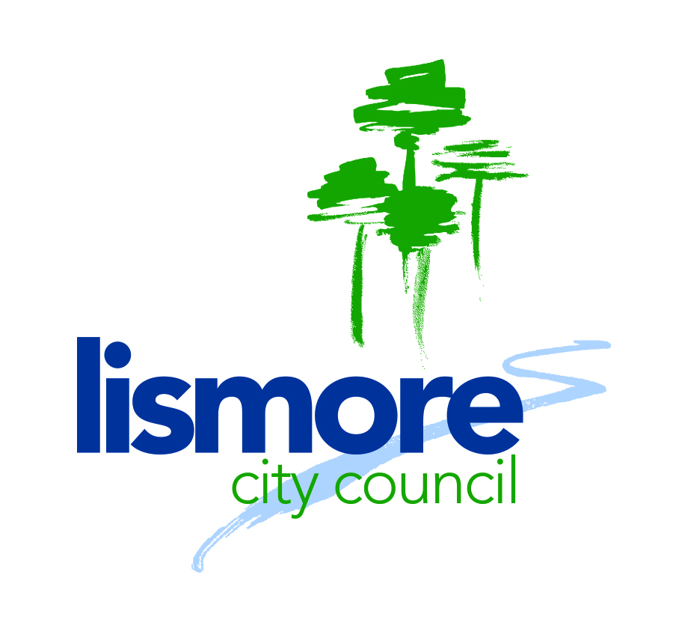
POSITION DESCRIPTION





Our Values:

Position title: Area Librarian
Position code:
Name:
Section: Partnerships, Planning and Engagement
Position reports to: Regional Library Manager
Band and level: Band 3 Level 2
Salary grade: Grade 15
Staff management: Yes
Budget responsibility: Yes

Primary function:

- The Area Librarian is a key member for Richmond Tweed Regional Library (RTRL) and is placed within the Partnerships, Planning and Engagement Directorate of Lismore City Council.
- All RTRL Staff are employed by the Executive Council, Lismore City Council.
- The primary objective of this position is to manage and co-ordinate the delivery of an effective and efficient public library service which is user-friendly, responsive to community needs and cost-effective within the local government area. That includes encouraging, supporting and advising community groups, local schools, and volunteers in the promotion of library services in the community.

Person Description

- The right person for this role will be self-motivated, proactive, observant and aware
- They will be a team player
- They will embody Council’s values

Responsibilities and duties:

The Area Librarian is responsible for ensuring that operational safety standards or other requirements are met at an operational level.

Entry level requirements:

- Sound Knowledge and understanding of public library trends and challenges.
- Demonstrated skills and experience in the marketing and promotion of library services.
- Demonstrated skills and experience in the strategic planning and implementing of library services and programs.
- Capacity to provide effective management to a multi branch library service.
- Ability to monitor and control staff and material and maintenance budget.
- Ability to organise the area branch’s workload, set appropriate goals and prioritise work.
- Adaptability, ability to respond to change, and a problem solving outlook.
- Ability to lead, train and develop staff individually and as a cohesive team to ensure strong focus on excellent customer service, knowledgeable assistance, good communication and a friendly, supportive work environment.
- Ability and experience in the preparation and management of grant and funding applications.
- Knowledge and understanding of effective and equitable staff rostering systems.
- IT Skills and experience in Microsoft applications and library database systems.
- Capacity to drive change in the delivery of library products and services.
- Knowledge and commitment to EEO, WHS and ethical practice principles
- Ensure that all corporate records are fully and accurately captured and maintained, to comply with legislative requirements and business needs.
- Undertake sustainable work practices that align with Council’s commitment to the principles of sustainability.

Qualifications and experience:

- Degree or post graduate qualification in Library and Information Services.
- Eligible for professional membership in ALIA.
- Minimum three years in a supervisory position, effectively managing the delivery of library and information services, preferably in a public library system.
- Australian Citizenship of appropriate working visa.
- Current Class C Drivers’ licence.
Skills STEPS

STEP 1

  - Ensure staff have clearly defined responsibilities; open communication; flexibility and
Co-operation amongst staff.
- Manage and co-ordinate the activities of staff and volunteers within the council area branches
- Support and advise staff members regarding customer service and related library services
- Work collaboratively with staff and volunteers to develop services and activities
  - Build high performing work teams by developing and training staff, including evaluation and monitoring of work performance and ensuring staff work within the guidelines of established policies procedures.
  - Create and maintain effective community and stakeholder relationships
- Conduct meetings and liaise the council staff and other community and information service providers within the area.
  - Prepare distribute and maintain high quality professional material promoting the library services and literacy.
  - Provide complex reference and research service to customers and other Council staff either in person, by telephone or by other electronic means.
  - Manage collection development to meet client needs following the RTRL Collection Development Policy guidelines and actively analysing community needs, interests and trends.

STEP 1 (cont)

  - Competently use specialised library software including online resources such as Spydus and e-Resources to produce a range of reports.
  - Identify and act upon opportunities for the libraries increased participation within the community
  - Constantly seek ways to improve client access to information within branches and online identifying opportunities for the delivery of new and existing services.
  - Ensure timely and effective program/activity delivery through management and evaluation of specific programs and activities to promote library services to specific customer groups (this may be to housebound, young or special needs people.
  - Evaluate and recommend to the branch supervisor areas of improvement in regard to resources, services and physical facilities.
- All resources are correctly located and readily accessible/retrievable.
  - Contribute to relevant change management, providing leadership to staff and active participation in related work team training and activities creating a progressive change environment
  - Liaise with support services staff in regard to the delivery of electronic resources to the public.
- Increase use of electronic resources by customers.
  - Actively contribute to the strategic and operational: planning and assessment of RTRL as a member of the management team
- Attend management meetings; assist with procedure and policy development.
  - Prepare deliver and review high quality professional training for both staff and patrons.
  - Actively promote the value of reading and literacy through council area participation in state and national programs such as book week, library week, summer reading program and national year of reading.
  - Prepare high quality and professional written reports for the RTRL Committee and Annual Reports following council communication guidelines.

STEP 2

2.1 Promote/represent RTRL to the wider community, increasing library members and visitors.
- Promote the library services and activities
2.2 Implement relevant actions in the RTRLStrategic Plan
2.3 Manage and acquit grant funding
2.4 Research, identify and evaluate to select new information resources, including print and electronic formats appropriate to council area needs
2.5 Provide continued high quality improvements to the library service through efficient use and promotion for patron use of the library management system and website.
2.6 Provide budget review assistance ensuring budget reflects needs of council area.
2.7 Source funding for events or services and prepare funding submissions.
2.8 Monitor staff and physical resources to ensure LCC Service Level Agreements are being met providing regular feedback to RTRL Manager.
2.9 Identify resources to fill collection gaps or to meet new trends identified by branch staff.
2.10 Demonstrate an understanding of teamwork and facilitate an inclusive environment where individual team member’s contributions are valued and acknowledged.
2.11 Evaluate and Develop local priorities and projects to prepare for and ensure best use of annual State Library funding.
- Utilise library usage statistics
2.12 Use well developed communication skills to provide library and literacy advice to internal and external bodies.
2.13 Seek opportunities to actively promote specific State Library information services such as LIAC, Drug Information.
- Hosting library talks or training for staff and patrons
2.14 Establish and manage effective networks with representatives from local schools in the council area.

STEP 3

- Build community relationships identifying needs to plan for and facilitate delivery of new and innovative services and programs including pilot and permanent services.
- Seek opportunities to remain aware of library & literacy trends and future developments
- Attend State Library seminars and forums in either NSW or QLD
- Or seek RTRL or NE Zone nomination as a state library working group participant
- Collate/analyse data to determine library effectiveness; implement changes
- Supervise the presentation of library programs and events
- Monitor performance against outcomes established in the RTRL Strategic Plan
- Modify work practices to increase efficiency and effectiveness across the council area.
- Problem solving/conflict resolution skills to ensure speedy; appropriate response to conflict within the workplace.
  - Manage and co-ordinate the activities of staff and volunteers in the branches.
- Plan, review and develop resources adequately to meet the agreed and future needs of the service level agreements.
- Complete a thorough annual review of council area library programs, including methods of delivery, attendance statistics to gauge effectiveness and make modifications.
- Establish relationships with sponsors, government providers and enhance the value of involvement of stakeholders.
- Advocate council for improved library buildings and facilities.
- Contribute to a “how to” package for programs/events to be utilised by internal and external library staff.
- Plan, develop and manage library displays, visiting exhibitions and special programs.
- Provide opportunities and advice for staff and volunteers to develop and grow professionally.
- Conduct library stocktake by coordinating resources and staff to carryout stocktake, produce relevant reports and follow up on stock maintenance.
- Contribute to the development of Library spaces to meet community needs.

STEP 4

- Deliver positive partnerships and strategic alliances with appropriate external providers such as universities, schools, retirement homes, other government agencies.
- Ensure the provision of best practice library service quality.
- Develop implement & coordinate a support or resource sharing program/opportunity for other libraries in the area.
- Evaluate effectiveness of managing staff and volunteers.
- Assist Regional Library Manager to develop and implement new regional policies and procedures.
- Maintain wider library industry liaison and involvement to assist with the provision of strategic advice for the council are on library trends and developments.

