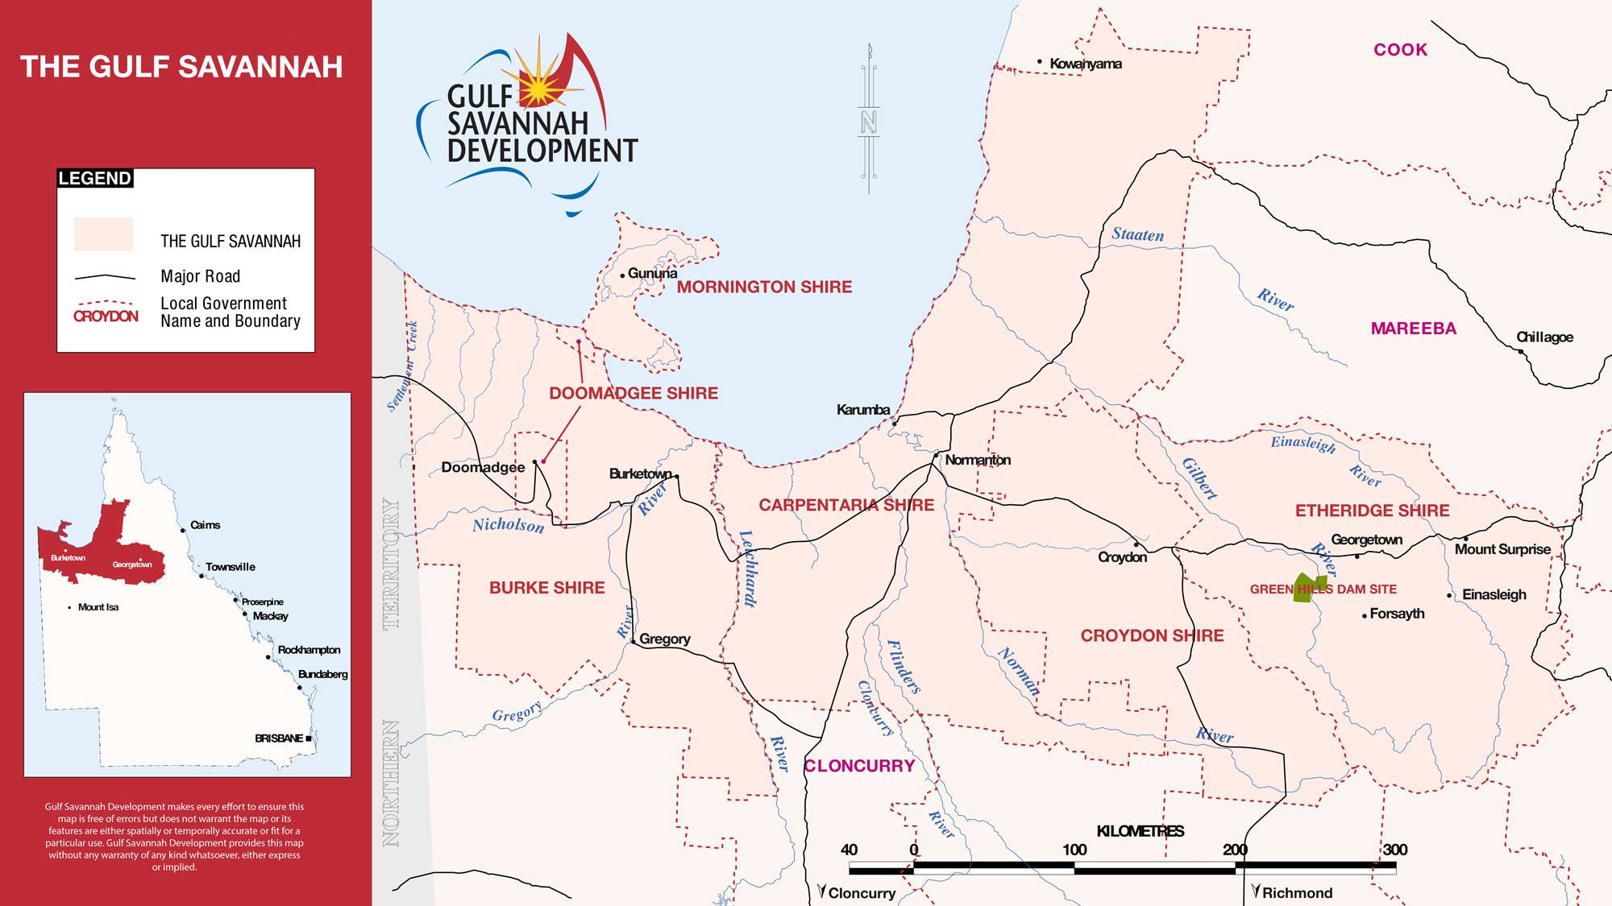
The Gulf Savannah region stretches from the edges of the Atherton Tablelands through to the Northern Territory border and south towards the Shires of Mt Isa and Cloncurry. It encompasses the Shires of Etheridge, Croydon, Carpentaria, Burke, Doomadgee and the offshore Mornington Island. The Gulf region is peppered by many communities that predominantly service local tourist, mining, pastoral and fishing industries. Each Shire has unique environmental and cultural heritage values, offers a relaxed lifestyle, a range of goods and services as well as opportunities to congregate and celebrate. The region enjoys an enviable climate full of sunny days, balmy breezes and warm winters. Even the Summer Wet Season, while it can be hot and humid, offers spectacular storms, flowing rivers and an unfolding green landscape soothing to the eyes and soul. The proactive Councils work tirelessly to address the challenges of remoteness, working to make improvements in infrastructure and services often in collaboration with each other and external stakeholders to ensure their communities remain resilient and sustainable.
Culturally and naturally, it has opportunities in abundance. The landscape encompasses the Gulf shoreline, escarpments, gorges and rugged spinifex covered hills, across grassy plains and along extensive riverine systems providing hikers, fishers, birdwatchers and campers innumerable opportunities to experience this rich natural history. The tourism industry is well established but there are still extensive prospects for expansion and diversification. Plentiful, untapped potential, leveraging off the unique and largely unspoiled landscape, exist to meet the needs of new tourism market segments and changing consumer preferences.
Economically, it is rich in potential: being part of the North West Minerals Province, an agricultural powerhouse for cattle and fishing industries, abundant water and with a functioning port to provide access to growing Asian markets. With the increased focus on the development of Northern Australia, there are opportunities for agricultural/aquacultural diversification, mining exploration and development and building trade routes and partnerships with our Asian neighbours. The small business sector is also considered to have opportunities to service this diverse and growing economy and the growth in population it will also stimulate.

Queensland’s Gulf Savannah region is well placed to offer a myriad of opportunities for anyone looking to live, work, innovate and invest in this exciting part of Northern Australia.

