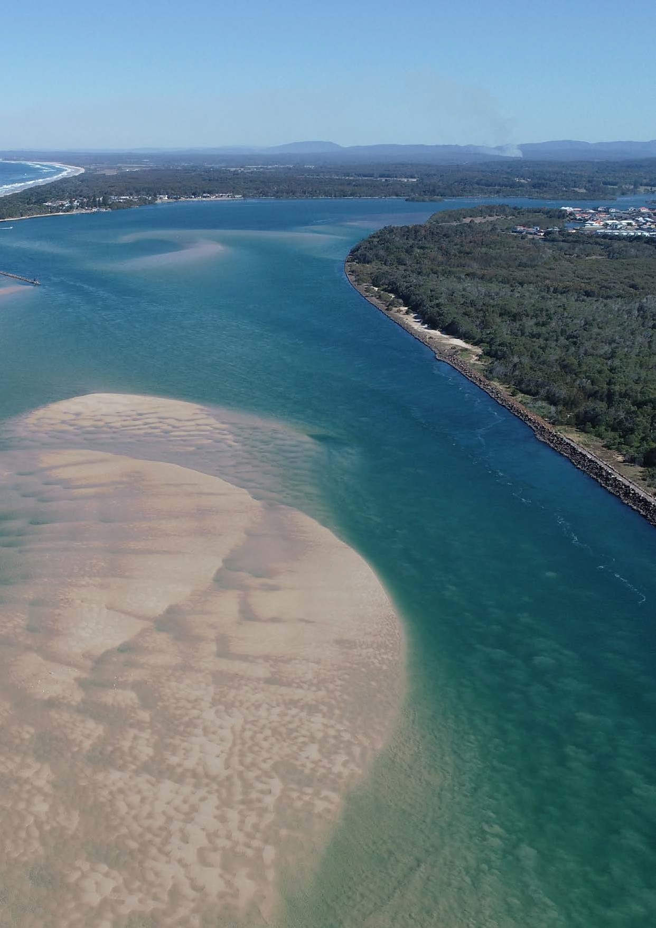
Executive Manager Success Profile, MidCoast Council 1

May 2023
SUCCESS PROFILE
Executive Manager, MidCoast Council

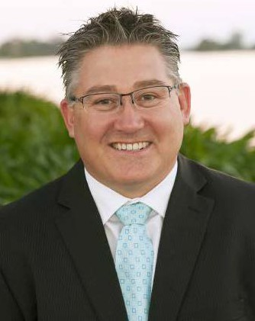

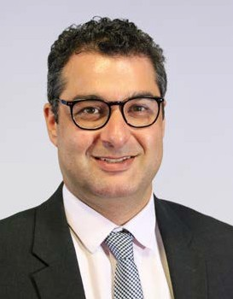

A MESSAGE FROM
THE GENERAL MANAGER

Our Mission at MidCoast Council is to deliver benefits for our community in a way that adds value and builds trust. I am proud to lead an organisation committed to delivering positive results for our community through a can-do attitude.
Since our inception in 2016 we have become an organisation where change is normal. This is because our fundamental vision is to be “better every day” and this requires regular evaluation of what we are doing and how we are doing. Ultimately, we want to build an organisation that is resilient and agile and where we collaborate to consistently improve, innovate and adapt to evolving expectations. The role of Executive Manager is fundamental to this.
Our Executive Managers will lead a group of Departments within Council, being responsible for service delivery, people & financial management, and customer experience. The role will sit on our leadership team and is responsible for coordinating strategic alignment across the organisation by proactively breaking down siloes and setting consistent delivery standards.
We are currently investing heavily in our organisation and in our people. This includes a recent relocation to a new state-of-the-art Customer Service and Administration Centre that enables activity- based working, collaboration, shared learning and innovation. Our Executive Managers represent a key part of that investment by growing our leadership team to provide increased direction and alignment across MidCoast Council.
I invite you to apply for this role and to come and make a difference in a community-orientated organisation.

ADRIAN PANUCCIO, GENERAL MANAGER
Executive Manager Success Profile, MidCoast Council 2

A MESSAGE FROM THE DIRECTOR LIVEABLE COMMUNITIES

Liveable Communities provides many of Council’s key frontline services to the local community. The division has a diverse service delivery base that includes but is not limited to:
- The provision of planning, waste and regulatory services that are timely, of a high standard and in-line with community expectations;
- Providing frontline services to the community by answering over 90,000 calls per year; facilitating 1 million web page views; 720,000 library loans by 37,000 library members, welcoming 43,221 visitors to the Manning Entertainment Centre and 18,000 to the Manning Regional Art Gallery each year;
- Maintaining 3,000 ha of parks and open spaces; 10 pools and 2 ocean pools; 58 playing fields; 26 sporting complexes; 86 playgrounds; 13 skate parks; 792 public buildings and 30 cemeteries;
- Supporting the regional and visitor economy, over 10,000 businesses and 2,700 visitors a night;
- Delivering direct services and community capacity building to over 1200 clients through our ageing, community strengthening and disability service teams; and
- The management and protection of our natural environment through partnerships with community, industry and other government agencies.
To deliver on this broad array of services we are looking for someone who is community focused with proven leadership experience. You will be able to motivate teams, be politically astute, have high business acumen, demonstrate emotional intelligence to influence outcomes, and be able to develop a culture of high achievement and continuous improvement.
In the immediate future, Liveable Communities is focusing on three areas:
- Quality services: providing quality professional services to meet the needs of our community;
- Effective governance: alignment of practices and maintaining clear, consistent and efficient processes and systems; and
- Collaboration: maximising collaboration within the departments and across the wider Council.
As a leader, I am focused on setting challenging but realistic goals and solving problems effectively by supporting my team and developing our employees so that they gain enjoyment from their work and provide high quality services.
PAUL DE SZELL, DIRECTOR
Executive Manager Success Profile, MidCoast Council 3

ABOUT MIDCOAST REGION

The MidCoast is a diverse region and community with an exciting future.
With an area of over 10,000 square kilometres that extends from our coastline, west to the escarpment of the Great Dividing Range with numerous national parks and green spaces in between, the MidCoast is a jewel of the mid north coast of New South Wales
It includes the Manning River Valley, the Wallis, Smiths and Myall Lakes systems, the northern foreshore of Port Stephens, the agricultural hinterland and the rugged, forested ranges of the Barrington Tops, Woko and Tapin Tops National Parks. In short, we have something for everyone!
We are a region rich in cultural pride and connection to the landscape and we embrace the spirit of reconciliation.
Being well known for our natural beauty, our region encompasses 58 National Parks and reserves, five coastal lagoons, one marine park, an internationally recognised wetland in the Myall Lakes, eight Aboriginal Places and the magnificent World Heritage listed Barrington Tops.

WHO IS MIDCOAST?
AGED 50+
Almost double the national average of 27.9%
53%

5.6% AGED 18-24

6.8%
IN HIGH
SCHOOL
Close to the national average (7.1%)

Statistics sourced from: Australian Bureau of Statistics, Census of Population and Housing 2011 and 2016.
Compiled and presented by .id , the population experts

22.4%
AGED 25-49
National average: 34.6%

12.2%
BABIES OR PRIMARY SCHOOLERS
National average: 15.2%

8.2%
6.2%
IDENTIFY AS ABORIGINAL OR TORRES STRAIT
ISLANDER
More than double the national average of 2.8%
LIVE WITH A DISABILITY
National average: 5.1%
Executive Manager Success Profile, MidCoast Council 5

Executive Manager Success Profile, MidCoast Council 4

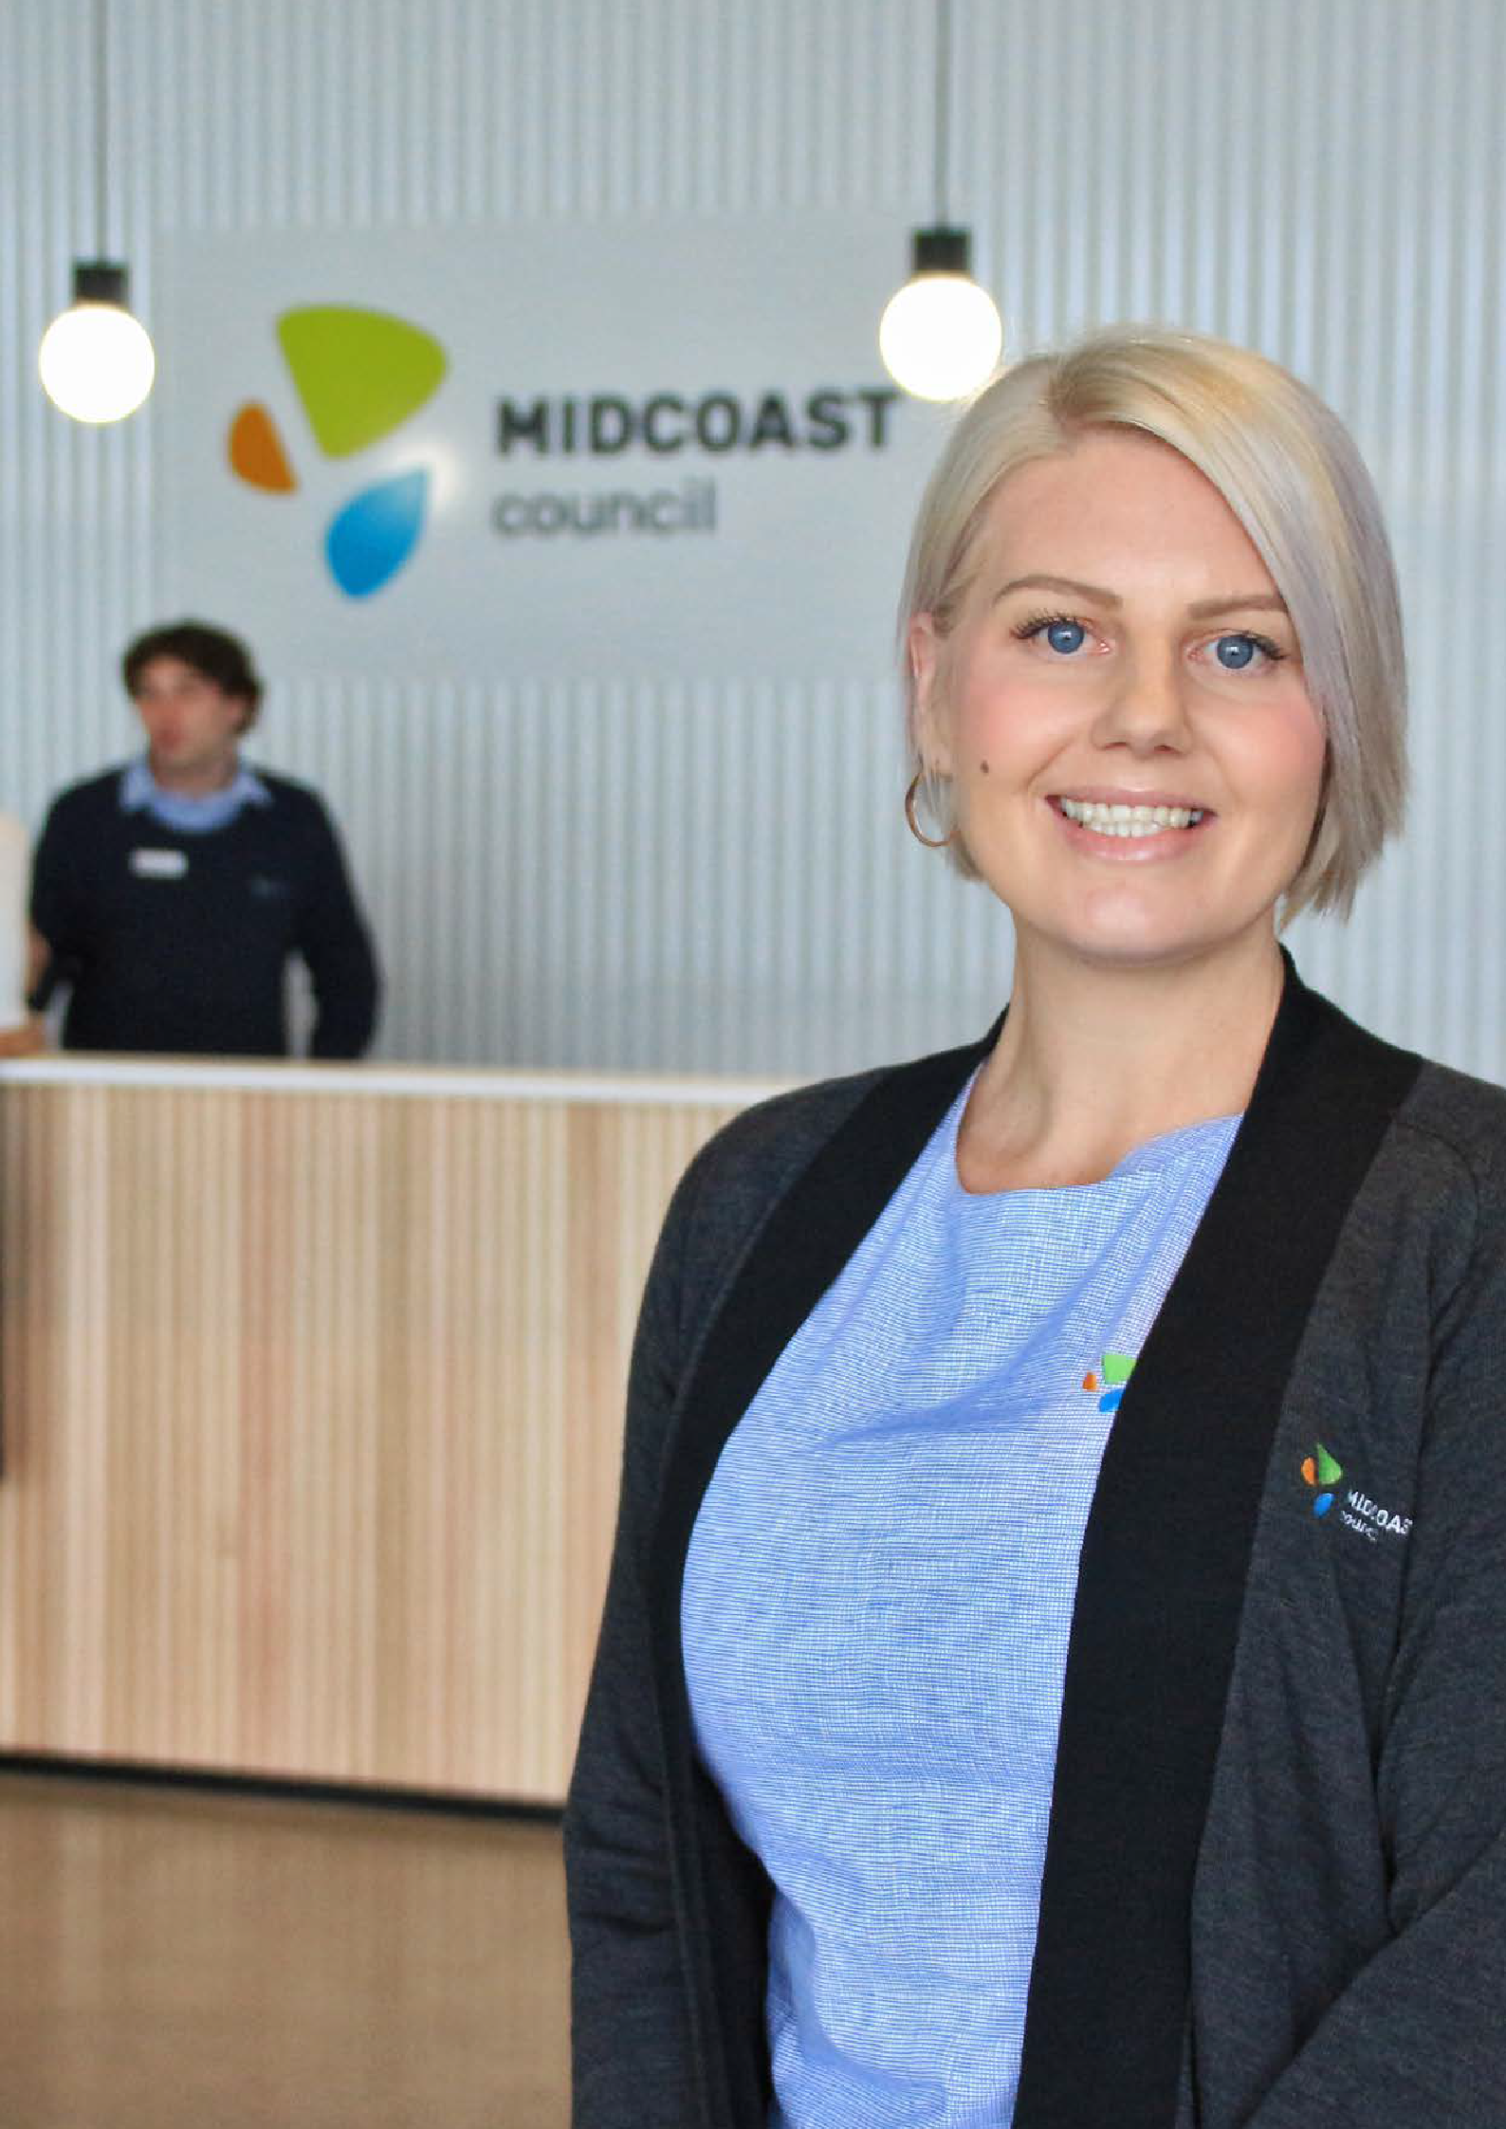
Executive Manager Success Profile, MidCoast Council 7

ABOUT MIDCOAST COUNCIL

Created in 2016, MidCoast Council is a young, vibrant and evolving organisation.
At the outset we determined that our Mission would be outward focused:

We deliver benefits for our community in a way that adds value and builds trust.
This Mission drives how we do things and keeps us focused on the community we serve. It also means that we are constantly searching for new ways to deliver more for our community.
As an organisation we also have a Vision of how we will work together to achieve our Mission:

Our vision is to be a high performing organisation where we are always striving to be better. One where we work collaboratively and are trusted. Better every day.
The services and infrastructure we deliver to our community are determined in line with our Community Strategic Plan MidCoast 2030: Shared Vision, Shared Responsibility. This plan was developed by our community and contains five values:
- We value our unique, diverse and culturally rich communities
- We value a connected community
- We value our environment
- We value our thriving and growing economy
- We value strong leadership and shared vision

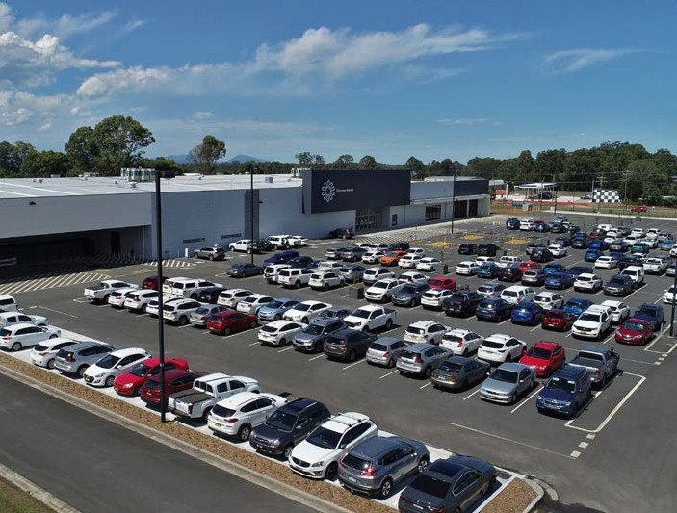
To turn these values into a practical actions Council has also developed a four-year Delivery Program and yearly Operational Plans. These documents outline Council’s work program and day-to-day actions to achieve our Mission.

Executive Manager Success Profile, MidCoast Council 6

WHAT YOU NEED TO SUCCEED AS AN EXECUTIVE MANAGER

The purpose of an Executive Manager

Strategic
- Set goals to deliver on the organisational Mission and Vision
- Determine strategy to achieve goals
- Establish an environment for innovation and the realisation of change
- Drive continuous improvement, organisational integration and alignment
- Organisational planning and prioritisation, i.e. financial and people resourcing
- Ensure Business Unit Plans are in place and aligned
- Build trust with the community, staff and other stakeholders

Council, Community and Government (External)
- Develop positive relationships with community and business
- Support the Management Executive in undertaking community engagement
- Partner with government agencies
- Submit Council reports
- Environmental scanning in area of responsibility
- Implement actions to ensure a positive customer experience

Organisational leadership (Internal)
- Model a constructive culture which supports behaviours consistent with our mission, vision and values
- Model a culture where collaboration, inclusion, WHS and wellbeing are valued
- Inspire, empower and develop our workforce
- Champion change
- Enable consistent, timely and accurate two-way flow of communications across the organisation
- Build leadership capability in Level 4 and 5 (Managers and Coordinators)

Reporting and monitoring
- Monitor organisational performance, including Corporate Scorecard – Customer, Finances, People, Systems

Executive Manager Success Profile, MidCoast Council 8

Decision-making
- Review Council’s Delivery Program, Operational Plan and Budget
- Make decisions by consensus where possible
- Make recommendations to the Leadership Executive as required
- Oversee performance on major projects and makes adjustments as required

What success looks like
- Positive customer experience
- Delivering community outcomes
- Achieving budget results
- Motivating our people through engagement and wellbeing
- Moving towards our preferred culture
- Enhancing the efficiency of our systems and processes
- Delivering our Delivery Program and Operational Plan
- Working effectively and cohesively as an executive management team
- Improving leadership capability across the organisation

Who we are looking for

We are looking for someone who is…
Community Focused | Proven Leader | Team Orientated
Business Acumen | Flexible Emotionally Intelligent
High Achievement Orientated | Coach & Mentor | Influencer
Strategic Thinker | Continuously Improving Collaborative
Relationship Builder | Develops others
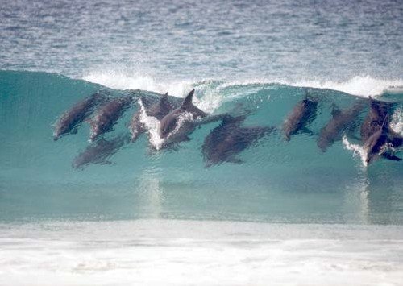
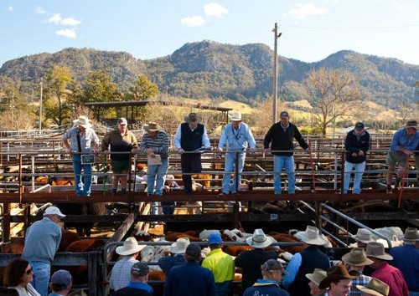

Executive Manager Success Profile, MidCoast Council 9

ORGANISATIONAL STRUCTURE

Executive Manager Liveability and Sustainable Development

Asset Planning & Development

Projects & Engineering

Transport Assets

Water Management & Treatment

Operations South

Water Project Delivery

Executive Manager Inclusive Communities
Executive Manager Innovation and Sustainable Futures

Executive Manager Community Spaces

Executive Manager Transport and Engineering

Executive Manager Water and Systems

Finance

Customer Experience

Strategy & Projects

Natural Systems
Growth, Economic Development & Tourism

Water Operations

Operations North

Governance

Major Assessment & Regulatory Services

Airport Operations

Trade Services

Parks & Gardens

Land Use Planning

Libraries & Community Services

Community Assets

Building & Environmental Health Services

Human Resources

Waste Services
MidCoast Assist (Ageing & Disability Services)

Director Engineering & Infrastructure Services
Director Liveable Communities
Director Corporate Services
General Manager

Legal & Property Services

Information Technology

Corporate Strategy & Development

Executive Manager Success Profile, MidCoast Council 11
Executive Manager Success Profile, MidCoast Council 10

Further Information
For a confidential discussion please contact: Paul De Szell, Director
Liveable Communities
(02) 7955 7407
paul.deszell@midcoast.nsw.gov.au

