Disability Support Worker 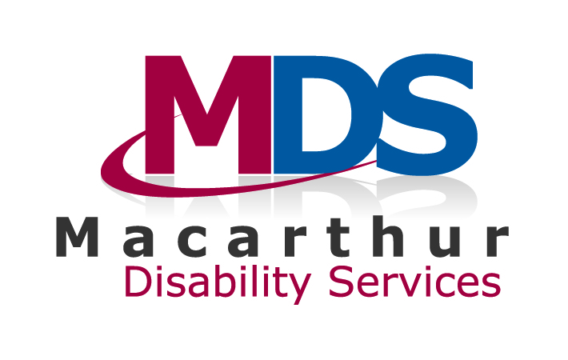

Developed using the workforce capability framework
Job family | Direct service delivery (DSD)
Workforce capability framework level | DSD 3
Reporting to | Service Coordinator
Directly supervising | Not applicable
Date prepared | February 2016

Position purpose
This position works under minimal supervision and involves assisting people with daily living skills and community inclusion and participation activities. Work is undertaken in the context of supporting the person to maintain their wellbeing, explore opportunities and work towards agreed outcomes that are important to, and for, the person.

Strategic core requirements
Key responsibility areas | Capability requirements | Key performance measures
Sector and organisation purpose and values | - Working knowledge of a human rights based approach to supporting a person with a disability and the services provided, the individual and community context, and sector and organisation purpose and values.  - Applies the approach and values in own work. | - Develops an appropriate supportive working relationship with each person supported.  - Gains the confidence, trust and respect of each person supported.  - Recognises and promotes the importance of dignity and the rights of each person they support.  - Provides support in line with all other aspects of the disability service standards and the organisation’s mission and values.  - Achieves respect from others in the workplace and demonstrates a confident approach to own contribution.
Leadership and teamwork | - Works collaboratively with team members.  - Able to organise own work, manage time and contribute to work planning.  - Shares knowledge and information with team members.  - Able to work with minimal supervision, knowing when to escalate issues. | - Demonstrates involvement in and contribution to the team’s results and effectiveness, engaging constructively with other team members.  - Organises own work effectively; completes work satisfactory and on time.  - Follows processes / procedures and learns from errors to eliminate them from future work.  - Understands what issues to escalate to the Service Coordinator or more experienced staff and when.  - Shows a willingness to share knowledge and information and guide others and receives positive feedback from other team members.
Communication | - Deals with non-routine enquiries.  - Uses effective listening skills and seeks, provides and/or shares information with people appropriately.  - Can adapt communication style to meet people’s needs.  - Able to resolve conflict with assistance.  - Has a network of internal and external contacts relevant to the role.  - Deals with practical issues presenting and enlists a more experienced person as needed. | - Understands what is being expressed or communicated by each person supported and is able to determine what is important to them.  - Achieves a positive relationship with each person supported using appropriate communication strategies and tools.  - Adapts communication to meet and if necessary de-escalate situations; seeks assistance when needed  - Advocates in specific situations on behalf of each person supported, e.g. at medical appointments; in the community; assisting at a social or recreational event  - Uses clear and concise communication.  - Provides relevant, clear and factual written information.  - Relates effectively to and has productive relationships with relevant people associated with the person that will benefit the support provided.
Customer relationships | - Assists customers to address their needs and expectations.  - Has practical knowledge of supports and services available.  - Is flexible and suggests alternative service solutions, provides information or makes necessary referrals.  - Demonstrates confidentiality and awareness of diversity in relation to sensitive issues.  - Assists with building and maintaining positive relationships with stakeholders. | - Aligns support to the individual needs, showing flexibility based on what is important to, and for, each person supported.  - Focuses on what is important within the agreed resources / budget / part of each person’s plan.  - Meets reasonable expectations of quality, quantity and timeliness of supports within the agreed supports / plan / budget.  - Relates positively with each person supported and their family, carers, etc.  - Escalates issues appropriately and makes appropriate referrals to more experienced staff.
Personal accountability | - Adheres to organisation policies & procedures and all relevant government legislation and relevant standards.  - Evaluates own work to ensure quality and safety standards are met.  - In own work area makes agreed changes.  - Adopts a professional approach to own personal accountability.  - Maintains organisation’s image and reputation. | - Complies with disability services standards and organisational policies and procedures relevant to the role.  - Contributes to the development and improvements of organisational policy and procedures through experience of use.  - Receives positive feedback on interactions with others and workplace beon time  - On timehaviour consistent with the values of the organisation.  - Complies with disability services standards, policies and procedures relevant to the role.  - Shows understanding of own role and personal responsibility and ownership of contributions.  - Efficiently and effectively completes agreed job procedures with minimal supervision.  - Works according to plan / maintains routines.  - Takes on board, accommodates and accepts feedback. Maximises use of resources and works within the limitations of the agreed plan and budget.  - Presents self as a role model on behalf of the organisation and in line with community expectations.
Innovation | - Undertakes tasks using a resourceful and creative approach.  - Suggests changes to improve quality in own work and makes agreed changes. Able to address and mitigate risk in own work.  - Assists with review and/or development, implementation and improvement of specific work practices and procedures. | - Participates in and is open to change.  - Gets actively involved in team problem solving and encourages others.  - Actively seeks creative solutions to overcome barriers in providing support.  - Identifies and reports areas for improvement using understanding of risk/quality framework.  - Identifies risks and possible solutions for immediate work problems.  - Corrects problems and escalates more complex problems  - Demonstrates initiative, recognising the need to adapt work schedule to changing needs of the person supported and other circumstances.
Experience and qualifications | - Senior first Aid certificate  - Drivers licence  - Equivalent to VET certificate three in relevant studies, or equivalent knowledge and experience. | - Shows commitment to ongoing skills development.  - Attends appropriate training for role.

Functional requirements
Key responsibility areas | Capability requirements | Key performance measures
Person centred knowledge and application | - Has a working knowledge of the process through which a person with a disability identifies their goals and aspirations and person centred plans are developed.  - Understands the person centred approach.  - Assists with practical implementation of plans and service. offerings/supports to meet a person’s goals. | - Respects what is important to each person supported and assists them to explore related opportunities.  - Actively encourages and engages each person supported to make independent decisions to their level of capability.  - Contributes to each person supported achieving their goals.  - Ensures consistency of support with the developed personal plan for each person supported.
Personal care, skill development and support | - Understands and follows individual support plans to address a person’s goals and health and wellbeing.  - Provides standard personal care, living skills, transport, social and other support.  - Engages with the person to support achieving goals and encourages further independence.  - Uses appropriate tools and technology to support the person’s skill development.  - Under guidance, administers medications and provides assistance involving precise and complicated procedures.  - Gathers information through awareness and observation.  - Supports necessary referrals. | - Shows awareness of and follows directions for the delivery of support to meet each person’s personal care, health and wellbeing support needs.  - Collects, records and monitors data and other information on progress, escalating or reporting back areas of concern.  - Contributes relevant information to decision making about referrals to other services or supports.  - Follows individual care/health and support plans and shows understanding of the practical impact on daily living.  - Follows specific procedures correctly, e.g. medication, and applies safety and preventative actions required.
Participation and inclusion | - Supports a person with a disability and their family/carers in the areas of life learning, participation, employment and inclusion.  - Supports the achievement of life learning, recreation, employment and educational goals and aspirations.  - Supports people and families in identifying and accessing community activities, education/training and employment.  - Advocates for a person as required. | - Follows plans and programs for support provided within home, community and group environments  - Proactively works to organise and reduce barriers to participation in the activities accessed by the person supported, seeking and guidance from others as needed  - Assists each person to safely explore opportunities to expand the likelihood of participation and inclusion at home and in their community
Community engagement and education | - General knowledge of functions of community networks and links with other community services providing direct services.  - Presents people with a disability positively and educates community members. | - Assists each person supported to access and be involved with the community as part of community based activities; e.g. as a purchaser of goods and services; a volunteer, voter, church goer, member of a club or interest group, etc.  - Applies knowledge of formal and informal supports relevant to each person supported.  - Demonstrates and role models dignified and respectful interactions with members of the broader community.  - Assists each person supported to be as independent as possible in community based activities.
Reporting, documentation and administration | - Adheres to reporting, documentation and administrative requirements about changes in a person’s achievements, self-care and/or behaviour.  - Maintains appropriate notes and other documentation.  - Uses relevant communications and technology systems to meet reporting and administrative requirements including creating/maintaining service and billing records.  - Suggests changes to improve documentation, reports and administration within the context of the role. | - Clearly creates and maintains records.  - Collects data using organisation systems.  - Makes suggestions on improvements to reporting and administration systems.  - Demonstrates a use of and willingness to use technology on the job.  - Accurately completes administrative work relevant to the support being provided.

