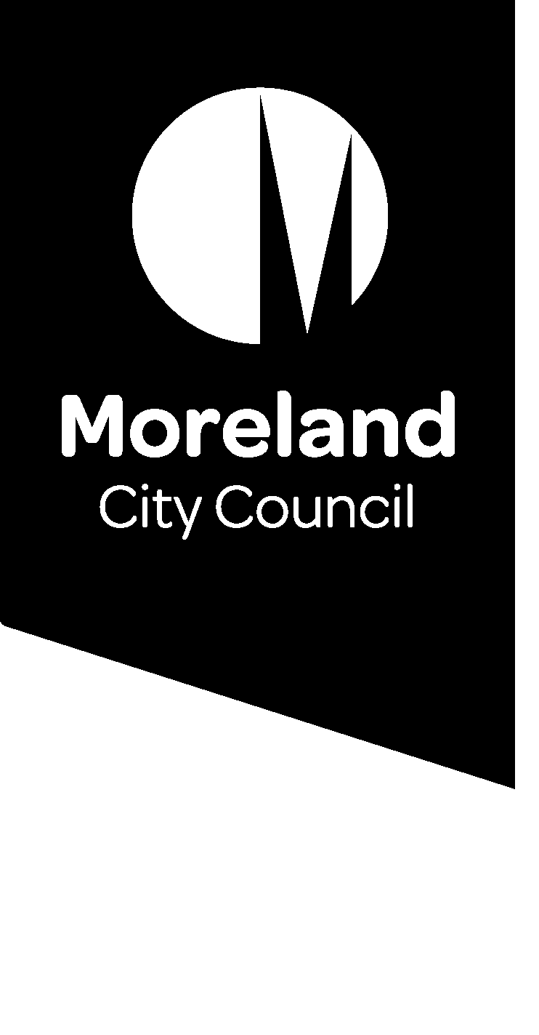
  - Unit Manager Building Services
  - and Environmental Health
  - Position Description
Position number: | 2590
Classification: | Senior Officer (Level 4)
Award / LWAA: | Moreland City Council Enterprise Agreement
Department / Branch | City Futures
Branch: | City Development
Unit: | Building Services  and Environmental Health
Reports to: | Manager City Development
Supervises: | All staff within Building Services Unit and Environmental Health Unit
Approved by: | Narelle Jennings Group Manager City Development
Organisational values:

Position objectives
- A key senior leadership role within the Moreland Leadership Team, this position will manage the statutory enforcement & statutory approvals operations of the Building Services and Environmental Health Units, ensuring the Units provide best value services to its clients and community, in line with Council’s service standards and within statutory timeframes where relevant.
- Reduce the risk to life and safety of people associated with Moreland’s building stock by ensuring a compliance culture within the operations of the Building Services Unit.
- To constructively challenge current policies and practices and drive continuous improvements to the Building Services processes.
- To develop and implement an effective proactive and reactive building enforcement framework in order to fulfil Council’s statutory obligations and appropriately manage risk.

Key responsibility areas

Unit Management:
- Ensure that all functions and responsibilities are carried out in accordance with the relevant Council policies and Local Laws, and the applicable Acts, Regulations, Codes.
- Ensure that all Council decisions and/or requests are executed promptly and efficiently. Responsible for accurate and timely financial and budget planning, control and processes.
- Provide sound financial management. Prepare the Units’ annual budget and following adoption of a budget by Council, monitor, report variances to the Group Manager City Development and be accountable for expenditure.
- Manage and improve systems and processes across all services.
- Provide efficient and effective administration of the Units.
- Manage relevant projects as required by the Group Manager City Development.
- Deputise for the Group Manager City Development as required.
- Develop and maintain performance monitoring and risk management systems and complex internal and external reporting systems.
- Oversee the preparation of Council reports on building and environmental health matters.

Personnel Management:
- Maximise the efficiency and effectiveness of the performance of the Units.
- Ensure that the Units are appropriately structured and staff are trained to meet the objectives and requirements of the Council.
- Provide appropriate feedback to staff as a central component of staff skills development and personal improvement.
- Provide leadership that fosters innovation, creativity, harmony and continuous improvement amongst staff and the organisation.
- Manage and develop a professional development program for the Units.
- Complete individual staff development plans for team members and take prompt corrective action where objectives or standards are not being met.
- Effectively supervise and direct staff, draft position descriptions, interview and recommend to the Group Manager City Development appointment of staff in accordance with Council policies and Unit budget constraints.
- Ensure that staff within the teams, are fully briefed when commencing duties and offered ongoing training and educational opportunities during their term of employment.

Undertake Statutory Functions
- Perform all functions empowered to the position of Unit Manager Building Services as a delegated officer of Council under the Building Act and Building Regulations.
- Ensure effective implementation of the statutory obligations of the Moreland City Council pursuant to Health Act, Food Act, Environment Protection Act, Local Government Act, Tobacco Act, Caravan Parks and Moveable Dwellings Act and other relevant legislation.
- Ensure all functions and responsibilities of the Units are carried out in accordance with relevant Council policies and legislative provisions.

Manage and Monitor Programs
- Manage the implementation of Council’s proactive (planned inspections) and reactive (response to complaints) building programs in accordance with Council policies and procedures.
- Recommend and establish processes to ensure key performance indicators for both proactive and reactive programs are actively monitored and report significant variances, with appropriate recommendations to the Group Manager City Development.
- Manage the registration and inspection program of the Environmental Health Unit, ensuring that the program is actively monitored and report significant variances, with appropriate recommendations to the Group Manager City Development.
- Assess and recommend appropriate use of resources to achieve the goals and objectives of the Units.
- Develop, review and manage associated policies and procedures to ensure the safety of the Moreland Community in accordance with the relevant legislative provisions and Council’s vision of a safe and amenable city.
- Report the Units’ activities and achievements to the Group Manager City Development, the Moreland Executive Group (MEG), Council and to external authorities, as required.
- Prepare correspondence, including submissions related to the Units’ operations as required.

Manage Council’s Investigative and Enforcement Functions
Ensure the implementation of, and compliance with policies and procedures that enable the Unit to:
- Conduct timely investigations into alleged breaches of relevant building and environmental health legislation.
- Conduct inspections and the performance of statutory functions aimed at achieving an acceptable level of compliance with relevant legislation.
- Issue of statutory Notices, Orders and Infringement Notices, in accordance with relevant legislation.
- Keep and ensure team member keep accurate and precise records of investigations to a standard whereby such records comply with the requirements of relevant legislation and could be used as evidence in legal or statutory proceedings.
- Prepare, review and authorise legal briefs and submissions to statutory tribunals and bodies for the approval of the Group Manager City Development.
- Represent Council at statutory tribunals and legal proceedings and exercise sound and professional judgement as required during these activities.

Facilitate Professional Development & Provide Advice
- Work in cooperation with others in the provision of advice on the implementation of, and compliance with, policies and procedures consistent with relevant legislation.
- Lead policy and procedure development and provide advice to the Group Manager City Development concerning policies and processes applicable to the operation of the Units.
- Prepare reports and submissions for and on behalf of Council, in relation to matters under the Building Act, Building Regulations, Building Code of Australia, Health Act, Food Act, Environment Protection Act, Local Government Act, Tobacco Act, Caravan Parks and Moveable Dwellings Act and other relevant Codes and associated legislation.
- Actively participate in external liaison groups and encourage a Unit culture of professional liaison with peers and external agencies to maintain professional competence and to ensure Council’s interests are maintained and promoted.
- Collaboratively develop and apply agreed performance benchmarks and report to Group Manager City Development on team performance and performance issues.
- Conduct regular team and individual team member meetings for dissemination of information and provide for uniformity of advice and implementation of legislation and Council requirements.
- Keep informed of new developments that may affect building surveying and environmental health practice.
- Consult with other Council departments in regard to building and environmental health matters as appropriate and provide specialist advice to other Council officers.
- Provide timely advice and assistance to the Group Manager City Development, Director City Futures, Councillors and Senior Management.
- Manage legal advice and other consultancies engaged to assist in building and environmental health matters.

Development and involvement in policies and guidelines to ensure consistency and certainty of decision-making and disseminating information
- Identify the need for and lead as well as contribute to the development of policy and procedures in consultation with Group Manager City Development.
- Regularly review the procedures for processing complaints to ensure the delays in response times and issuing advice is minimised and ensure procedures are documented and adhered to by the teams.
- Develop procedures and tools to improve the consistency and performance of the teams.
- Be aware of pending legislation, changes and recommend to the Group Manager City Development changes to Council systems and processes to meet legislative obligations.

After Hours Work
- Participate in an after-hours emergency response roster.

Management
- Provide strategic direction and drive change, whilst ensuring continuing delivery of service. This will be achieved through the ongoing development of a culture of continuous improvement, innovation, inclusion and collaboration.
- Positively designing and implementing change management processes in complex and sensitive circumstances.
- Support, develop, coach and mentor staff, both within the City Development branch/Directorate and across the organisation, with the aim of building a culture of teamwork, collaboration, and learning, to create the best community outcomes.
- Manage the Units to achieve budget targets and contribute to long term financial planning to support the achievement of Council goals and the sustainability of community services (current operational budget approximately $2.4m for Building Services and $2.1m for Environmental Health).
- Develop and review relevant strategies, policies and plans.

Leadership competencies and accountabilities

Competencies:
- Community and Customer First: Building strong customer relationships and delivering community / customer-centric solutions.
- Ensures Accountability: Holding self and others accountable to meet commitments.
- Collaborates: Building partnerships and working collaboratively with others to meet shared objectives.
- Instils Trust: Gaining the confidence and trust of others through honesty, integrity, and authenticity.
- Drives Results: Consistently achieving results, even under tough circumstances.
- Plans & Aligns: Planning and prioritizing work to meet commitments aligned with organisational goals.

Accountabilities:
- Foster an ethical culture and behave ethically.
- Champion customer-centric behaviours and community engagement which puts the community at the heart.
- Champion environmental sustainability and include environmental objectives and targets into projects and programs.
- Promote inclusion, diversity and equity in the workplace.
- Implement and maintain health and safety requirements, promote a culture of safety, and demonstrate effective leadership on workplace health and safety.
- Promote cross-team and cross-organisation collaboration.
- Ensure strong and effective fraud and corruption controls are in place and regularly reviewed for the work area.
- Lead risk management practice by identifying, assessing, influencing, preventing, treating and monitoring risk relevant to the role, the work area and broader organisation.
- Implement and maintain continuous improvement.

Other duties:
- Required to undertake other duties as directed.

Organisational relationships
Internal Relationships | The Executive; Senior Leadership Team (SMT); All Staff; Mayor and Councillors; All Council Departments and Council’s Municipal Building Surveyor.
External Relationships | Victorian Building Authority its statutory boards  Registered building practitioners  Architects  Metropolitan Fire and Emergency Services Board  General community and businesses  Clients  Utilities  Victorian WorkCover Authority  Registrar of courts  Magistrates Court  Bureau of Statistics  Solicitors  Other councils  Professional liaison groups  Heritage Victoria  Consumer Affairs Victoria  Victorian Civil and Administrative Tribunal  Department Sustainability and Environment.  Department of Health  Environment Protection Authority  Victoria Police
Extent of Authority | Unit managers are supported to make all decisions in relation to their Branch by the Group Manager City Development in accordance with Council’s policies and procedures, Council authorisations and the instrument of sub-delegations from the Chief Executive Officer.

Task analysis
In the course of his/her duties, a person in this position may be expected to work in or be exposed to the following conditions or activities as marked.
Condition/Activity | Constant | Frequent | Occasional
Performing clerical duties
Working on a keyboard
Driving cars and/or trucks
Other (please specify

Key selection criteria
- A Tertiary qualification (degree/diploma) in Applied Science (Environmental Health) or Building Surveying OR extensive relevant experience. Post-graduate qualifications in a Management or Business discipline are highly desirable.
- Extensive knowledge and experience in managing regulatory teams.
- Sound knowledge and experience in the functions and operations of a Council Building Services team, plus an understanding of Private Building Surveying practice.
- Demonstrated experience in local government Environmental Health. Knowledge and understanding of Environmental Health Legislation and associated Codes of Practice and the ability to administer, explain, interpret and enforce such legislation.
- Ability to proactively lead and inspire staff to work with a team spirit, focused on and committed to continuous improvement and organisational goals and objectives.
- An advanced capacity to effectively participate and contribute to a management team and play an organisational leadership role.
- Sound understanding of legal and risk management requirements associated with the management of a Building Unit or Environmental Health Unit within a local government context.
- Highly developed problem solving skills and a demonstrated ability to manage investigations for a timely resolution and effectively adjust plans and schedules when necessary.
- Excellent written and verbal communication skills and highly developed interpersonal skills.
- Ability to prepare and implement a compliance framework and associated policy and achieve Council objectives.
- Ability to prepare program budgets and achieve budget targets.
- A current driver’s licence is required

