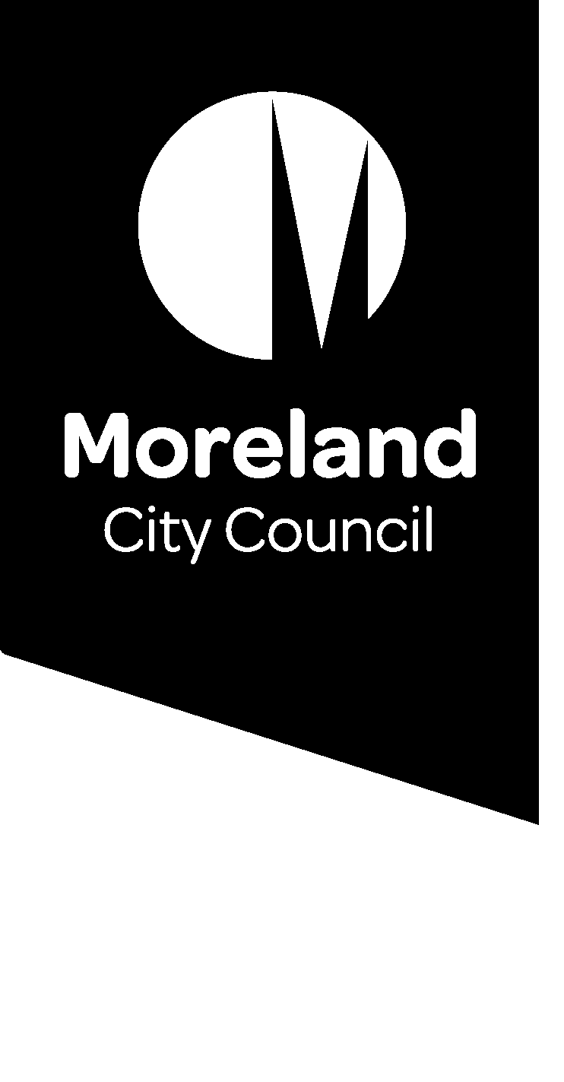
Corporate Planner
  - Position Description
Position number: | 1095
Classification: | Band 7
Award / LWAA: | Moreland City Council Enterprise Agreement
Department / Branch | Business Transformation
Branch: | Governance & Strategy
Unit: | Corporate Planning
Reports to: | Manager Governance & Strategy
Supervises: | N/A
Approved by: | Director Business Transformation
Organisational values:

Position objectives
A key strategic role within Council, this position is responsible for coordinating Council’s Corporate Strategy activities and initiatives as follows:
- Lead Council’s Corporate planning and reporting activities to facilitate and improve organisational planning, reporting and performance with a focus on improving consistency and quality across the organisation.
- Take a whole of organisation approach to build organisational capacity to understand and engage in the strategic directions of council.
- Build constructive working relationships and develop partnerships with managers, team leaders and staff in fostering a culture which values excellence and the seeking of opportunities for alignment and continuous improvement.
- Lead the development and implementation of the Council Plan.
- Coordinate Annual Business Planning group activities, including organisational reporting and data/metrics collection, collation and analysis; ensuring effective planning and reporting outcomes are delivered for the organisation in line with legislative frameworks; and foster a continuous improvement approach.

Key responsibility areas

Undertake corporate planning functions of Council in accordance with Moreland Council’s values, objectives and plans
- Coordinate the development and implementation of the Council Plan, the corporate planning and reporting framework and annual strategic delivery documents, in compliance with the Local Government Act and relevant codes or directives issued by Ministers or Departments.
- Stewardship of the ongoing development and usage of Councils corporate planning and reporting platform.
- Coordinate regular reports to the Council and Moreland Executive Group on the performance, progress and achievement against the appropriate Council corporate plans.
- Coordinate Council’s Organisational KPI’s, report results to management and enact initiatives that support ongoing review and improvement.
- Analyse strategic and business issues and formulate effective conclusions and recommendations from the analysis.
- Develop and review relevant strategies, policies and plans.

Ensure Council meets relevant statutory requirements, particularly in relation to the Local Government Act
- Coordinate Council’s obligations against the Local Government Performance Reporting Framework (LGPRF) to ensure that required reporting is delivered. This includes providing support and guidance to subject matter experts in provision of accurate and timely information, regular reporting to Moreland Executive Group and responsibility to meet internal and external statutory reporting obligations.
- Coordinate service planning activities that respond to statutory performance and monitoring associated with Rate Capping legislation.
- Ensure Council has effective mechanisms in place to demonstrate accountability and to comply with statutory requirements.

Support Council’s corporate planning functions
- Coordinate activities and initiatives that focus on improving alignment between strategy, policy, planning and resources.
- Be the subject matter expert for Council on all areas of responsibility and work across the corporate planning unit to ensure there is an ongoing improvement in quality and consistency.
- Guide constructively and in a manner that develops the organisations capacity for corporate reporting.
- Improve the systems and processes within the Unit so they support high quality outcomes and high levels of productivity.
- Develop, maintain and implement relevant policies and frameworks across the organisation.
- Positively design and implement change management processes in complex and sensitive circumstances.
- Support, develop, coach and mentor staff across the organisation, with the aim of building a culture of teamwork, collaboration, and learning, to create the best community outcomes.

Leadership competencies and accountabilities

Competencies:
- Community and Customer Focus: Building strong customer relationships and delivering community / customer-centric solutions.
- Ensures Accountability: Holding self and others accountable to meet commitments.
- Collaborates: Building partnerships and working collaboratively with others to meet shared objectives.
- Instils Trust: Gaining the confidence and trust of others through honesty, integrity, and authenticity.

Accountabilities:
- Champion customer-centric behaviours and staff and community engagement that supports collaboration and richer outcomes which puts the community at the heart.
- Implement and maintain Continuous Improvement System standards and procedures.
- Incorporate Council’s environmental sustainability objectives and targets into projects and programs.
- Promote and participate in a culture of environmental sustainability.
- Implement and maintain health and safety standards and procedures according to legislation and consistent with MoreSafe.
- Demonstrate effective leadership on OHS matters.
- Undertake all duties with an awareness of and sensitivity to diversity and equity in accordance with Council policy.
- Ensure that complete and accurate records relating to business activities are maintained and stored in Council’s electronic records management system (including correspondence, reports, emails) in accordance with Council policy.

Other duties:
- Required to undertake other duties as directed.

Organisational relationships
Internal Relationships | The Executive; Senior Leadership Team (SMT); All Staff; Mayor and Councillors.
External Relationships | Local and State government authorities, specialist consultants where applicable, Essential Services Commission and Local Government Victoria.

Job Characteristics relevant to the Position
The following Job Characteristics should be read in the context of the definitions describing the characteristics required of a Band 7 employee as outlined in Part B of the Enterprise Agreement (Victorian Local Authorities Award 2001, Appendix A, Part A - Employee Band 7, Clause 7)
- Accountability and extent of authority:
- Exercising judgment, initiative and discretion in the context of identified objectives and outcomes.
- Coordination support for the collaborative activities of the Annual Business Planning Group and/or any other working groups.
- Accountable for developing and producing statutory plans and reports required of Council under the Local Government Act and at the direction of Manager Governance & Strategy.
- Producing work of high quality within established time frames.

- Judgement and decision making:
- The position requires the application of specialised methods and techniques in relation to strategic business planning and business improvement.
- Judgement is required in supporting the development of Council plans and in the interpretation and reporting of performance against Council objectives and goals.
- Judgement is also required in developing approaches to business planning, service planning & business improvement interventions.
- Ability to appreciate the diversity and complexity of Council services and to exercise judgement in addressing Council planning and performance monitoring issues.
- Ability to appreciate and operate within the statutory and political environment of local government.
- Development and recommendations of policy will be required in areas of responsibility from time to time.
- Guidance may not always be available within the organisation.

- Specialist knowledge and skills:
- Substantial knowledge and experience in strategic and business planning, performance management and the conduct of business improvement initiatives.
- Demonstrated ability to understand the strategic goals of Council and the responsibilities and functions of the Moreland Executive Group, and management team.
- Well-developed conceptual and analytical skills.
- Knowledge and understanding of the relevant legislative and regulatory requirements in which Local Government operates.
- Sound Knowledge of Council services and their interactions.
- A high level of computer literacy and the ability to apply information technology to business requirements.
- Experience in Project Management.

- Management skills:
- Ability to analyse strategic and business issues and formulate effective conclusions and recommendations from the analysis.
- The ability to liaise with and influence other staff to obtain co-operation and commitment to carry out the duties of the role.
- The ability to competently manage time and prioritise the duties and responsibilities of the position.
- The ability to recognise and maximise opportunities and achieve goals and objectives having regard to constraints in regard to projects and areas of responsibility.
- Demonstrated understanding, knowledge and skills associated with administration and management.
- Commitment to customer service and operational efficiency.

- Interpersonal skills:
- Well-developed interpersonal skills with an ability to engage and negotiate with customers and other organisations.
- Well-developed communication, presentation and facilitation skills, including the ability to deliver to a range of audiences.
- Ability to build and maintain positive working relationships within the team and across diverse and multi-faceted business units.
- Ability to lead, influence and gain the cooperation of internal stakeholders in a consultative and supportive manner.
- Ability to write concise and clear reports and plans for a range of audiences.
- Well-developed ability to think strategically.

- Qualifications and experience:
- Degree level qualifications in public policy, social research, business, and/or related disciplines are essential.
- Substantial experience in corporate, strategic and business planning in complex organisations.
- Substantial experience in corporate performance monitoring and reporting.
- Experience in using and developing strategic planning information systems.
- Proven Project Management experience.
- A sound understanding of the social, political and legal frameworks in which Local Government operates.

Task analysis
In the course of his/her duties, a person in this position may be expected to work in or be exposed to the following conditions or activities as marked.
Condition/Activity | Constant | Frequent | Occasional
Performing clerical duties
Working on a keyboard
Driving cars and/or trucks

Key selection criteria

- Relevant degree level qualifications in public policy, social research, business, and/or related disciplines are essential.
- Demonstrated substantial knowledge and experience in corporate, strategic and business planning, performance management.
- Proven Project Management experience.
- Demonstrated experience in the development and use of information systems associated with strategic and business planning.
- Well-developed communication, presentation and facilitation skills, including the ability to deliver to a range of audiences.
- The ability to competently manage time and prioritise the duties and responsibilities of the position.

