POSITION DESCRIPTION

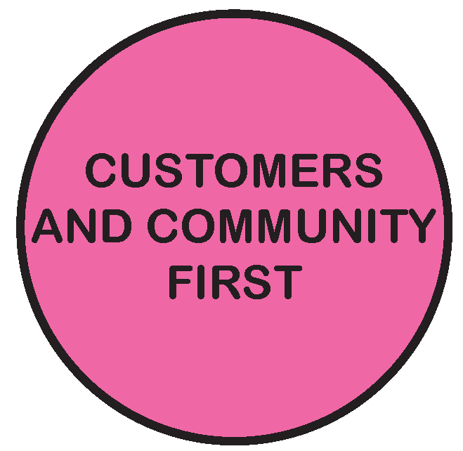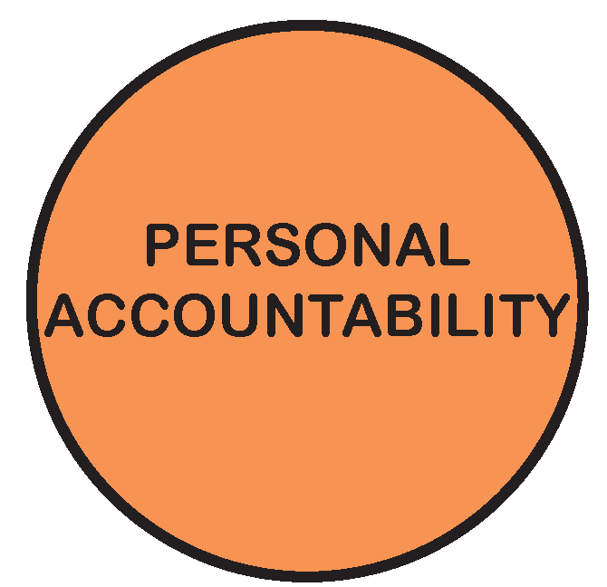

POSITION TITLE | ICT Delivery Lead
POSITION NO | 865
CLASSIFICATION | Band 8
AWARD / LWAA | Moreland City Council Enterprise Agreement 2018
DEPARTMENT |  | Business Transformation
BRANCH |  | Information Technology
WORK UNIT |  | Project Services
REPORTS TO |  | Unit Manager Project Services
SUPERVISES |  | NIL
PREPARED BY |  | Unit Manager Project Services
APPROVED BY |  | Manager Information Technology

As an employee of Moreland City Council you are required to observe all Policies, Codes of Conduct, use and wear personal protective clothing and equipment (where applicable) and follow work instructions and relevant regulations.

- POSITION OBJECTIVES:

The ICT Delivery Lead is responsible for initiating, planning, executing, controlling and closing ICT projects as approved by the Manager Information Technology and assigned by the Unit Manager Project Services. The role collaborates with internal and external stakeholders to clarify and agree the project scope and deliverables, to ensure solutions are appropriate, sustainable and clearly understood. Projects may involve any facet of information technology including IT infrastructure, communications, applications, cyber security and Smart Cities. The ICT Delivery Lead ensures projects are executed in alignment with Council’s project governance framework, procurement policy, legislative requirements and strategic objectives.

Value | Statement
 | We acknowledge our main purpose is to work with our Community and customers
 | I will support and value others
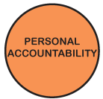 | I take pride in my work and am responsible for doing it well
 | I will do what I say
 | We will work within and across the organisation to achieve community outcomes

KEY RESPONSIBILITY AREAS
- Project Delivery
  - Provide a single point of coordination and oversight of the project lifecycle for assigned digital initiatives and ICT projects.
  - Collaborate with internal and external stakeholders to clarify and agree the project scope and deliverables, to ensure solutions are appropriate, sustainable and clearly understood.
  - Lead, plan, direct and coordinate activities to manage and implement the ICT stream for the projects approved by the Manager Information Technology and assigned by the Unit Manager Project Services.
  - Champion the continuous improvement of activities across the IT Branch and update policies, procedures and processes as required.
  - Adhere and drive accountability to the project governance framework, ICT policies and guidelines related to the project execution.
  - Deliver outcomes as agreed with stakeholders.
  - Participate and provide ICT delivery expertise to the Project Services and other ICT Teams.

- Strategic thinking and Impact
  - Champion and promote the value of technology to improve Council’s service delivery capability.
  - Contribute to the ICT strategy, business planning activities and ensure operational projects and initiatives are in alignment with IT and Council objectives.
  - Provide creative and innovative solutions to complex issues, through extensive research, consultation and networking across government, IT and other industry bodies as appropriate.

- Partnering and Change
  - Build successful stakeholder relationships by developing a clear understanding of business needs, acting as a trusted advisor, and giving expert advice on the design and implementation of operational initiatives through technology.
  - Build and leverage internal and external relationships, including industry bodies, vendors, and technology leaders for Council’s benefit.
  - Design and implement strategies and plan to enable successful transition for Council’s digital initiatives and ICT transformation projects.
  - Plan and coordinate communications for projects with the change team.
- Financial Management
  - Assist the Unit Manager Project Services, Manager Information Technology and Finance Business Partner in preparation of the annual budget and quarterly forecasts for managed cost centres and projects.
  - Manage the expenditure against budget for allocated cost centres and projects in line with governance requirements.
  - Analyse expenditure, participate in budget reviews and report on trends/issues.

- Customer Service
  - Provide effective service to internal customers, external customers and the broader community.
  - Ensure customer needs are incorporated into strategic and operational activities.
  - Present a positive image of Council.

- Corporate Governance and Effective Work Practices
  - Carry out work in line with relevant legislative and statutory requirements and /or industry codes, practices and standards.
  - Adhere to the Code of Conduct, EEO and anti-discrimination policies.
  - Contribute to a productive work environment and contribute to workplace change.
  - Undertake workplace tasks as directed.
  - Work cooperatively with others to facilitate workplace learning.
  - Work in an ethical manner and comply with Council’s Code of Conduct and various organisational governance framework.
  - Resolve workplace conflict in line with council policy.
  - Undertake recordkeeping activities in accordance with Council’s Records Management policy, procedures and guidelines.
- Workplace Health and Safety (WHS)
  - Perform work in accordance with WHS policies and procedures and attend training as required
  - Ensure completion of training by contracted staff on assigned projects as required.
  - Ensure procedures have been risk-assessed, and risk assessments are reviewed in line with designated timeframes.
  - Monitor implementation and use of risk control measures.
  - Participate in consultative processes for the management of WHS, and ensure consultation processes are available to, and used by, contracted staff on assigned projects.

Qualifications, Experience and Specialist Skills & Knowledge
Essential
- A tertiary qualification in Computer Science, Information Technology, Business or other relevant discipline.
- Proven success in managing complex, enterprise-wide ICT projects (infrastructure, communications, ERP/application implementations, etc).
- Skills evaluating new technology, products and vendors.
- Significant experience with vendor/contract negotiation and navigating procurement policies and processes in a regulated environment.
- Demonstrated project management skills such as prioritisation, business case development, planning, procurement, governance, budgeting, resourcing, scheduling and change
- Strong stakeholder management and influencing skills, and the ability to lead and drive outcomes.
- Knowledge of and experience with IT systems and project delivery methodologies.
- Broad understanding of current and emerging information and communication technologies.
- An analytical mindset with superior communication and problem-solving skills
- Experience leading multi-disciplinary project teams to drive and deliver unified outcomes.

Desirable
- Experience in local government.
- Extensive experience and knowledge of change management principles, methodologies and tools.
- Experience with SMART Cities projects delivery.

ORGANISATIONAL RELATIONSHIP:

Reports to: Unit Manager Project Services

Supervises: Nil

Internal Liaison: All levels of Organisation
High level of interaction/teamwork with the Project Services and other support staff in IT Branch.

External Liaison: Vendors for technical support and change management
ICT staff in other Local Government organisations
User group forums

JOB CHARACTERISTICS RELEVANT TO THE POSITION

The following Job Characteristics should be read in the context of the definitions describing the characteristics required of a Band 8 employee as outlined in Part B of the Enterprise Agreement (Victorian Local Authorities Award 2001, Appendix A, Part A - Employee Band 7, Clause 7)

PHYSICAL REQUIREMENTS OF THE POSITION

TASK ANALYSIS

In the course of his/her duties, a person in this position may be expected to work in or be exposed to the following conditions or activities as marked.

Condition/Activity | Constant | Frequent | Occasional | N/A
Manual handling weights -above 10kgs  -below 10kgs | ( )  ( ) | ( )  ( ) | ( )  ( ) | ( x )  ( x )
Manual handling frequency | ( ) | ( ) | ( ) | ( x )
Repetitive manual work | ( ) | ( ) | ( ) | ( x )
Repetitive bending/twisting | ( ) | ( ) | ( ) | ( x )
Working with arms above head | ( ) | ( ) | ( ) | ( x )
Lifting above shoulder height | ( ) | ( ) | ( ) | ( x )
Using hand tools – vibration/powered | ( ) | ( ) | ( ) | ( x )
Operating precision machinery | ( ) | ( ) | ( ) | ( x )
Close inspection work | ( ) | ( ) | ( ) | ( x )
Wearing hearing protection | ( ) | ( ) | ( ) | ( x )
Wearing eye protection | ( ) | ( ) | ( ) | ( x )
Working in dusty conditions | ( ) | ( ) | ( ) | ( x )
Working in wet/slippery conditions | ( ) | ( ) | ( ) | ( x )
Wearing Gumboots | ( ) | ( ) | ( ) | ( x )
Wearing safety shoes/boots (steel cap) | ( ) | ( ) | ( ) | ( x )
Working with chemicals/solvents/detergents | ( ) | ( ) | ( ) | ( x )
Washing hands with soap (hygiene) | ( ) | ( ) | ( ) | ( x )
Working at heights | ( ) | ( ) | ( ) | ( x )
Working in confined spaces | ( ) | ( ) | ( ) | ( x )
Working in chillers (+4 degrees C) | ( ) | ( ) | ( ) | ( x )
Performing clerical duties | ( x ) | ( ) | ( ) | ( )
Working on a keyboard | ( x ) | ( ) | ( ) | ( )
Driving cars and/or trucks | ( ) | ( ) | ( x ) | ( )
Other (please specify)_______________________ | ( ) | ( ) | ( ) | ( )

Other special features (e.g. nature of chemicals, travelling requirements, etc):
____________________________________________________________________________________________________________________________________________

KEY SELECTION CRITERIA

Essential
- Tertiary qualification in Computer Science, Information Technology, Business or other relevant discipline.
- Proven success in managing complex, enterprise-wide ICT projects (infrastructure, communications, ERP/application implementations, etc.)
- Demonstrated project management skills such as prioritisation, business case development, planning, procurement, governance, budgeting, resourcing, scheduling and change.
- Strong stakeholder management and influencing skills, and the ability to lead and drive outcomes.
- Experience leading multi-disciplinary project teams to deliver unified outcomes
- Extensive experience and knowledge of project and change management principles, methodologies and tools
- Demonstrated understanding of current and emerging information and communication technologies
- Significant experience with vendor/contract negotiation and navigating procurement policies and processes in a regulated environment.
- An analytical mindset with superb communication and problem-solving skills

Desirable
- Experience in local government
- Skills in new technology evaluation, product and vendor evaluation, contract negotiation, and procurement management.
SIGNATURE PAGE

This is to certify that the position description has been drawn up/reviewed by both employee & Supervisor/Manager.

Date / /
(Staff member’s signature)

Date / /
(Supervisor/Manager’s signature)

Please send original signed document to the HR Officer (Human Resources) and also forward an electronic version to be filed in the Position Description database.

