POSITION DESCRIPTION

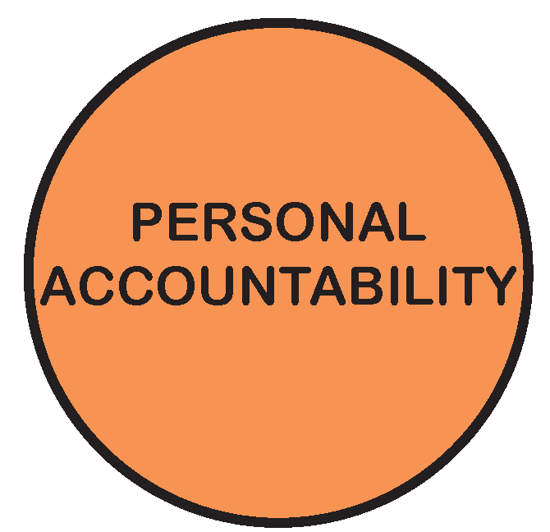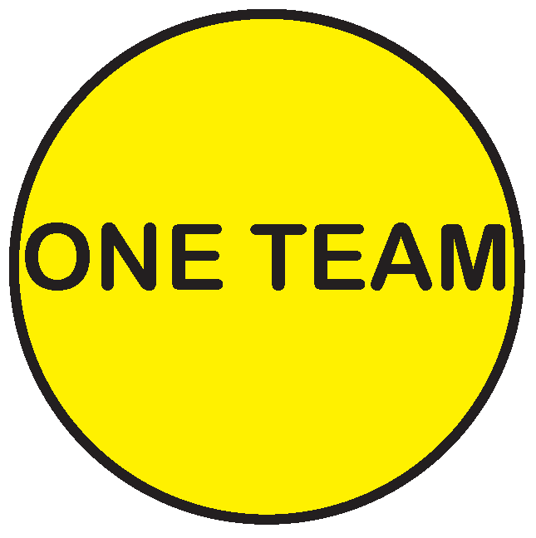

POSITION TITLE: | Waste Driver/Operator – Side Loader
POSITION NO: | Various
CLASSIFICATION: | Driver/Operator – Side Loader – CI LAWA
AWARD / LWAA: | Moreland City Council Enterprise Agreement 2012
DEPARTMENT: |  | City Infrastructure
BRANCH: |  | City Operations
WORK UNIT: |  | Waste Services
REPORTS TO: |  | Works Officer, Waste Services
SUPERVISES: |  | NIL
PREPARED BY: |  | Unit Manager, Waste Services
APPROVED BY: |  | Group Manager, City Operations

As an employee of Moreland City Council you are required to observe all Policies, Codes of Conduct, use and wear personal protective clothing and equipment (where applicable) and follow work instructions and relevant regulations.

- POSITION OBJECTIVES:

- To provide high quality garbage, recycling and green waste collection services throughout the northern area of the Municipality;
- Work with colleagues in a safe, efficient and effective manner to achieve service delivery obligations;
- Work in accordance with the directives of the Works Officer, established Schedules and within accepted work practices.

Value | Statement
 | We acknowledge our main purpose is to work with our Community and customers
 | I will support and value others
 | I take pride in my work and am responsible for doing it well
 | I will do what I say
 | We will work within and across the organisation to achieve community outcomes

- KEY RESPONSIBILITY AREAS:

Collection Standards
Ensure all mobile garbage, recycling and green waste bins are emptied correctly, and returned to the designated areas including picking up of any spilt material.
Take proper care in the handling of the mobile bins and to report any damaged or burnt out mobile bins, to document and submit to Team Leader / Works Officer daily.
Report any extra rubbish, recyclables or green waste noticed in undertaking duties, for example, bins rubbished by animals, placing extra bags around bins, dumped rubbish, recyclables, etc, document and give to Works Officer at the end of the day.

Customer Service

Ensure public courtesy in conducting the collection of mobile garbage, recycling and green waste bins and the promotion of Councils waste collection services throughout the Municipality.

Operational

Rotate between garbage, recycling and green waste services as required to meet daily operational needs.
Take instructions from Team Leader, Works Officer and Unit Manager to ensure all tasks and work objectives are completed as set out in the daily works program within a team environment.
Actively participate in the development and implementation of waste minimisation programs and actions.
Actively participate in team meetings, corporate programs including occupational health and safety training/information sessions, Best Value/continuous improvement programs and other related program undertaken from time to time by the Waste Unit.
Dispose of collected garbage, recyclables or green waste at the nominated disposal sites on a daily basis.
Respond to two-way radio calls when assistance is required.
Be available for overtime on an emergency and rostered basis.
Support the Team Leader/Works Officer in the allocation of crew members to facilitate the green waste, garbage and recycling collections.
Ensure group task finish is achieved and undertaken in accordance with the Enterprise Agreement 2012.
Assist the Team Leader to monitor the tipping weights to ensure compliance with statutory or density requirements.

Vehicle
Maintain an accurate daily work records and time allocation as required including plant usage as per Quality System.
Undertake the basic daily vehicle checks to ensure that the vehicle is operational and report any faults, including mechanical faults, requiring repair and/or attention.
Ensuring that the vehicle is ready for the next day, this includes washing, cleaning and disinfecting the vehicle.
Ensure driver’s truck keys are left in the Waste Services key locker before going home.

Continuous Improvement
Implement and maintain Continuous Improvement System standards and procedures.

Occupational Health & Safety
Implement and maintain health and safety standards and procedures according to legislation and consistent with MoreSafe.

Occupational Health & Safety
Contribute to the achievement of a safe and healthy environment by carrying out the responsibilities outlined in the MoreSafe Manual.

Diversity & Equity
Undertake all duties with an awareness of and sensitivity to diversity and equity in accordance with Council policy.

- ORGANISATIONAL RELATIONSHIP:

Reports to: Works Officer Waste Services

Supervises: Nil

Internal Liaison: Unit Manager Waste Services
Operations Centre Administration Team
Workshop Staff

External Liaison: Residents & the General Public

- ACCOUNTABILITY AND EXTENT OF AUTHORITY:

Perform tasks involving the utilisation of developed skills.

Utilise safe work practices and ensure the creation and maintenance of a safe working environment.

Responsible for the quality and quantity of work performed and working as part of a team to ensure the completion of daily tasks.

Completion of tasks within a set time schedule.

Safe and efficient care and operation of the vehicle and tools and equipment used.

Assist in providing “on the job” training based on skills and experience if and when required.

Report any observed dangerous drainage, road or similar conditions.

- JUDGEMENT AND DECISION MAKING:

Resolve minor problems that relate to immediate work tasks, including occasions when the Team Leader is not available for advice.

- SPECIALIST KNOWLEDGE AND SKILLS:

Knowledge and skills to generate to operate and maintain machinery associated with the emptying of mobile garbage bins.

Physically capable of undertaking a range of manual handling duties including lifting/manoeuvring of mobile garbage, recycling and green waste bins.

A basic understanding of the requirements of the Occupational Health & Safety Act 1985 and VicRoads guidelines.

Basic First Aid Skills.

Understanding of Vehicle Safety Standards.

- MANAGEMENT SKILLS:

Complete tasks and achieves work objectives as set out in a daily works program, within a team environment.

Works both independently and in a team environment.

- INTERPERSONAL SKILLS:

Demonstrated oral and written communication skills as evidenced by understanding written and verbal instructions.

Experience in working in co-operation with others and working as part of a team.

Ability to read and understand a Street Directory and work rosters.

Ability to discuss and resolve minor problems.

Ability to carry out duties and responsibilities in a manner, which maintains Council’s commitment to quality customer service.

- QUALIFICATIONS AND EXPERIENCE:

A current Victorian Driver’s Licence with a Heavy Rigid Licence Endorsement.

Skilled in the safe and competent operation of side loading waste collection vehicles.

Experience in driving of a rear loader vehicle including the emptying of mobile garbage, recycling and green waste bins with the aid of a bin lifter.

Ability to carry out the duties and responsibilities, in a professional and courteous manner.

Demonstrated oral and written communication skills as evidenced by understanding written and verbal instructions.

Ability to read and understand a Street Directory and work rosters.

- PHYSICAL REQUIREMENTS OF THE POSITION

TASK ANALYSIS

In the course of his/her duties, a person in this position may be expected to work in or be exposed to the following conditions or activities as marked.

Condition/Activity | Constant | Frequent | Occasional | N/A
Manual handling weights -above 10kgs  -below 10kgs | ( )  ( ) | ( )  ( ) | ( x )  ( x ) | ( )  ( )
Manual handling frequency | ( ) | ( ) | ( x ) | ( )
Repetitive manual work | ( ) | ( ) | ( x ) | ( )
Repetitive bending/twisting | ( ) | ( ) | ( x ) | ( )
Working with arms above head | ( ) | ( ) | ( x ) | ( )
Lifting above shoulder height | ( ) | ( ) | ( x ) | ( )
Using hand tools – vibration/powered | ( ) | ( ) | ( ) | ( x )
Operating precision machinery | ( ) | ( ) | ( ) | ( x )
Close inspection work | ( ) | ( ) | ( x ) | ( )
Wearing hearing protection | ( ) | ( ) | ( x ) | ( )
Wearing eye protection | ( ) | ( ) | ( x ) | ( )
Working in dusty conditions | ( ) | ( ) | ( x ) | ( )
Working in wet/slippery conditions | ( ) | ( x ) | ( ) | ( )
Wearing Gumboots | ( ) | ( ) | ( x ) | ( )
Wearing safety shoes/boots (steel cap) | ( ) | ( x ) | ( ) | ( )
Working with chemicals/solvents/detergents | ( ) | ( x ) | ( ) | ( )
Washing hands with soap (hygiene) | ( ) | ( x ) | ( ) | ( )
Working at heights | ( ) | ( ) | ( ) | ( x )
Working in confined spaces | ( ) | ( ) | ( ) | ( x )
Working in chillers (+4 degrees C) | ( ) | ( ) | ( ) | ( x )
Performing clerical duties | ( ) | ( ) | ( x ) | ( )
Working on a keyboard | ( ) | ( ) | ( x ) | ( )
Driving cars and/or trucks | (x ) | ( ) | ( ) | ( )
Other (please specify)_______________________ | ( ) | ( ) | ( ) | ( )

________________________

Other special features (e.g. nature of chemicals, travelling requirements, etc):
____________________________________________________________________________________________________________________________________________

- KEY SELECTION CRITERIA

Current Victorian Driver’s Licence with Heavy Rigid Endorsement.

Experience operating side loader waste collection vehicles.

Understanding of current safe working practices.

Willingness to work as part of a team to achieve group task-finish.

SIGNATURE PAGE

This is to certify that the position description has been drawn up/reviewed by both employee & Supervisor/Manager.

Date / /
(Staff member’s signature)

Date / /
(Supervisor/Manager’s signature)

Please send original signed document to the HR Officer (Human Resources) and also forward an electronic version to be filed in the Position Description database.

