POSITION DESCRIPTION

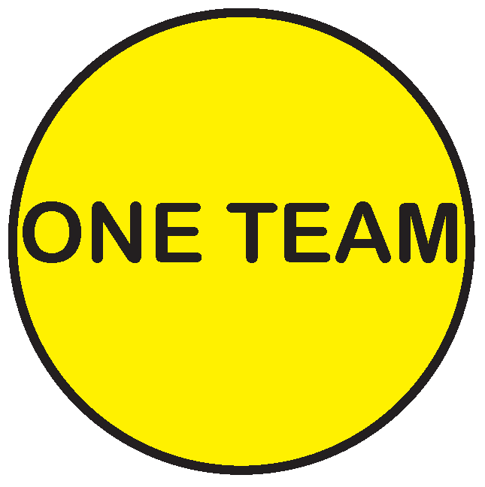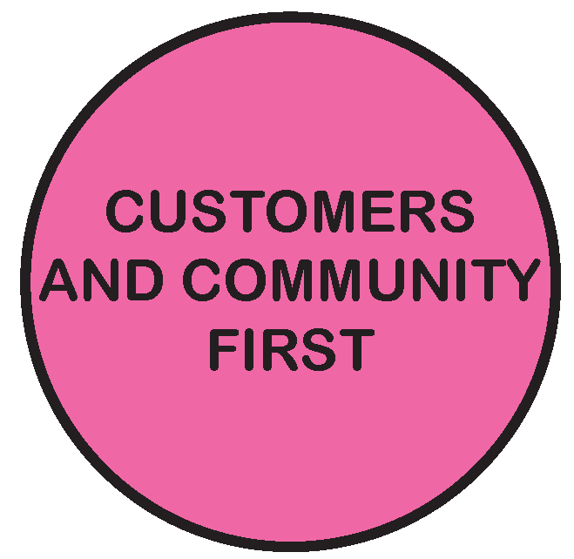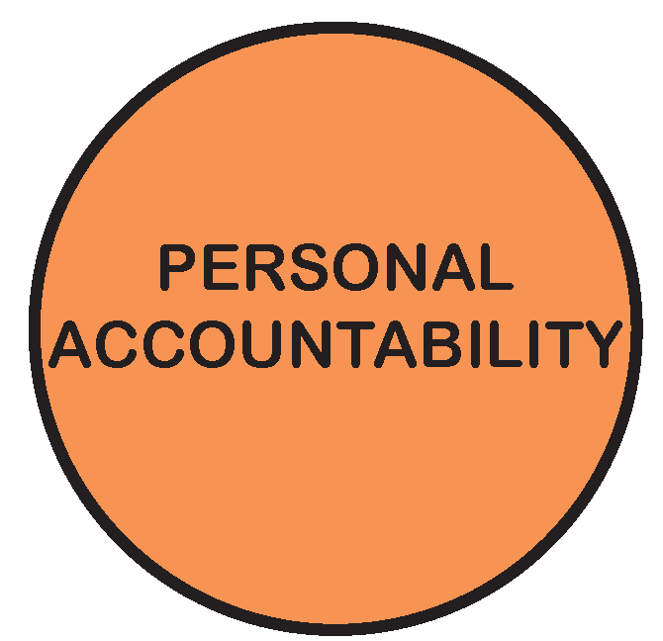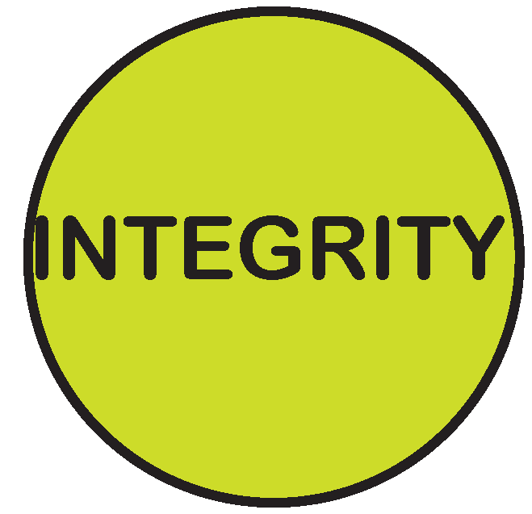

POSITION TITLE: | Unit Manager Open Space Design and Development
POSITION NO: | 296
CLASSIFICATION: | SEO
AWARD / LWAA: | Moreland City Council Enterprise Agreement 2012
DEPARTMENT: |  | City Infrastructure
BRANCH: |  | Open Space and Street Cleansing
WORK UNIT: |  | Open Space Design and Development Unit
REPORTS TO: |  | Manager Open Space and Street Cleansing
SUPERVISES: |  | Landscape Architects, Open Space Planning and Design Officer, Natural Resource Management Officer, Capital Works Project Officers.
PREPARED BY: |  | Unit Manager Open Space Design and Development
APPROVED BY: |  | Manager Open Space and Street Cleansing

As an employee of Moreland City Council you are required to observe all Policies, Codes of Conduct, use and wear personal protective clothing and equipment (where applicable) and follow work instructions and relevant regulations.

- POSITION OBJECTIVES:

This position is responsible for leading the Open Space Design and Development Unit and across the organisation to plan, design, develop and conserve quality open space for the City of Moreland. The four core service responsibilities that the position is responsible for leading and supporting are:

- Strategic planning and policy development for public open space
- Creek and Bushland conservation and development for the City
- Open Space Capital works planning, design and delivery
- Engaging and consulting the community in the development and conservation of public open space for the City

Value | Statement
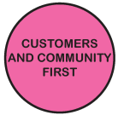 | We acknowledge our main purpose is to work with our Community and customers
 | I will support and value others
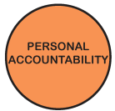 | I take pride in my work and am responsible for doing it well
 | I will do what I say
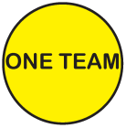 | We will work within and across the organisation to achieve community outcomes

- KEY RESPONSIBILITY AREAS:

- Leading the Organisation and Open Space Design and Development team in the development of Open Space policies, strategies as well as implementation and delivery of projects and programs.

- Coordinating the staged implementation of the Moreland Open Space Strategy, the Moreland Street Landscape Strategy and sections of the Merri, Moonee Ponds and Edgars Creek Strategies, specific to the Moreland catchment.

- Coordinate, manage, implement and report on the delivery of the Open Space Capital Works program, including management of the annual budget for all open space capital works projects

- Providing specific design and project management advice and assistance to Open Space Design and Development Unit team members.

- Coordinate internal and external communications and internal referrals for open space planning and development issues.

- Develop and maintain productive relationships with key external stakeholders such as consultants, contractors, creek committees and members of the community.

Continuous Improvement
- Implement and maintain Continuous Improvement System standards and procedures.

Environmental Sustainability
- Incorporate Council’s environmental sustainability objectives and targets into projects and programs.
- Promote and participate in a culture of environmental sustainability.

Occupational Health and Safety
- Implement and maintain health and safety standards and procedures according to legislation and consistent with MoreSafe.
- Demonstrate effective leadership on OHS matters

Diversity and Equity
- Undertake all duties with an awareness of and sensitivity to diversity and equity in accordance with Council policy.

Other duties
- Required to undertake other duties as directed.

- ORGANISATIONAL RELATIONSHIP:

Reports to: Manager Capital Works Delivery

Supervises: Landscape Architects, Open Space Planning and Design Officer, Natural Resource Management Officer, Capital Works Project Officers and Consultants as required.

Internal Liaison: Unit Managers, Managers, Staff and Directors from other key Departments

External Liaison: Local residents, Community Groups, Creek Committees, State and federal Government Agencies

- ACCOUNTABILITY AND EXTENT OF AUTHORITY:

The position is accountable to the Manager Capital Works Delivery, and is responsible for achieving and maintaining a high level of efficiency and effectiveness in the management and operations of the Open Space Design and Development Unit.
- Accountable for the overall management of the Unit including human resources, financial management and annual business planning in line with Council’s service plans.

- The position is responsible for the management of staff, including establishing performance indicators, providing feedback on performance, including acknowledging, rewarding, coaching and managing performance as appropriate.

- Accountable for the satisfactory completion on time and budget of agreed and specified projects.

- Accountable for the management of contracts and service delivery through third party providers to the community

- Accountable for the collation, research, and analysis of data for projects in order to prepare future forward planning and policy recommendations, reports and presentations to the Manager Capital Works Delivery , Director City Infrastructure, Moreland Executive Group (MEG) and /or Council.

- JUDGEMENT AND DECISION MAKING:

- Judgement and decisions are required across a broad spectrum of areas on a day to day basis, including technical project matters, financial and budget management and through policy and strategy development

- Judgement and decision making will involve a high level of analytical and research input

- High level problem solving skills are required to develop solutions to issues within broad organisational policies.
- Judgements and decision making is required to demonstrate an awareness and consideration of diversity of opinions and hidden sensitivities.
- The position is accountable for decisions which are often required without opportunity for guidance from Manager or Director.

- SPECIALIST KNOWLEDGE AND SKILLS:

- Demonstrated understanding of the long term goals of the organisation, of its values and aspirations, of long term state and federal policy context, and of current developments and future changes within the open space development / public realm.

- Demonstrated ability to develop and implement capital works programs and manage associated performance of agreements, including demonstrated project management experience

- Ability to identify options and contribute to plans and policy for the longer term planning, protection and provision of public open space.

- Ability to interpret relevant legislative, budgetary, political and industry requirements to specific tasks or issues.

- Demonstrated understanding of Natural Resource Management issues and current practices in conservation and maintaining biodiversity of natural areas

- Understanding of broad community issues and capacity to work effectively with a diverse community.

- Demonstrated experience in community consultation, including facilitating negotiations, problem solving, and relationship management and advocacy skills.

- Sound knowledge of budget preparation and management

- MANAGEMENT SKILLS:

- Demonstrated capacity to plan, prioritise, and organise work, both on an individual and team basis within set timelines and against competing priorities
- Ability to manage competing community needs and effective dispute resolution capability.
- Ability to coordinate projects and initiatives both within the team and cross-functional

- Ability to develop strong and professional relationships with relevant stakeholders and maintain productive relationships with contractors and service providers

- Ability to adapt to and support the implementation of change.
- Understanding of, and ability to assist in implementing personnel practices for teams including equal opportunity, privacy, health and safety, and team development.

- INTERPERSONAL SKILLS:

- Demonstrated ability and experience in managing, leading, motivating, and developing staff to create a positive outcome focussed and performance orientated culture.

- Ability to lead and work in a multidisciplinary team environment and achieve desired outcomes

- Ability to articulate a strong vision of high quality open space development and public realm, to consult and negotiate with and gain co-operation and assistance from a range of people including other staff, residents and ratepayers, community groups, statutory and government personnel, community interest groups etc.

- High level of ability to discuss and resolve problems.

- Highly developed oral and written communications skills.

- QUALIFICATIONS AND EXPERIENCE:

- A tertiary qualification in Landscape Architecture, Urban Design, Open Space Planning, Horticulture or related disciplines and/or relevant experience in the Public Realm and Local Government environment.

- Significant experience in project design, management and delivery, including strategic open space planning, Natural Resource Management, and capital works projects.

- A current Victorian Drivers Licence

- PHYSICAL REQUIREMENTS OF THE POSITION

TASK ANALYSIS

In the course of his/her duties, a person in this position may be expected to work in or be exposed to the following conditions or activities as marked.

Condition/Activity | Constant | Frequent | Occasional | N/A
Manual handling weights -above 10kgs  -below 10kgs | ( )  ( ) | ( )  ( ) | ( )  ( ) | ( )  ( )
Manual handling frequency | ( ) | ( ) | ( ) | ( )
Repetitive manual work | ( ) | ( ) | ( ) | ( )
Repetitive bending/twisting | ( ) | ( ) | ( ) | ( )
Working with arms above head | ( ) | ( ) | ( ) | ( )
Lifting above shoulder height | ( ) | ( ) | ( ) | ( )
Using hand tools – vibration/powered | ( ) | ( ) | ( ) | ( )
Operating precision machinery | ( ) | ( ) | ( ) | ( )
Close inspection work | ( ) | ( ) | ( ) | ( )
Wearing hearing protection | ( ) | ( ) | ( ) | ( )
Wearing eye protection | ( ) | ( ) | ( ) | ( )
Working in dusty conditions | ( ) | ( ) | ( ) | ( )
Working in wet/slippery conditions | ( ) | ( ) | ( ) | ( )
Wearing Gumboots | ( ) | ( ) | ( ) | ( )
Wearing safety shoes/boots (steel cap) | ( ) | ( ) | ( ) | ( )
Working with chemicals/solvents/detergents | ( ) | ( ) | ( ) | ( )
Washing hands with soap (hygiene) | ( ) | ( ) | ( ) | ( )
Working at heights | ( ) | ( ) | ( ) | ( )
Working in confined spaces | ( ) | ( ) | ( ) | ( )
Working in chillers (+4 degrees C) | ( ) | ( ) | ( ) | ( )
Performing clerical duties | ( ) | ( ) | ( ) | ( )
Working on a keyboard | ( ) | ( ) | ( ) | ( )
Driving cars and/or trucks | ( ) | ( ) | ( ) | ( )
Other (please specify)_______________________ | ( ) | ( ) | ( ) | ( )

________________________

Other special features (e.g. nature of chemicals, travelling requirements, etc):
____________________________________________________________________________________________________________________________________________

- KEY SELECTION CRITERIA

- A tertiary qualification in Landscape Architecture, Urban Design, Open Space Planning, Horticulture or related disciplines and/or relevant experience in the Public Realm and Local Government environment.
- Significant experience in project design, management and delivery, including strategic open space planning, Natural Resource Management, and capital works projects.
- Demonstrated ability to develop and implement capital works programs and manage associated performance of agreements
- Demonstrated ability and experience in managing, leading, motivating, and developing staff to create a positive outcome focussed and performance orientated culture.
- Demonstrated ability to develop, implement and report on open space and natural resource management policies and strategies
- Demonstrated experience in community consultation, including facilitating negotiations, problem solving, and relationship management and advocacy skills.
- Demonstrated capacity to compile, collate, analyse, and interpret data leading to identifying innovative solutions to community based issues and projects.
- Sound knowledge of budget preparation and management.
- Highly developed written and oral communication skills and the ability to communicate effectively with a diverse range of internal and external stakeholders.

SIGNATURE PAGE

This is to certify that the position description has been drawn up/reviewed by both employee and Supervisor/Manager.

Date / /
(Staff member’s signature)

Date / /
(Supervisor/Manager’s signature)

Please send original signed document to the HR Officer (Human Resources) and also forward an electronic version to be filed in the Position Description database.

