POSITION DESCRIPTION

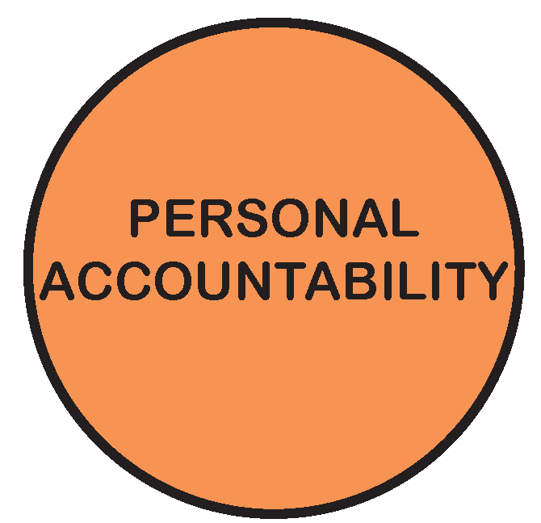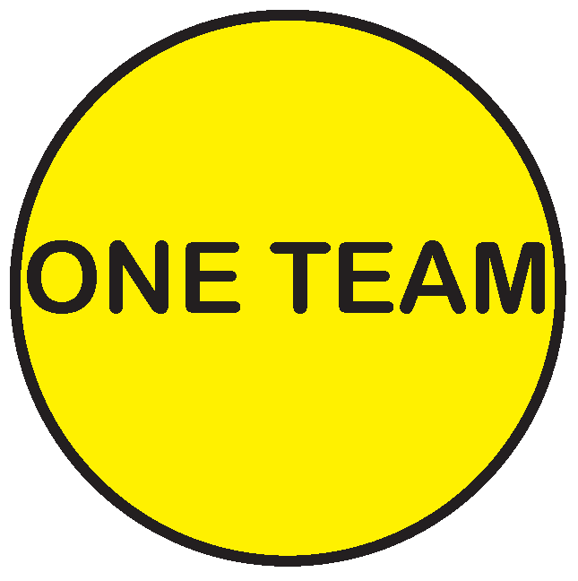

POSITION TITLE: | Asset Management GIS Officer
POSITION NO: | 206
CLASSIFICATION: | Band 6
AWARD / LWAA: | Moreland City Council Enterprise Agreement 2018
DEPARTMENT: |  | City Infrastructure
BRANCH: |  | Strategic Transport & Property
WORK UNIT: |  | Asset Management
REPORTS TO: |  | Asset Management Coordinator
SUPERVISES: |  | Nil
PREPARED BY: |  | Asset Management Coordinator
APPROVED BY: |  | Director City Infrastructure

As an employee of Moreland City Council you are required to observe all Policies, Codes of Conduct, use and wear personal protective clothing and equipment (where applicable) and follow work instructions and relevant regulations.

- POSITION OBJECTIVES:

The primary objective is to ensure that Council’s Asset Management System maintains a quality spatial information which is available to users of council to facilitate business operations and decision making capabilities.

More specifically, the Asset Management GIS Officer will be required to:

- Provide specialist GIS advice and support to the AM team and the GIS unit in relation to asset data, mapping and reporting.
- Actively contribute towards a focus on long term asset planning, development and management, particularly in respect of mapping, maintaining and integrating graphical spatial data for all Council assets including buildings, road-related assets, drainage, open space and other Council facilities.
- Provide system support and data administration, plus the time-effective delivery of projects associated with the on-going implementation and development of Council’s Asset Management System (Assetic), Geographical Information System (GIS) and Mobile Technology.
- Contribute within the AM team to the timely production of financial data associated with assets
- Apply technical knowledge to day to day activities whilst working within regulations, set policies and budgets within a continuous improvement environment.
- Deliver quality outputs with minimal supervision, including the achievement of own work schedules and deadlines ensuring currency and accuracy at all times.

Value | Statement
 | We acknowledge our main purpose is to work with our Community and customers
 | I will support and value others
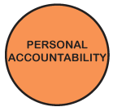 | I take pride in my work and am responsible for doing it well
 | I will do what I say
 | We will work within and across the organisation to achieve community outcomes
- KEY RESPONSIBILITY AREAS:

Graphical Information System (GIS) & Mobile Technology
- Responsible for the recording of assets spatially along with appropriate asset references, attributes, dimensions and descriptors.
- Responsible for the creation and manipulation of spatial data and relevant data from the asset management system to facilitate interpretation and analysis.
- Review, identify and record issues relating to integrity of data within Council’s GIS and asset management systems. Create or amend asset details, where necessary in accordance with the relevant procedures.
- Develop, test and document a derived capital works layer for display of annual capital works in GIS.
- Investigate and assist with the diagnosis and problems experienced with the use of GIS and related software. “troubleshooting”
- Provide technical support and advice in the ongoing development of Mobile Solution Technology for the capture of asset data.
- Provide ongoing support and training to members of the Asset Management team in the familiarisation and use of GIS.

Asset Planning/Management
- Active involvement in team activities including planning, development, documentation and implementation of policies, standards and procedures pertinent to the management and maintenance of corporate infrastructure data and adherence to such.
- Provide financial data for Council assets, to provide annual fair value assessment and asset revaluations.
- Preparation of financial data and statistics for annual Local Government Performance Reporting Framework and Victoria Grants Commission reports.
- In conjunction with the Asset Management Team, analyze data sets for long-term financial modeling of infrastructure replacement.
- Undertake onsite investigations and inspections of assets as and when required.

Capital Works
- Responsible for interpreting Engineering Capital Works technical drawings and plans and updating asset data attributes to reflect new, disposed and changed assets.
- Responsible for the provision of annual financial reconciliations relating to drainage assets, gifted assets, found assets and new development assets for Local Government Accounting audit purposes.

Citizen/Customer Service
- Provide the highest quality service to citizens and customers ensuring all information is delivered on time and accurate

Continuous Improvement
- Contribute to the effective implementation of the Moreland Continuous Improvement system in the work area and achievement of quality outcomes.

Occupational Health & Safety
- Comply with all workplace policies, procedures and safety standards according to legislation and consistent with MoreSafe.
- Demonstrate effective leadership on OHS matters

Diversity & Equity
- Undertake all duties with an awareness of and sensitivity to diversity and equity in accordance with Council policy.

Other duties
- Required to undertake other duties as directed.

- ORGANISATIONAL RELATIONSHIP:

Reports to: Asset Management Coordinator

Supervises: Nil

Internal Liaison: Directors
Managers / Coordinators
Other Staff

External Liaison: Contractors & Consultants
State & Federal Government Departments
Service Utilities (as required)
Moreland Community (including traders)
Other Local Government Officers

JOB CHARACTERISTICS RELEVANT TO THE POSITION

- ACCOUNTABILITY AND EXTENT OF AUTHORITY:

- Accountable for the provision of specialist GIS advice and support to internal staff in relation to GIS data, mapping and reporting.
- Accountable for maintaining Council’s infrastructure data held in GIS, ensuring currency and accuracy at all times to support the capital works budget programming process and facilitation of Asset Management Strategies and Plans.
- Accountable for planning and managing allocated work within regulations, set policies and budges within a continuous improvement environment.
- Accountable for own work quality including the achievement of own work schedules and deadlines.
- Accountable for carrying out duties and responsibilities as directed, in a courteous, timely and professional manner to ensure a high level of service efficiency including year-end asset reconciliation and valuation activities.
- Work with a moderate degree of autonomy and with minimal supervision.
- Authorised to make decisions on matters which are the responsibility of the position subject to the decision being within delegated authority, legislative requirements and established policy or recognised standards.

- JUDGEMENT AND DECISION MAKING:

- Act as a subject matter expert utilising, initiative, resourcefulness and judgement to provide ideas and solutions toward the improvement of business processes.
- Must be able to solve problems whilst performing day-to-day duties, by using knowledge and experience to evaluate and make recommendations based on the evaluation.
- Maximise use of technology to continually improve Council’s Corporate Systems
- To work within organisation objectives.

- SPECIALIST KNOWLEDGE AND SKILLS:

- Specialist experience in ESRI ArcGIS Desktop software to map, edit or create assets
- Experienced in GIS concepts, image interpretation, and conveying GIS/spatial information to non-GIS/technical people
- Understanding of technical plans and drawings
- Skilled in the use of computer-based asset management systems.
- A good understanding of financial issues which relate to asset valuations, including the end of the year Financial statement
- A good understanding of legislation and regulations that impact on Asset Management.
- A strong understanding of continuous improvement.
- An understanding and ability to apply relevant legislation, policies, procedures, standards and regulations.
- Advanced use of word processing, spreadsheet and database applications, particularly using the Microsoft Office suite of applications.

- MANAGEMENT SKILLS:

- Demonstrated ability to be proactive in setting priorities and to perform under pressure in the face of competing demands, so that objectives are achieved within budget and time constraints.
- Demonstrated ability to analyse problems, and make professional decisions on a daily basis.
- Exercise a high level of initiative, resourcefulness and judgement in particular methods or processes to be used and in the provision of advice and recommendations.
- Maintain a continuous improvement focus that contributes to departmental activities.

- INTERPERSONAL SKILLS:

- Ability to resolve problems with members of the public and other employees.
- Ability to develop and write Standard Operating Procedures
- Professional report writing skills
- A high level of commitment to a service culture.
- Very effective communication skills, both verbal and written.
- A high level of self-motivation, initiative, problem solving and analytical skills.
- A high level of energy and commitment to achieve goals and deadlines.
- Ability to work as part of a team.

- QUALIFICATIONS AND EXPERIENCE:

- Demonstrated experience in the use and application of GIS and asset management databases.
- Industry based training in GIS and Asset Management Software plus experience in a similar role or more extensive experience.
- Local Government experience would be an advantage.
- A current Victorian Drivers Licence.

- PHYSICAL REQUIREMENTS OF THE POSITION

TASK ANALYSIS

In the course of his/her duties, a person in this position may be expected to work in or be exposed to the following conditions or activities as marked.

Condition/Activity | Constant | Frequent | Occasional | N/A
Manual handling weights -above 10kgs  -below 10kgs | ( )  ( ) | ( )  ( ) | (x)  (x) | ( )  ( )
Manual handling frequency | ( ) | ( ) | (x) | ( )
Repetitive manual work | ( ) | ( ) | ( ) | (x)
Repetitive bending/twisting | ( ) | ( ) | ( ) | (x)
Working with arms above head | ( ) | ( ) | ( ) | (x)
Lifting above shoulder height | ( ) | ( ) | ( ) | (x)
Using hand tools – vibration/powered | ( ) | ( ) | ( ) | (x)
Operating precision machinery | ( ) | ( ) | ( ) | (x)
Close inspection work | (x) | ( ) | ( ) | ( )
Wearing hearing protection | ( ) | ( ) | (x) | ( )
Wearing eye protection | ( ) | ( ) | (x) | ( )
Working in dusty conditions | ( ) | ( ) | (x) | ( )
Working in wet/slippery conditions | ( ) | ( ) | (x) | ( )
Wearing Gumboots | ( ) | ( ) | (x) | ( )
Wearing safety shoes/boots (steel cap) | ( ) | ( ) | (x) | ( )
Working with chemicals/solvents/detergents | ( ) | ( ) | ( ) | (x)
Washing hands with soap (hygiene) | ( ) | ( ) | (x) | ( )
Working at heights | ( ) | ( ) | (x) | ( )
Working in confined spaces | ( ) | ( ) | (x) | ( )
Working in chillers (+4 degrees C) | ( ) | ( ) | ( ) | (x)
Performing clerical duties | ( ) | ( ) | (x) | ( )
Working on a keyboard | (x) | ( ) | ( ) | ( )
Driving cars and/or trucks | ( ) | (x) | ( ) | ( )
Other (please specify)_______________________ | ( ) | ( ) | ( ) | (x)

________________________

Other special features (e.g. nature of chemicals, travelling requirements, etc):

- KEY SELECTION CRITERIA

- High level of competency and experience in the use of mainstream GIS software (essential).
- Demonstrated knowledge and ability to interpret standard construction drawings and specifications.(essential)
- Demonstrated knowledge in computer-based asset management systems. (highly regarded)
- Demonstrated experience with mobile (GPS enabled) data collection devices and with associated GIS software. (highly regarded)
- Well-developed communication and interpersonal skills with a strong focus on the capacity to develop and maintain positive and effective relationships and partnerships, both internally and externally.
- Demonstrated ability to exercise personal judgement and work both independently and as part of a team, including fostering team spirit.
- Demonstrated analytical and problem solving skills.
- Demonstrated commitment to quality assurance practices, workplace health and safety, and environmental standards, practices, and procedures.

SIGNATURE PAGE

This is to certify that the position description has been drawn up/reviewed by both employee & Supervisor/Manager.

Date / /
(Staff member’s signature)

Date / /
(Supervisor/Manager’s signature)

Please send original signed document to the HR Officer (Human Resources) and also forward an electronic version to be filed in the Position Description database.

