POSITION DESCRIPTION

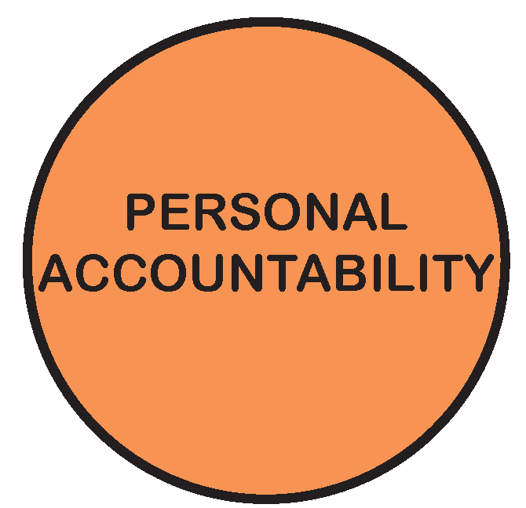

POSITION TITLE: | URBAN PLANNER Band 5 / SENIOR URBAN PLANNER Band 6
POSITION NO:
CLASSIFICATION: | Band 5/6 (Broadbanded)
AWARD / LWAA: | Victorian Local Authorities Award 2001
DEPARTMENT: |  | CITY FUTURES
BRANCH: |  | CITY DEVELOPMENT
WORK UNIT: |  | CITY DEVELOPMENT
REPORTS TO: |  | GROUP MANAGER CITY DEVLELOPMENT  UNIT MANAGER CITY DEVELOPMENT  PLANNING COORDINATOR
SUPERVISES: |  | NIL
PREPARED BY: |  | GROUP MANAGER CITY DEVELOPMENT
APPROVED BY: |  | DIRECTOR CITY FUTURES

D19/
As an employee of Moreland City Council you are required to observe all Policies, Codes of Conduct, use and wear personal protective clothing and equipment (where applicable) and follow work instructions and relevant regulations.

- POSITION OBJECTIVES:

- To assist in the performance of Council’s statutory planning duties and to ensure compliance with the Planning and Environment Act, the Moreland Planning Scheme and other related legislation.
- To provide a high level of customer service to all parties involved in the development approvals process.
- To contribute to the achievement of Council’s corporate, strategic and economic objectives.
- To undertake such duties, in consultation with the Planning Coordinator, Unit Manager City Development and Group Manager City Development, as are necessary to achieve compliance with the Moreland Planning Scheme, Planning and Environment Act and related legislation.

Value | Statement
 | We acknowledge our main purpose is to work with our Community and customers
 | I will support and value others
 | I take pride in my work and am responsible for doing it well
 | I will do what I say
 | We will work within and across the organisation to achieve community outcomes

- KEY RESPONSIBILITY AREAS:

Planning decision-making and advice
- Provision of high quality planning advice at pre-application meetings with applicants.
- Consider applications for planning permits, make the necessary referrals to other officers and external organisations, give notification of applications, make requests for further information and negotiate with applicants and residents.
- Carry out site inspections requiring use of a Council vehicle, research and collect information.
- Facilitate the timely consideration and determination of applications and particularly expedite less complex applications of a minor nature in accordance with established Fast Track processes.
- Attend consultative meetings with Councillors and other interested parties outside normal working hours as required by the Planning Coordinator, Unit Manager City Development or Group Manager City Development.
- Prepare reports to Council on planning application and enforcement matters under the supervision of the Planning Coordinator.
- Compile and present matters before the Victorian Civil & Administrative Tribunal and at other forums under the supervision of the Planning Coordinator.
- Note: Higher level and more complex planning decision making and advice will be undertaken at Band 6.

Customer Service
- Provide high quality town planning advice to all participants in the planning process either at the counter, by telephone and in response to written enquiries
- Establish and maintain a high level of cooperation and service to residents, officers, applicants and the City Development Branch.
- Be available at all times during working hours to assist with the provision of high quality customer service to all participants in the planning process.

Continuous Improvement (Band 5)
- Contribute to the effective implementation of the Moreland Continuous Improvement system in the work area and achievement of quality outcomes.

Continuous Improvement (Band 6)
- Implement and maintain Continuous Improvement System standards and procedures.

Environmental Sustainability
- Incorporate Council’s environmental sustainability objectives and targets into projects and programs.
- Promote and participate in a culture of environmental sustainability.

Occupational Health & Safety
- Contribute to the achievement of a safe and healthy environment by working in accordance with Council’s OHS Policy and Procedures.

Diversity & Equity
- Undertake all duties with an awareness of and sensitivity to diversity and equity in accordance with Council policy.

Other duties
- Required to undertake other duties as required.

- ORGANISATIONAL RELATIONSHIP:

Reports to: Group Manager City Development
Unit Manager City Development
Planning Coordinator

Supervises: Nil

Internal Liaison: City Development Branch
Urban Safety Branch
City Strategy & Design Branch
City Economy & Places Branch
Open Space Branch
Strategic Transport & Property Branch
Governance Branch
Councillors

External Liaison:

External communication and interaction is required with external organisations, service providers, consultants, industry professionals, government agencies and community groups to resolve problems and provide advice on specific matters. External liaisons include:

- Residents, industry and commercial business
- Other service provision agencies
- Community groups
- Development industry interest groups
- Statutory authorities/agencies
- Department of Land Water Environment and Planning
- Victorian Building Commission
- Victorian Civil & Administrative Tribunal
- Victorian Commission for Gambling & Liquor Regulation
- Heritage Victoria

In particular the incumbent has the ability to gain the cooperation and assistance of customers, members of the public and employees of other organisations.

JOB CHARACTERISTICS RELEVANT TO THE POSITION – Band 5

The following Job Characteristics should be read in the context of the definitions describing the characteristics required of a Band 5 employee as outlined in Part B of the Enterprise Agreement (Victorian Local Authorities Award 2001, Appendix A, Part A - Employee Band 5, Clause 5)

JOB CHARACTERISTICS RELEVANT TO THE POSITION – Band 6

The following Job Characteristics should be read in the context of the definitions describing the characteristics required of a Band 6 employee as outlined in Part B of the Enterprise Agreement (Victorian Local Authorities Award 2001, Appendix A, Part A - Employee Band 6, Clause 6)

- ACCOUNTABILITY AND EXTENT OF AUTHORITY:

- Responsible for the provision of advice and preparation of reports to Council on a range of statutory planning matters under the supervision of the Planning Coordinator and with high level advice and report preparation required at Band 6.
- Responsible for ensuring that appropriate action is taken, in consultation with the Planning Coordinator to ensure compliance with the Planning and Environment Act and related legislation.
- At Band 6 responsible for checking and signing off on planning reports of other officers.

- JUDGEMENT AND DECISION MAKING:

- Exercise problem solving skills, judgement and decision-making on planning matters under delegated authority of Council, in consultation with the Planning Coordinator. Higher level skills are required at Band 6.
- Assess a range of applications in accordance with relevant State and Council policies and in consultation with the Planning Coordinator. More complex application assessment required at Band 6.
- Analyse applications and suggest improvements in keeping with relevant policies and guidelines, make recommendations to the Planning Coordinator, Unit Manager City Development and Group Manager City Development.
- In respect to more complicated town planning and enforcement matters, seek input and direction from the Planning Coordinator, Unit Manager City Development or Group Manager City Development, as required.

- SPECIALIST KNOWLEDGE AND SKILLS:

- An understanding of Town Planning legislation the planning process and planning principles (relating to parking, heritage, landscaping, site planning, urban design, site contamination community participation) as they operate in Victoria and progressing to an advanced understanding by Band 6.
- Ability to drive a standard Council vehicle to attend external meetings and undertake site inspections.

- MANAGEMENT SKILLS:

- An ability to manage time, to set work priorities and achieve desired results incrementally increasing to an advanced level by attainment of Band 6.

- INTERPERSONAL SKILLS:

- High level verbal and written communication skills are essential. Higher order of skills required by Band 6 level.
- The ability to work effectively as part of a team and to gain the cooperation and assistance of others progressing to an advanced level.
- The ability to provide information and assistance to people at the counter, by phone and in writing in a clear and pleasant manner.
- A self-motivated, enthusiastic person capable of acting independently.

- QUALIFICATIONS AND EXPERIENCE:

- A tertiary qualification in Town Planning or extensive experience in statutory planning is required.
- It is desirable that applicants have some relevant town planning experience but this is not essential. Experience could include work experience as part of a recognised Town Planning course. A minimum of 3 years of town planning experience would be required before progressing to Band 6.
- Practical computer and word processing skills are required.
- A current Victorian Drivers Licence and the ability to drive a standard Council vehicle to meetings and site inspections is essential.

- PHYSICAL REQUIREMENTS OF THE POSITION

TASK ANALYSIS

In the course of his/her duties, a person in this position may be expected to work in or be exposed to the following conditions or activities as marked.

Condition/Activity | Constant | Frequent | Occasional | N/A
Manual handling weights -above 10kgs  -below 10kgs |  | X | X
Manual handling frequency |  | X
Repetitive manual work |  |  |  | X
Repetitive bending/twisting |  |  |  | X
Working with arms above head |  |  |  | X
Lifting above shoulder height |  |  | X
Using hand tools – vibration/powered |  |  |  | X
Operating precision machinery |  |  |  | X
Close inspection work |  |  |  | X
Wearing hearing protection |  |  |  | X
Wearing eye protection |  |  |  | X
Working in dusty conditions |  |  |  | X
Working in wet/slippery conditions |  |  |  | X
Wearing Gumboots |  |  | X
Wearing safety shoes/boots (steel cap) |  |  | X
Working with chemicals/solvents/detergents |  |  |  | X
Washing hands with soap (hygiene) |  |  |  | X
Working at heights |  |  |  | X
Working in confined spaces |  |  |  | X
Working in chillers (+4 degrees C) |  |  |  | X
Performing clerical duties | X
Working on a keyboard | X
Driving cars and/or trucks |  | X
Other (please specify)Attending potential and active construction sites_______________________ |  | X

Other special features (e.g. nature of chemicals, travelling requirements, etc):
Undertake site inspections

- KEY SELECTION CRITERIA

- Relevant tertiary qualifications in town planning or significant relevant experience and a tertiary qualification in a related discipline.
- Demonstrated knowledge of statutory planning and related legislation
- Practical IT and word processing competency skills applicable to statutory planning processes
- Commitment to excellence in customer service and managing stakeholder relations in a politically sensitive environment
- Well developed conceptual and analytical skills, including problem solving skills
- A high level of verbal and written communication skills
- A current Victorian Drivers Licence and competency to drive a standard Council vehicle is essential.

SIGNATURE PAGE

This is to certify that the position description has been drawn up/reviewed by both employee & Supervisor/Manager.

Date / /
(Staff member’s signature)

Date / /
(Supervisor/Manager’s signature)

Please send original signed document to the HR Officer (Human Resources) and also forward an electronic version to be filed in the Position Description database.

