POSITION DESCRIPTION
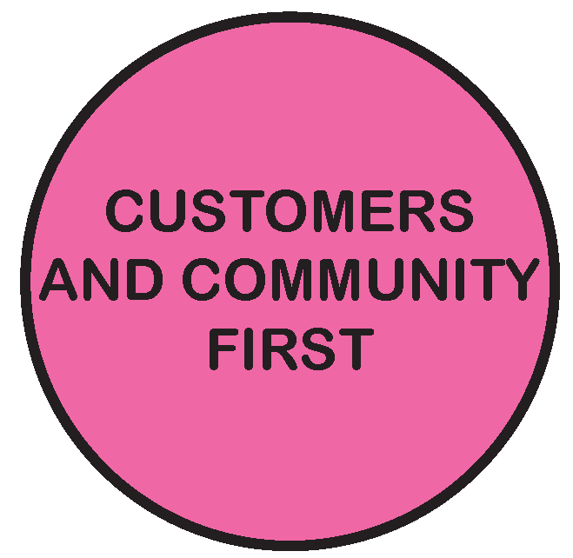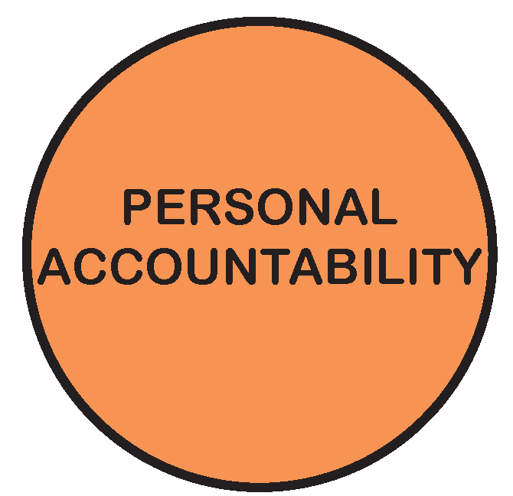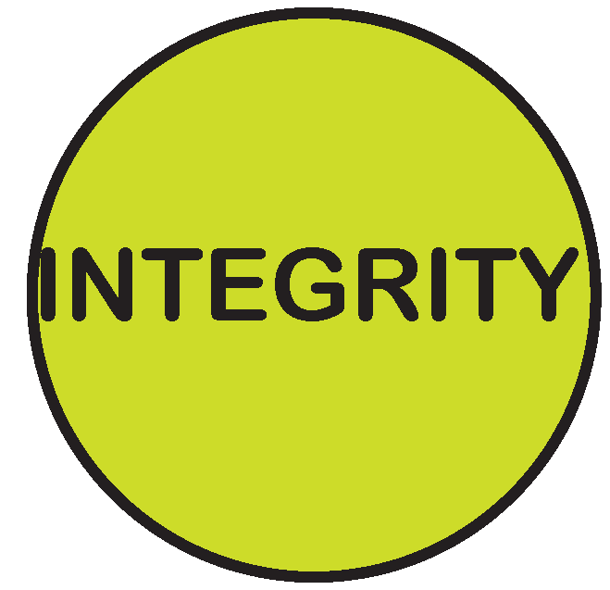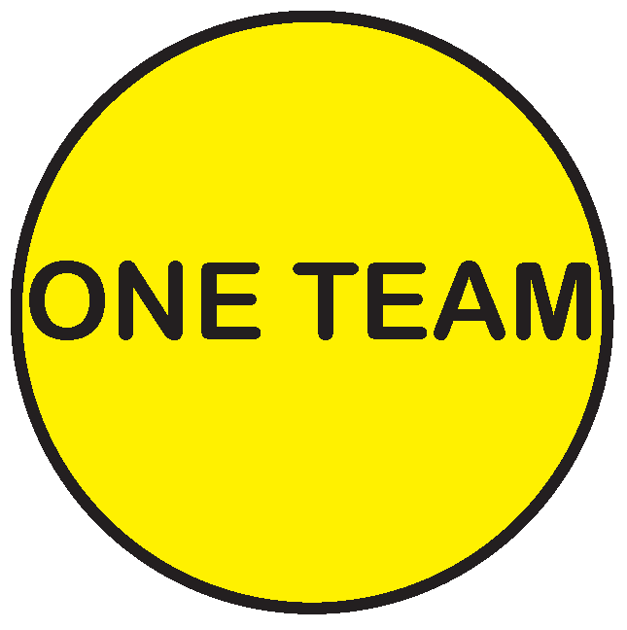

POSITION TITLE: | Team Leader Building Services
POSITION NOS: | 3415
CLASSIFICATION: | Band 8
AWARD / LWAA: | Moreland City Council Enterprise Agreement 2018
DEPARTMENT: | City Futures
BRANCH: | City Development
WORK UNIT: | Building Services
REPORTS TO: | Unit Manager Building Services and Environmental Health
SUPERVISES: | Team of staff within Building Services Unit including: Senior Building Surveyor, Building Approvals Officer, Assistant Building Surveyor and Cadet Building Surveyor
PREPARED BY: | Unit Manager Building Services and Environmental Health
APPROVED BY: | Group Manager City Development

As an employee of Moreland City Council you are required to observe all Policies, Codes of Conduct, use and wear personal protective clothing and equipment (where applicable) and follow work instructions and relevant regulations.

- POSITION OBJECTIVES:

- Supervise a number of the staff within the building compliance or approvals operations of the Building Services Unit as directed by the Unit Manager Building Services and Environmental Health assisting the Unit to provide best value services to its clients and community, in line with Council’s service standards and within statutory timeframes, where relevant.

- To deputise as the Municipal Building Surveyor as prescribed within the Building Act from time to time.

- Reduce the risk to life and safety of people & property associated with Moreland’s building stock by ensuring a compliance culture within the operations of the Building Services Unit.

- Assist the Unit Manager to constructively challenge current policies and practices and drive continuous improvements to the Building Services processes.

- Assist the Unit Manager in the developing, refining, implementing and maintaining an effective proactive and reactive building enforcement framework in order to fulfil Council’s statutory obligations and appropriately manage risk.

- Provision of efficient customer orientated building approvals services.

Value | Statement
 | We acknowledge our main purpose is to work with our Community and customers
 | I will support and value others
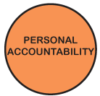 | I take pride in my work and am responsible for doing it well
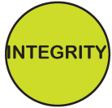 | I will do what I say
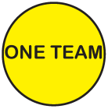 | We will work within and across the organisation to achieve community outcomes

- KEY RESPONSIBILITY AREAS:

Management

- Ensure that all functions and responsibilities are carried out in accordance with the relevant Council policies and Local Laws, and the applicable Acts, Regulations.
- Ensure that all Council decisions and/or requests are executed promptly and efficiently.
- Manage and improve systems and processes as assigned by the Unit Manager Building Services and Environmental Health.
- Provide efficient and effective administration of the team responsibilities assigned by the Unit Manager.
- Manage relevant projects as required by the Group Manager City Development or Unit Manager Building Services and Environmental Health
- Act in the position of Unit Manager Building Services and Environmental Health and fulfil the role of Municipal Building Surveyor in as required from time to time.
- Assist the development, refinement and maintenance of performance monitoring and risk management systems and complex internal and external reporting systems.
- Oversee the preparation of Council or management reports on building matters assigned by the Unit Manager Building Services and Environmental Health.

Personnel Management and Team Leadership

- Maximise the efficiency and effectiveness of the performance of a team of staff within the Building Services Unit, effectively monitoring, identifying and managing any areas of underperformance both formally and informally through agreed practice.
- Ensure that the team is appropriately structured and trained to meet the objectives and requirements of the Council.
- Provide appropriate feedback to staff as a central component of staff skills development and personal improvement.
- Develop, coach and mentor staff providing leadership that fosters innovation, creativity, harmony and continuous improvement amongst the Unit and Organisation.
- Manage and develop a professional development program for the assigned team members, recognising people development and team performance improvement opportunities.
- Complete individual staff development plans for assigned team members and take prompt corrective action where objectives or standards are not being met.
- Effectively supervise and direct staff, draft position descriptions, interview and recommend to the Unit Manager Building Services and Environmental Health appointment of staff in accordance with Council policies.
- Ensure that staff within the team, are fully briefed when commencing duties and offered ongoing training and educational opportunities during their term of employment.
- Role model leadership behaviour to the team in line with organisational values and performance objectives.

Undertake Statutory Functions
- Perform all functions empowered to the position of Municipal Building Surveyor and delegated officer of Council under Building Act and Building Regulations.

- Ensure all functions and responsibilities of assigned staff are carried out in accordance with relevant Council policies and legislative provisions.

Manage and Monitor Programs

- Implement Council’s proactive (planned inspections) and reactive (response to complaints) building programs in accordance with Council policies and procedures.

- Establish systems and processes to ensure key performance indicators for building approvals and compliance programs are actively monitored and report significant variances, with appropriate recommendations to the Unit Manager.

- Assess and recommend appropriate use of resources to achieve the goals and objectives of the Team.

- Review and manage proactive and reactive compliance programs and associated policies and procedures to ensure the programs minimise risks to property, life and safety to users of Moreland’s building stock and that building activity is in accordance with the relevant legislative provisions and Council’s vision of a safe and amenable city.

- In collaboration with the Unit Manager Building Services and Environmental Health report the team’s activities and achievements to the Group Manager City Development, the Moreland Executive Group (MEG), and Council and to external authorities, as required.

- Prepare correspondence, including drafting submissions on building approvals and control issues.

Manage Council’s Investigative and Enforcement Functions

Assist the implementation of, and compliance with policies and procedures that enable the Building Services Unit to:

- Conduct timely investigations into alleged breaches of the Building Act and Regulations

- Conduct inspections of building work and the performance of statutory functions aimed at achieving an acceptable level of building stock compliance

- Issue of statutory Notices, Orders and Infringement Notices, in accordance with the Building Act and Regulations

- Keep and ensure team member keep accurate and precise records of investigations to a standard whereby such records comply with the requirements of the Building Act and Building Regulations and could be used as evidence in legal or statutory proceedings.

- Prepare, review and authorise legal briefs and submissions to statutory tribunals and bodies for the approval of the Group Manager City Development.

- Represent Council and the office of the Municipal Building Surveyor at statutory tribunals and legal proceedings and exercise sound and professional judgement as required during these activities.

Facilitate Professional Development & Provide Advice

- Work in cooperation with others in the provision of advice on the implementation of, and compliance with, policies and procedures consistent with the Building Act, Regulations and Codes.

- Lead policy and procedure development and provide advice to the Unit Manager Building Services and Environmental Health concerning policies and processes applicable to the operation of the Unit.

- Assist the Unit Manager Building Services and Environmental Health prepare reports and submissions for and on behalf of Council, in relation to matters under the Building Act, Building Regulations, Building Code of Australia, relevant Codes and associated legislation.

- Actively participate in external building regulatory liaison groups and encourage a staff culture of professional liaison with peers and external agencies to maintain professional competence and to ensure Council’s interests are maintained and promoted.

- Assist the Unit Manager Building Services and Environmental Health to collaboratively develop and apply agreed performance benchmarks and report to the Unit Manager Building Services and Environmental Health on team performance and performance issues.

- Conduct regular team and individual team member meetings for dissemination of information and provide for uniformity of advice and implementation of legislation and Council requirements.

- Keep informed of new developments that may affect building surveying practice.

- Consult with other Council departments in regard to building compliance and building approval matters as appropriate and provide specialist advice to other Council officers.

- Provide timely advice and assistance to the Unit Manager Building Services and Environmental Health Group Manager City Development, Director Planning & Economic Development, Councillors and Senior Management.

- Manage legal practitioners and other consultancies assigned by the Unit Manager to assist in building matters.

Development and involvement in policies and guidelines to ensure consistency and certainty of decision-making and disseminating information

- Identify the need for, and lead as well as contribute to the development of policy and procedures in consultation with the Unit Manager Building Services and Environmental Health.

- Assist the Unit Manager Building Services and Environmental Health to review the procedures and ensure procedures are documented and adhered to by the team members.

- Assist the Unit Manager Building Services and Environmental Health to develop procedures and tools to improve the consistency and performance of building compliance and building approvals systems.

- Be aware of pending legislation, changes to the building system and recommend to the Unit Manager Building Services and Environmental Health changes to building systems.

After Hours Work
- Participate in an after-hours emergency response roster.

PERFORMANCE CRITERIA
Performance Criteria for this position include assist the Unit Manager Building Services and Environmental Health in the:
- Delivery of Council Plan and Service Unit responsibilities
- Delivery of initiatives and projects in line with allocated budgets and timelines
- A commitment to staff development, innovation and continuous improvement in service delivery
- Effective leadership and management to the Building Services unit to ensure the effective delivery of policy and service functions

Performance criteria will be reviewed annually in conjunction with the Unit Manager Building Services and Environmental Health. The criteria form part of the Officer’s Employment Contract and are the basis for Performance Reviews along with other performance objectives and key performance indicators.

Audit & Risk Management
- Behave ethically when undertaking duties, ensure strong and effective fraud and corruption controls are established and regularly reviewed for the work area and provide advice and educate Branch staff.
- Lead risk management practice by identifying, assessing, influencing, preventing, treating and monitoring risk relevant to the role, the work area and broader organisation.

Community Engagement
Champion customer-centric behaviours and staff and community engagement that supports collaboration and richer outcomes

Continuous Improvement
- Assist the Unit Manager to implement and maintain Continuous Improvement System standards and procedures.
- Support a continuous improvement culture through the building approvals and compliance service.

Environmental Sustainability
- Incorporate Council’s environmental sustainability objectives and targets into projects and programs.
- Promote and participate in a culture of environmental sustainability.

Occupational Health & Safety
- Implement and maintain health and safety standards and procedures according to legislation and consistent with MoreSafe.
- Demonstrate effective leadership on OHS matters

Diversity & Equity
- Undertake all duties with an awareness of and sensitivity to diversity and equity in accordance with Council policy.

Records Management
- Ensure that complete and accurate records relating to business activities are maintained and stored in Council’s electronic records management system (including correspondence, reports, emails) in accordance with Council policy.

Other duties
- Required to undertake other duties as directed.

- ORGANISATIONAL RELATIONSHIP:

Reports to: Unit Manager Building Services and Environmental Health

Supervises: A team of up to 5 staff within the Building Services Unit

Internal Liaison: All Council Departments

External Liaison: Victorian Building Authority and its statutory boards
Registered building practitioners
Architects
Metropolitan Fire and Emergency Services Board
General community
Clients
Utilities
Victorian WorkCover Authority
Registrar of courts
Bureau of Statistics
Solicitors
Other councils
Professional liaison groups, (AIBS, VMBSG and others)
Heritage Victoria
Consumer Affairs Victoria
Victorian Civil and Administrative Tribunal
Department of Environment Water Land & Planning.

- ACCOUNTABILITY AND EXTENT OF AUTHORITY:
- The Team Leader is directly accountable to the Unit Manager Building Services and Environmental Health for the overall conduct and performance of the Team in relation to the attainment of Council’s corporate objectives and the implementation of Council’s polices which relate to the Building Services function.
- Ensure the operations and functions of the team members and the Unit are carried out in a safe and compliant manner to approved standards, within budget limitations and in accordance with Council’s Best Value framework.
- Ensure compliance with all legislative requirements relating to the functions of the Building Services Unit.
- Liaise and co-operate with other Departments to bring about an effective corporate team approach to meeting Building Act and Council objectives.
- Required to provide support to the Unit Manager Building Services and Environmental Health and Group Manager City Development to achieve organisational goals. Ability to be creative, innovative and sensitive to the needs of staff to obtain support for projects. To develop strategic objectives whilst operating within the limit of available resources in consultation with the Unit Manager Building Services and Environmental Health.
- To give effect to all decisions in a fair and timely fashion for matters within the province of the Municipal Building Surveyor as they relate to policy, statute or delegated authority.
- Accountable for implementation of human resource policies and procedures to ensure a high level of performance and motivation from staff.
- Act in the position of Unit Manager Building, as required.

- JUDGEMENT AND DECISION MAKING:

- The position exercises the authority and accountability as delegated by the Municipal Building Surveyor as defined in the Building Act.

- The position requires the application of specialist knowledge to situations, which require the understanding and interpretation of building legislation and codes to new and sometimes complex situations. Such situations require a high level of problem solving using methods, procedures and processes generally developed from building and local government management and administration theory or precedent. However the position requires the need to recognise when these established techniques are not appropriate to a given situation.

- The position requires judgements and decisions, frequently involving the protection of life and safety, guided by the interpretation of building legislation and/or Council policies and procedures, to be made during investigations and inspections and sometimes in emergency situations after normal business hours.

- The position requires a knowledge of policy development, particularly in the area of continuous improvement in relation to building surveying practice. The ability to research and analyse and service options before a recommendation is made is essential.

- Exercise judgement to refer sensitive and contentious issues for discussion/consultation with the Unit Manager Building Services and Environmental Health.

- SPECIALIST KNOWLEDGE AND SKILLS:

- Sound knowledge of local government and private building surveying practice.

- Detailed knowledge of the Building Act, Building Regulations, Building Code of Australia, Codes , Practice & Advisory Notes and subordinate legislation, the underlying principles of their application and an ability to apply legislative provisions, where appropriate, to solve problems.

- Sound understanding of legal and risk management requirements associated with building control matters.

- Demonstrated ability to manage investigations and non-compliant matters to timely resolution.

- Sound understanding of the principles of continuous improvement and Best Value.

- Ability to prepare and implement policy and achieve Council objectives.

- SUPERVISORY SKILLS:

- Demonstrated ability to proactively lead and inspire staff to work with a team spirit, focused on and committed to organisational goals and objectives.

- Ability to achieve results within set timeframes against conflicting priorities.

- An understanding of and ability to implement Council’s Human Resources policies and practices, including the MCC Enterprise Agreement and Victorian Local Authorities Award 2001, equal opportunity and occupational health and safety policies, recruitment and selection procedures and techniques, position descriptions and employee development schemes. The development and implementation of long-term Unit staffing strategies is also expected of the position.

- Excellent time management skills and the ability to function under pressure.

- Highly developed skills in people management skills and demonstrated experience in leadership of building approvals and compliance teams.

- Ability to effectively delegate to and motivate staff in a supportive manner.

- INTERPERSONAL SKILLS:

- Highly developed interpersonal skills with the ability to effectively communicate and negotiate with industry professionals, management, elected members, staff and the community.

- Ability to work effectively and make decisions under pressure, including prompt resolution of life and property safety matters in an emergency situation.

- Ability to disseminate technical requirements and decision making to stakeholders commensurate with their level of knowledge and experience.

- Excellent public relations and conflict negotiation skills.

- Highly developed capacity to lead, motivate and managing staffing issues in a team leadership role with sound knowledge of human resources policy and procedures.

- Ability to prepare correspondence, Council and management reports and industry submissions, on behalf of Council or the Executive Leadership.

- Ability to network with peers within the local government sector and key stakeholders within the building industry context, so as to remain abreast of best industry practice.

- QUALIFICATIONS AND EXPERIENCE:

- Registration as a building surveyor – unlimited with the Building Practitioners Board.

- Postgraduate qualifications in performance based Building and Fire codes.

- Postgraduate qualifications in management/leadership or demonstrated experience in managing and leading a functional team is highly desirable.

- Excellent written and verbal communication skills and highly developed interpersonal skills.

- Sound knowledge and experience in the functions and operations of a Council Municipal Building Surveyor and Private Building Surveying practice.

- Sound understanding and demonstrated use of PC based computer system software, particularly software used in the management of municipal building services data management.

- A current driver’s licence is required.

PHYSICAL REQUIREMENTS OF THE POSITION

TASK ANALYSIS

In the course of his/her duties, a person in this position may be expected to work in or be exposed to the following conditions or activities as marked.

Condition/Activity | Constant | Frequent | Occasional | N/A
Manual handling weights -above 10kgs  -below 10kgs | ( )  ( ) | ( )  ( ) | ( x )  ( x ) | ( )  ( )
Manual handling frequency | ( ) | ( ) | ( x ) | ( )
Repetitive manual work | ( ) | ( ) | ( x ) | ( )
Repetitive bending/twisting | ( ) | ( ) | ( x ) | ( )
Working with arms above head | ( ) | ( ) | ( x ) | ( )
Lifting above shoulder height | ( ) | ( ) | ( x ) | ( )
Using hand tools – vibration/powered | ( ) | ( ) | ( ) | ( x )
Operating precision machinery | ( ) | ( ) | ( ) | ( x )
Close inspection work | ( ) | ( ) | ( x ) | ( )
Wearing hearing protection | ( ) | ( ) | ( x ) | ( )
Wearing eye protection | ( ) | ( ) | ( x ) | ( )
Working in dusty conditions | ( ) | ( ) | ( x ) | ( )
Working in wet/slippery conditions | ( ) | ( ) | ( x ) | ( )
Wearing Gumboots | ( ) | ( ) | ( x ) | ( )
Wearing safety shoes/boots (steel cap) | ( ) | ( ) | ( x ) | ( )
Working with chemicals/solvents/detergents | ( ) | ( ) | ( ) | ( x )
Washing hands with soap (hygiene) | ( ) | ( ) | ( x ) | ( )
Working at heights | ( ) | ( ) | ( ) | ( x )
Working in confined spaces | ( ) | ( ) | ( ) | ( x )
Working in chillers (+4 degrees C) | ( ) | ( ) | ( ) | ( x )
Performing clerical duties | ( ) | ( x ) | ( ) | ( )
Working on a keyboard | ( ) | ( x ) | ( ) | ( )
Driving cars and/or trucks | ( ) | ( ) | ( x ) | ( )
Other (please specify)_______________________ | ( ) | ( ) | ( ) | ( x )

________________________

- KEY SELECTION CRITERIA

- A Degree or Advanced Diploma in Building Surveying or other relevant experience and qualifications together with full registration with the Victorian Building Authority (Building Surveyor Unlimited).

- Extensive technical knowledge and experience in the functions and operations of a Municipal Building Surveyor, the Building Act 1993, Building Regulations 2006 with a strong understanding of Private Building Surveying practice and ability to apply this knowledge.

- Proven experience & capacity to proactively lead and motivate a team of staff to work within a constructive team culture focused on and committed to organisational goals and objectives.

- Sound understanding of legal and risk management requirements associated with building services within a local government context.

- Demonstrated ability to manage investigations and non-compliant matters to timely resolution.

- Excellent written and verbal communication skills and highly developed interpersonal skills.

- Demonstrated experience in the preparation and implementation of a compliance framework and associated policy & procedures to achieve Council objectives.

- Demonstrated experience in the continuous improvement of building systems and processes to deliver improved team performance and customer service outcomes

- Proven capacity to adapt, interpret and utilise service data and reports to communicate and influence improved service delivery.

- A current driver’s licence is required.

