POSITION DESCRIPTION

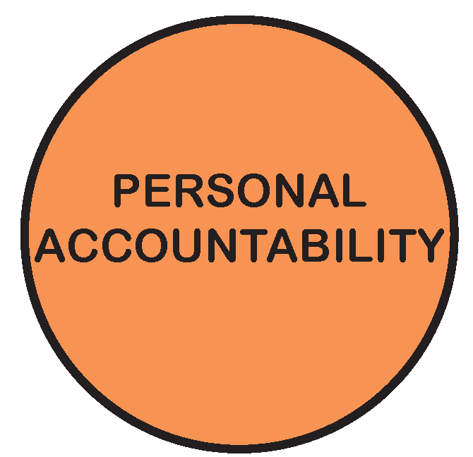

POSITION TITLE: | Immunisation Nurse - Casual
POSITION NO: | 2685, 46,974
CLASSIFICATION: | Immsal
AWARD / LWAA: | Moreland City Council Enterprise Agreement 2018
DEPARTMENT: |  | Social Development
BRANCH: |  | Social Policy and Early Years
WORK UNIT: |  | Maternal and Child Health and Immunisation Services
REPORTS TO: |  | Maternal and Child Health Coordinator
SUPERVISES: |  | Nil
PREPARED BY: |  | Unit Manager Maternal and Child Health
APPROVED BY: |  | Unit Manager Maternal and Child Health

As an employee of Moreland City Council you are required to observe all Policies, Codes of Conduct, use and wear personal protective clothing and equipment (where applicable) and follow work instructions and relevant regulations.

- POSITION OBJECTIVES:

To provide a pre-school and school immunisation service which is effective, safe, convenient, reaches the maximum number of the target group and is in accordance with the National Health & Medical Research Council recommended schedule.

To provide immunisation opportunities for special risk groups in addition to the National Health & Medical Research Council recommended schedule.

Value | Statement
 | We acknowledge our main purpose is to work with our Community and customers
 | I will support and value others
 | I take pride in my work and am responsible for doing it well
 | I will do what I say
 | We will work within and across the organisation to achieve community outcomes

- KEY RESPONSIBILITY AREAS:

- Pre-School and School Immunisation Programs:

- Implement the National Immunisation Program within the immunisation team at pre-school and school immunisation sessions as rostered
- Administer vaccines at Council immunisation sessions.
- Administration:

- Assist with data processing required to deliver the program through documentation at sessions, tallying and balancing of vaccines given at both pre-school and student sessions and if required assisting with data processing within the ImPS program

Continuous Improvement
- Contribute to the effective implementation of the Moreland Continuous Improvement System standards and procedures.

Environmental Sustainability
- Incorporate Council’s environmental sustainability objectives and targets into projects and programs.
- Promote and participate in a culture of environmental sustainability.

Occupational Health & Safety
- Contribute to maintaining health and safety standards and procedures according to legislation and consistent with MoreSafe.
- Demonstrate effective leadership on OHS matters

Diversity & Equity
- Undertake all duties with an awareness of and sensitivity to diversity and equity in accordance with Council policy.

Other duties
- Required to undertake other duties as directed.

- ORGANISATIONAL RELATIONSHIP:

Reports to: Coordinator Maternal and Child Health and Immunisation Services

Supervises: Nil

Internal Liaison: Municipal Immunisation Nurses
Immunisation Administrative Officer
Maternal Child & Health staff
Municipal staff requiring vaccination.

External Liaison: Children and Parents
Teachers and Principals

Health Department Victoria
Other members of the public

JOB CHARACTERISTICS RELEVANT TO THE POSITION

The following Job Characteristics should be read in the context of the definitions describing the characteristics required of a Immunisation employee as outlined in Part A of the Enterprise Agreement (Victorian Local Authorities Award 2012) Section 11.3 and Section 12.

- ACCOUNTABILITY AND EXTENT OF AUTHORITY:

Accountability

The person will be responsible for:

- The effective implementation of the National Immunisation Program within Council’s
Immunisation Program.
- Achievement of program objectives.
- Actions and decisions made at Immunisation Sessions
- Cold Chain management
- Maintaining 20 hours of continuous professional development (CPD)

Extent of Authority

- Authority to prepare and administer vaccines according to the National Immunisation Program
as in the latest edition of the Australian Immunisation Handbook.
- Once trained may be required to prepare for, and be in charge of an immunisation session in
the absence of permanent staff

- JUDGEMENT AND DECISION MAKING:

The person needs to:

- Keep abreast of changes to the Immunisation Program.
- Constantly review the most effective procedures and professional techniques
required to undertake duties.
- Be conscious that decision making impacts on infants, children and parents.
- Apply specialist skills to address problems during Immunisation sessions.

- SPECIALIST KNOWLEDGE AND SKILLS:

- A thorough knowledge of the National Health and Medical Research Council Immunisation
Procedures as in the latest edition of the Australian Immunisation Handbook.
- “Strive for Five” Cold Chain Management( Dept of Health and Ageing)
- The ability to competently administer intramuscular, subcutaneous and oral vaccines.
- The ability to competently use a computer and printer.
- Recent CPR and Anaphylaxis / Immunisation Emergency training
- Assist in the development of immunisation catch ups as required

- MANAGEMENT SKILLS:

- The ability to carry out duties with a minimum of supervision.
- The ability to manage time and to work steadily toward achieving objectives.

- INTERPERSONAL SKILLS:
- The ability to communicate clearly and patiently with a broad range of people from varying background.
- The ability to educate, assist and advise members of the public on issues relating to immunisation.
- To be an effective team member.
- Sound written and oral skills.

- QUALIFICATIONS AND EXPERIENCE:

Essential:
- Qualified Registered Nurse holding a current National Registration.

- Qualifications as an Accredited Vaccinator

- Current CPR and Anaphylaxis/ Immunisation Emergency certificate.

- Have Personal Professional Indemnity Insurance

- A current Victorian Driver’s Licence.

- A current Working with Children Check.

- A current Police Check

Desirable:
- Previous experience or exposure to mass immunisation campaigns particularly within local
government.

- A basic knowledge of the ImPS software program.

- PHYSICAL REQUIREMENTS OF THE POSITION

TASK ANALYSIS

In the course of his/her duties, a person in this position may be expected to work in or be exposed to the following conditions or activities as marked.

Condition/Activity | Constant | Frequent | Occasional | N/A
Manual handling weights -above 10kgs  -below 10kgs | ( )  ( ) | ( )  (√) | (√)  ( ) | ( )  ( )
Manual handling frequency | ( ) | (√) | ( ) | ( )
Repetitive manual work | ( ) | ( ) | (√) | ( )
Repetitive bending/twisting | ( ) | (√) | () | ( )
Working with arms above head | ( ) | ( ) | (√) | ( )
Lifting above shoulder height | ( ) | ( ) | (√) | ( )
Using hand tools – vibration/powered | ( ) | ( ) | ( ) | (√)
Operating precision machinery | ( ) | ( ) | ( ) | (√)
Close inspection work | ( ) | ( ) | ( ) | (√)
Wearing hearing protection | ( ) | ( ) | ( ) | (√ )
Wearing eye protection | ( ) | ( ) | (√ ) | ( )
Wearing a mask | ( ) | (√ ) | ( ) | ( )
Working in wet/slippery conditions | ( ) | ( ) | ( ) | (√)
Wearing Gumboots | ( ) | ( ) | ( ) | (√)
Wearing safety shoes/boots (steel cap) | ( ) | ( ) | ( ) | (√)
Working with chemicals/solvents/detergents | ( ) | ( ) | ( ) | (√)
Washing hands with sanitising gel (hygiene) | (√ ) | ( ) | ( ) | ( )
Working at heights | ( ) | ( ) | ( ) | (√)
Working in confined spaces | ( ) | ( ) | ( ) | (√)
Working in chillers (+4 degrees C) | ( ) | ( ) | ( ) | (√)
Performing clerical duties | ( ) | ( ) | (√) | ( )
Working on a keyboard | ( ) | ( ) | (√) | ( )
Driving cars and/or trucks | ( ) | () | (√) | ( )
(please specify)_______________________ | ( ) | ( ) | ( ) | ( )
Other special features (e.g. nature of chemicals, travelling requirements, etc):
Exposure to infectious conditions from clients

- KEY SELECTION CRITERIA

- A thorough knowledge of the National Health and Medical Research Council Immunisation Procedures as in the latest edition of the Australian Immunisation Handbook.

- “Strive for Five” Cold Chain Management( Dept of Health and Ageing)

- Qualified Registered Nurse holding a current National Registration.

- Qualifications as an Accredited Vaccinator

- Hold a current CPR and Anaphylaxis/ Immunisation Emergency certificate.

- Have Personal Professional Indemnity Insurance

- A current Victorian Driver’s Licence.

- A current Working with Children Check.

- A current Police Check

- Previous immunisation experience

SIGNATURE PAGE

This is to certify that the position description has been drawn up/reviewed by both employee & Supervisor/Manager.

Date / /
(Staff member’s signature)

Date / /
(Supervisor/Manager’s signature)

Please send original signed document to the HR Officer (Human Resources) and also forward an electronic version to be filed in the Position Description database.

