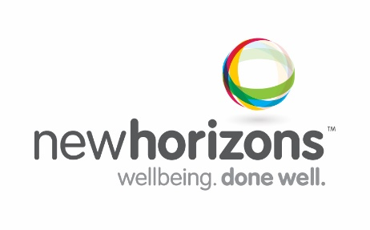
Position Description
Role/Department: Peer Support Worker
Role reports to: Customer Service Manager
Classification/Level: SCHADS 3 (SACS 3) Location: Tweed Heads
Our Vision and Organisation’s Purpose
Communities collaborating to create opportunity and improve quality of life. We provide innovative services which support individuals, strengthen communities and enhance physical, social and emotional wellbeing.

Position Summary and Purpose
This role is designed to equip PIR participants and their families with information, skills and resources to be confident, experienced decision makers in NDIS and effective self-advocates in exercising choice and control. Peer Workers are people with lived experience of mental health recovery who use their common experience to support and inspire hope and recovery in others and ultimately to positively influence participant outcomes. Peer Workers in PIR will focus on the following primary areas: a) supporting participants to prepare for NDIS b) facilitating a strong, active consumer network within their region and c) supporting applicants who aren’t eligible for PIR to connect with local services and natural supports that meet their needs and d) strengthening recovery oriented approaches in the region.

Reporting lines and stakeholder relationships
Internal - Works positively with all staff. May interact with Senior Managers
External – Communicates and interacts regularly with other service providers, Government agencies, consultants, health professionals, family members/guardians and community members. May interact with senior staff of PIR partner organisations.
Key Result Areas | 1-5
Key Tasks:
Key Peer Worker responsibilities:
- To be a powerful role model and evidence of the reality of recovery to foster hope, self-management and social inclusion.
- To work within PIR, the broader mental health service system and the community to support positive cultural change where people are respected as their own greatest resource and adverse life experiences can be sources of resilience and personal growth.
- To work collaboratively within PIR to design, develop and deliver peer lead information and education for PIR participants, carers and families.
- Work collaboratively with Support Facilitators to strengthen factors shown to sustain recovery (eg: employment, reconnection with family/culture, purposeful activities and achievement, having a strong sense of belonging and community inclusion).
- Establish and facilitate the development of consumer groups (or work with existing consumer networks in the region) to help strengthen preparation leading up to NDIS transition through peer learning initiatives, case studies, information and pre-planning activities.
- To deliver and evaluate accredited recovery workshop packages that help participants to identify and use their strengths and skills to transform their situation by exploring choices and taking responsibility for those choices.
- Follow up with ineligible PIR participants to offer time limited support to assist people with information about service and natural supports available in the local area to meet their needs.
- Work collaboratively with NDIA and other agencies to support an NDIS transition that maximises choice and independence for people with psycho-social disabilities.
- To proactively stay abreast of new developments in peer work roles within NDIS and recommend new programs and opportunities for consortium agencies in a consumer market.
- Consult and provide information, resources and where appropriate advice to the clinical and non-clinical mental health sectors on ways to strengthen recovery oriented services and environments.
- Actively engage in team and individual supervision and take responsibility for own development in the current role and future career progression.
Skills/Knowledge/Experience – Essential & Desirable
Key Selection Criteria
- Minimum Certificate IV or relevant qualification or currently working towards e.g. Certificate IV in Mental Health, Community Services/Development;
- Personal lived experience of mental health recovery;
- A positive and person-centred approach with a strong guiding belief about everyone’s capacity to self-right and grow within and beyond their current circumstances;
- A deep understanding from combined lived experience and professional development about factors that support recovery and a proven ability to use this to positively support others on their recovery journey;
- Highly developed interpersonal and relationship skills and past success in using own experience to effectively challenge assumptions and to promote recovery oriented approaches;
- Well-developed written and verbal communication skills, strong administrative skills and proficient use of technology (database, mobile devices);
- A strong community development approach with group-work and facilitation skills to support individuals, families and groups to maximise self-agency, control and choice;
- Personal development and self-awareness including mastery with own wellness and confidence in own resilience;
- Demonstrated professional approach to the role including maintaining professional boundaries;
- Current drivers licence, satisfactory police check and current working with children check.

