Role: Community Personal Care Attendant (PCA)
Task Description  The role of the Community PCA is to support clients to remain independent in the home and community, for as long as is safe. This is achieved by completing the following tasks  - Personal care support – this involves assisting clients with showering and washing (body and hair) in confined spaces, shaving, drying and dressing, oral care (teeth cleaning, denture cleaning) and skin care.  - Medication support – this involves assisting with administration of medication to clients or observing clients self-administering medication.  - Attendance and transport for medical and allied health appointments.  - Attendance and transport for grocery and social needs.  - The above involves transporting clients, typically completed with the PCA’s own vehicle. This also involves transferring any gait aids in/out of the vehicle. Travel is typically kept to 1 hour maximum, each way. Gait aids commonly weigh <5kg.  - Home care support – this can involve vacuuming, sweeping, mopping, stripping linen, making beds, completing laundry, hanging laundry, cleaning toilets and bathrooms and wiping down kitchen areas. De-cluttering of residences is ad-hoc.  Infrequently two Community PCA’s will attend a residence together, for safety reasons. Furthermore, Community PCA’s are encouraged to use their judgement to leave or not enter a residence if it is considered unsafe.  Modification Options  - Community PCA’s can return to select, not all, duties listed above if restrictions limit the PCA from performing all duties. |  | Body Map  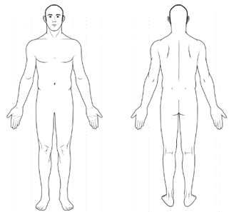
 |  | Demands Category
 |  | Physical Demand |  | Emotional Demand
 |  | Cognitive Demand |  | Role Demand

Photos
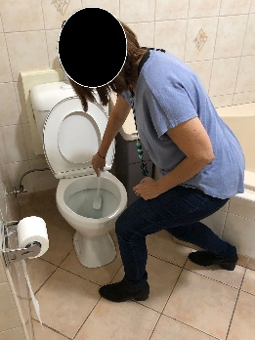 | 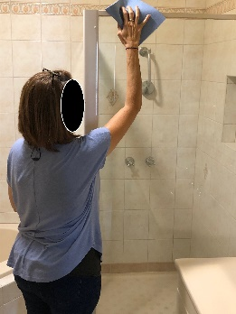 |  | 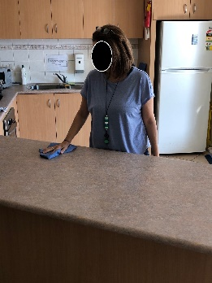
Toilet cleaning | Shower glass cleaning |  | Wiping kitchen benches
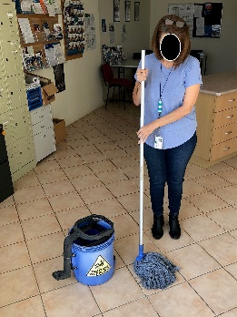 | 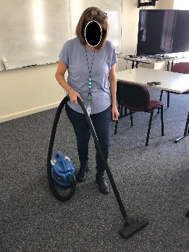
Mopping | Vacuuming |  | Computer-based activity

Job Activity | Frequency |  |  | Comments
 | O  <33% | F  33-66% | C  >66%

Physical Demands
Neck movement:
Trunk movement:
Shoulder movement: above shoulder height |  |  |  | Wiping glass (not overstretched reaching).
Shoulder movement: below shoulder height
Elbow movement:
Hand movement: |  |  |  | Grasping items – cloths, toilet brushes, vacuum, mop, steering wheel, typing, writing notes etc.
Foot movement:
Standing:
Sitting: |  |  |  | Driving, entering case notes / documentation.
Walking:
Squatting / kneeling: |  |  |  | Cleaning toilets, making beds, laundry tasks
Lifting:
Average weight: 2-5kg |  |  |  | Green bags of groceries, walking aids.
Maximum weight: 10-12kg |  |  |  | 24 packs of drinks, average <twice a week.
Climbing / stairs: |  |  |  | Stair climbing at residence or in community.
Push / pull (clothing bins, Ladders): |  |  |  | Clients in wheelchairs, grocery trolley, bins, vacuum and mop bucket (if on wheels).
Sensory:

Psychological Demands
Reading comprehension
Oral comprehension
Oral expression |  |  |  | Communicating with stakeholders.
Writing
Numerical reasoning
Critical thinking
Attention to detail
Judgment and decision making |  |  |  | Need to judge environment and whether safe.
Active listening
Memory
Concentration

Emotional Demands
Social perceptiveness |  |  |  | Need to be aware of client’s behaviour.
Stress tolerance
Persuasion
Dealing with customers |  |  |  | Frequently interacting with clients within role.
Resolving conflicts & negotiating with others
Deal with unpleasant or angry people |  |  |  | Sexually inappropriate language at times.
Work with work group or team |  |  |  | Attend residence with colleague infrequently.

Role Demands
Adaptability and flexibility |  |  |  | Requirements may change once arrived to appointment / job.
Time pressure |  |  |  | Manage daily appointments within constraints
Time management
Coordinate and lead others
Impact of decisions on co-workers or company results

Key Definitions
Term | Definitions
Physical Demands
Sedentary Work | Manual handling involving < 5kg occasionally or < 1kg frequently to lift, carry, push, pull or otherwise move objects. Sedentary work involves sitting most of the time, but may involve walking or standing for brief period of time. Jobs are Sedentary if walking and standing are required only occasionally and all other Sedentary criteria are met. Sedentary work may involve repetitive action (i.e. typing).
Light Work | Manual handling < 10kg of force occasionally, or < 5kg of force frequently, or a negligible amount of force constantly to move objects. Physical demand requirements are in excess of those for Sedentary work. Even though the weight lifted may be only a negligible amount, a job should be rated as Light Work:  When it requires walking or standing to a significant degree: or  When it requires sitting most of the time but entails pushing or pulling of arm or leg controls  When the job requires working at a production rate pace entailing the constant pushing or pulling of materials even though the weight of those materials is negligible
Medium Work | Manual handling 10kg to 25kg occasionally, or 5kg to 10kg frequently, or up to 5kg constantly to move objects. Physical demand requirements are in excess of those for Light Work.
Heavy Work | Manual handling 25 to 50kg occasionally, or 10 to 25kg frequently, or 5 to 10kg constantly to move objects. Physical demand requirements are in excess of those required for medium work.
Psychological Demands
Lowest | Cognitive:  < 3 cognitive demands in the frequent or constant on the frequency rating and / or < 5 occasional ratings | Emotional:  < 3 emotional demands in the frequent or constant on the frequency rating | Role:  < 2 role demands in the frequent or constant on the frequency rating
Light | Cognitive:  Between 3 & 5 cognitive demands in the frequent or constant on the frequency rating and / or between 6-7 occasional ratings | Emotional:  Between 3 & 4 emotional demands in the frequent or constant on the frequency rating | Role:  2 role demands in the frequent or constant on the frequency rating
Medium | Cognitive:  Between 6 & 8 cognitive demands in the frequent or constant on the frequency rating and / or 8-10 occasional ratings | Emotional:  Between 5 & 6 emotional demands in the frequent or constant on the frequency rating | Role:  3-4 role demands in the frequent or constant on the frequency rating
High | Cognitive:  >8 cognitive demands in the frequent or constant on the frequency rating and / or 11 plus occasional ratings | Emotional:  > 6 emotional demands in the frequent or constant on the frequency rating | Role:  5 role demands in the frequent or constant on the frequency rating

