Role: Food Service Assistant (FSA)
Task Description  - Food Service Assistants assist in the kitchen to serve and pack meals.  - Throughout the shift, FSA’s are required to move meals on and off trays on trolleys, which are then moved in and out of the fridge/freezers. These trolley shelves range from ground level to above head height, with trays ranging from 1-10kg each.  - Meals are sorted into tubs based on date and type - to sort ready for the days/ahead.  - FSA are required to check temperature of food to determine when to move between fridges and freezers and when lids can be placed on trays of food once chilled.  - FSA serve meals from trays onto plates and then cling wrap plates to place on serving trolleys to be taken away to the rest of the facility or off to other sites.  - Surfaces are wiped down between bouts of dishing up meals and any used trays are taken to wash area, food scraps are scraped from trays and cutlery and items are left for assigned FSA to complete dishes.  - FSA complete 2 hours of dish washing per shift. This requires scraping off of food scraps, spraying down items, manually cleaning down items, placing of items into pull down dish wash machine and manually drying of items. Items then stacked away on storage racks and shelves (below and above shoulder height).  - FSA assist unloading of truck when deliveries arrive.  Modification Options  - Heavier lifting may be partner assisted by other kitchen employees. |  | Body Map  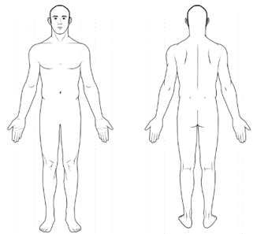
 |  | Demands Category
 |  | Physical Demand |  | Emotional Demand
 |  | Cognitive Demand |  | Role Demand

Photos
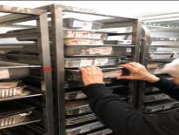 | 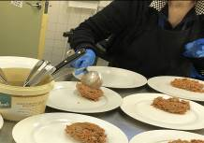 |  | 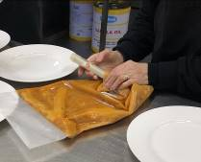
Stacking trolley with food trays | Serving dishes |  | Checking temperatures
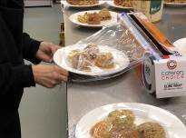 | 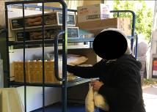 |  | 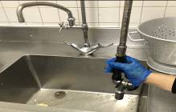
Wrapping food | Unloading deliveries |  | Dishes

Job Activity | Frequency |  |  | Comments
 | O  <33% | F  33-66% | C  >66%

Physical Demands
Neck movement |  |  |  | Looking down to bench top and lower trolley shelves. Looking up to high trays on trolley
Trunk movement |  |  |  | Occurs to move trolleys around kitchen, to load / unload trays and assist unpacking deliveries
Shoulder movement: above shoulder height |  |  |  | May occur to access high storage
Shoulder movement: below shoulder height |  |  |  | Access low storage, prepare meals, use utensils
Elbow movement |  |  |  | Occurs when lifting and servicing plates
Hand movement |  |  |  | Occurs when lifting and servicing plates
Foot movement |  |  |  | Occurs when walking around kitchen
Standing |  |  |  | When standing at bench to dish out plates
Sitting | Not applicable
Walking |  |  |  | Occurs to move around kitchen
Squatting / kneeling |  |  |  | When collecting stock from low storage and loading and unloading trays
Lifting:
Average weight |  |  |  | May include plates, food items, and trays.
Maximum weight: |  |  |  | May include full trays of food (10kg), stock from delivery (10-15kg boxes to decant).
Climbing / stairs | Not applicable
Push / pull |  |  |  | Push/pull of food trolleys
Sensory |  |  |  | Required to safely work in kitchen area

Psychological Demands
Reading comprehension |  |  |  | To read food orders/dietary requirements
Oral comprehension |  |  |  | To follow instruction from other kitchen staff
Oral expression |  |  |  | Must be able to speak with other staff
Writing |  |  |  | Must be able to label food items
Numerical reasoning |  |  |  | Must be able to count stock/plates/servings etc.
Critical thinking |  |  |  | Checking temperatures of food and ensuring food safety standards upheld
Attention to detail |  |  |  | Required to ensure meals served accurately
Judgment and decision making |  |  |  | When meals need to be moved around kitchen
Active listening |  |  |  | Must be able to listen to other kitchen staff
Memory |  |  |  | Required to recall amount of servings needed
Concentration |  |  |  | Required to focus on each task to be completed

Emotional Demands
Social perceptiveness |  |  |  | Required to work in team environment
Stress tolerance |  |  |  | Required due to busy nature of shifts
Persuasion | Not applicable
Dealing with customers | Not applicable
Resolving conflicts & negotiating with others | Not applicable
Deal with unpleasant or angry people | Not applicable
Work with work group or team |  |  |  | Team environment in kitchen

Role Demands
Adaptability and flexibility |  |  |  | Required to work with and around co-workers
Time pressure |  |  |  | Busy schedule to ensure all tasks completed
Time management |  |  |  | To ensure tasks completed in timely manner
Coordinate and lead others |  |  |  | Team environment
Impact of decisions on co-workers or company results |  |  |  | Required to uphold food safety

Key Definitions
Term | Definitions
Physical Demands
Sedentary Work | Manual handling involving < 5kg occasionally or < 1kg frequently to lift, carry, push, pull or otherwise move objects. Sedentary work involves sitting most of the time, but may involve walking or standing for brief period of time. Jobs are Sedentary if walking and standing are required only occasionally and all other Sedentary criteria are met. Sedentary work may involve repetitive action (i.e. typing).
Light Work | Manual handling < 10kg of force occasionally, or < 5kg of force frequently, or a negligible amount of force constantly to move objects. Physical demand requirements are in excess of those for Sedentary work. Even though the weight lifted may be only a negligible amount, a job should be rated as Light Work:  When it requires walking or standing to a significant degree: or  When it requires sitting most of the time but entails pushing or pulling of arm or leg controls  When the job requires working at a production rate pace entailing the constant pushing or pulling of materials even though the weight of those materials is negligible
Medium Work | Manual handling 10kg to 25kg occasionally, or 5kg to 10kg frequently, or up to 5kg constantly to move objects. Physical demand requirements are in excess of those for Light Work.
Heavy Work | Manual handling 25 to 50kg occasionally, or 10 to 25kg frequently, or 5 to 10kg constantly to move objects. Physical demand requirements are in excess of those required for medium work.
Psychological Demands
Lowest | Cognitive:  < 3 cognitive demands in the frequent or constant on the frequency rating and / or < 5 occasional ratings | Emotional:  < 3 emotional demands in the frequent or constant on the frequency rating | Role:  < 2 role demands in the frequent or constant on the frequency rating
Light | Cognitive:  Between 3 & 5 cognitive demands in the frequent or constant on the frequency rating and / or between 6-7 occasional ratings | Emotional:  Between 3 & 4 emotional demands in the frequent or constant on the frequency rating | Role:  2 role demands in the frequent or constant on the frequency rating
Medium | Cognitive:  Between 6 & 8 cognitive demands in the frequent or constant on the frequency rating and / or 8-10 occasional ratings | Emotional:  Between 5 & 6 emotional demands in the frequent or constant on the frequency rating | Role:  3-4 role demands in the frequent or constant on the frequency rating
High | Cognitive:  >8 cognitive demands in the frequent or constant on the frequency rating and / or 11 plus occasional ratings | Emotional:  > 6 emotional demands in the frequent or constant on the frequency rating | Role:  5 role demands in the frequent or constant on the frequency rating

