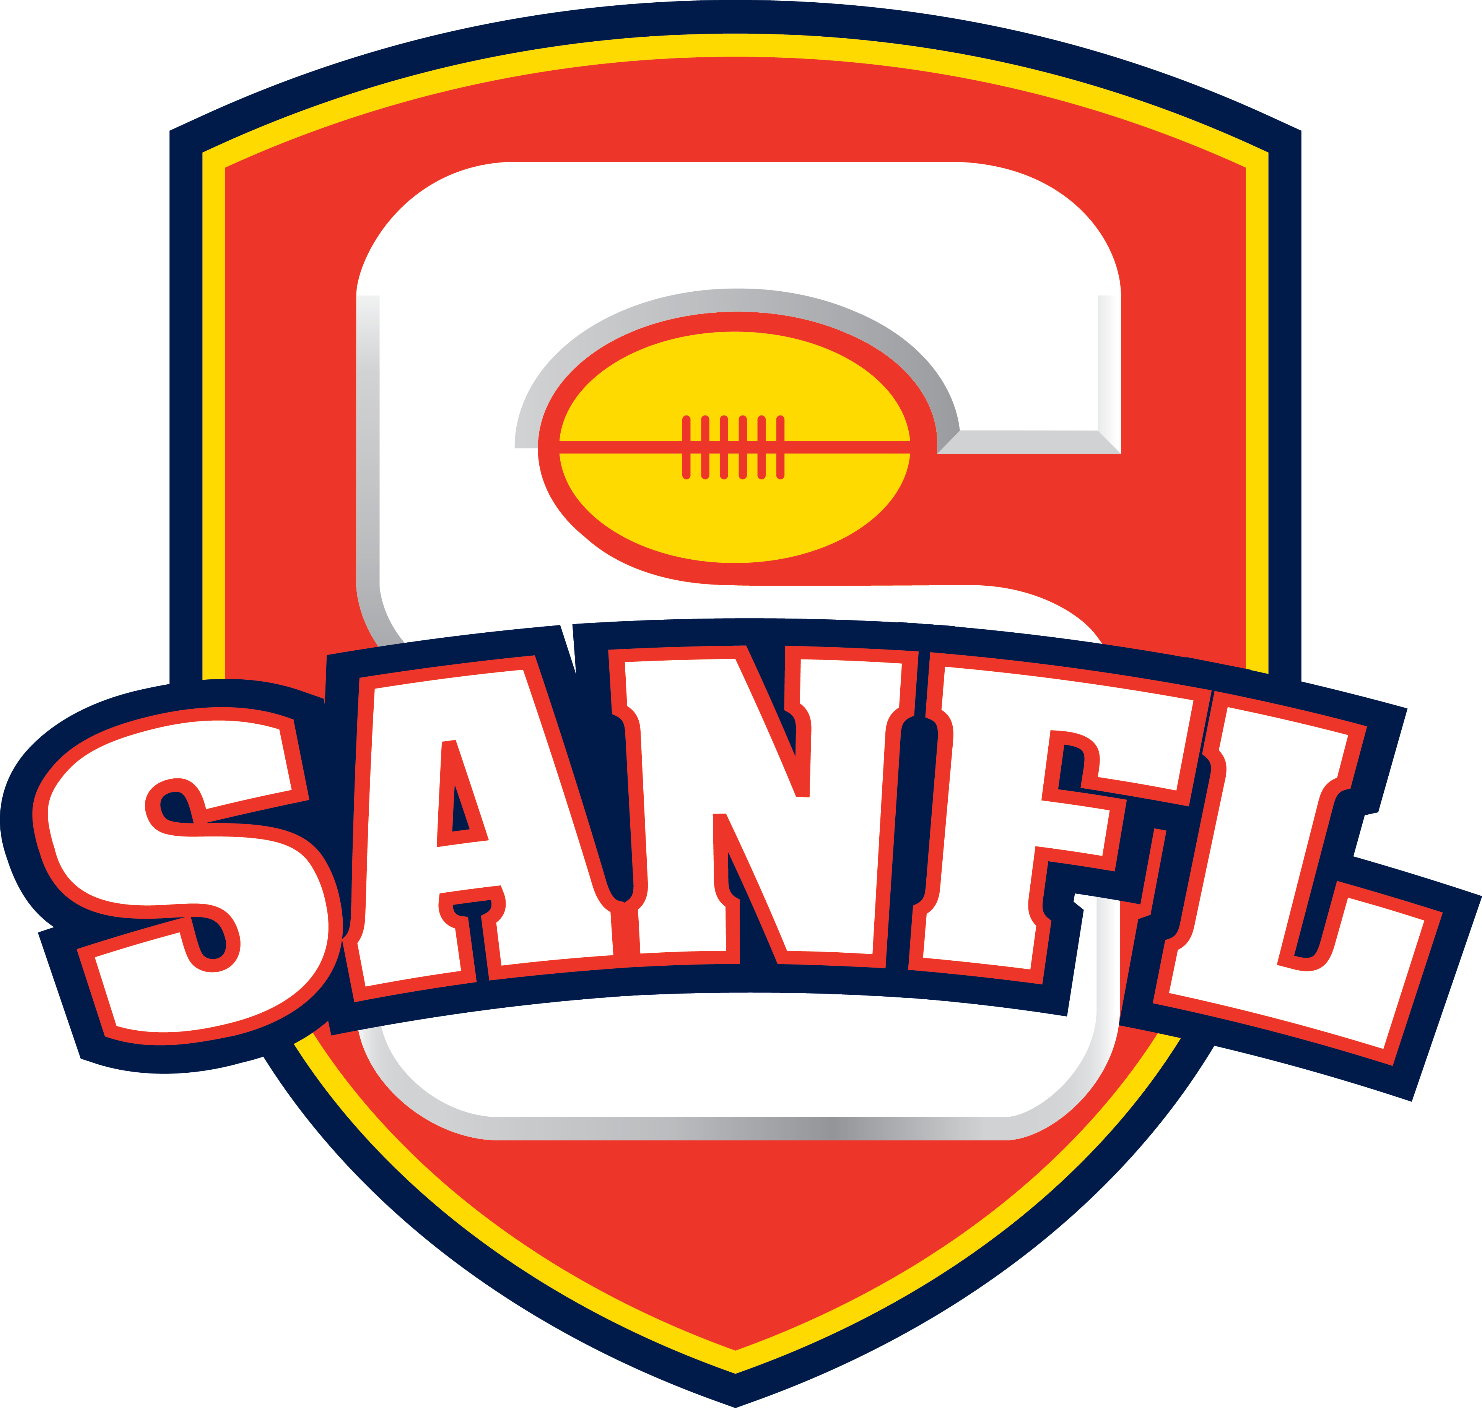
Position Title | Football Operations Coordinator – State League
Award Level | Sporting Organisation Award – Clerical and Administration Grade 6
Direct Reports | NIL
Review Date | 19 October 2017

SANFL VISION & VALUES
Healthier, more connected lives through the enjoyment of footy.
AUTHENTIC | FUN | TEAM | PROGRESSIVE

KEY OBJECTIVES
SANFL is committed to the professionalism, progression and administration of the SANFL Competition.
The Football Operations Coordinator – State League will provide essential administrative and operational assistance to the Head of Football Operations to ensure all State League competitions (including Men’s, Women’s and Underage) are managed and administered in accordance with the SANFL Constitution and Rules & Regulations and are delivered to the standard expected.
The Football Operations Coordinator will assist the Head of Football Operations in working constructively and collaboratively with the 8 SANFL clubs and 2 AFL Clubs in assisting the clubs to administer their State League football operations.

KEY RESPONSIBILITIES
Responsibility | Objective | Performance Measure
State League: Football Administration & Coordination (All Competitions) | - Timely and accurate completion of all week-to-week in-season tasks (Attendance, Powerade Breakthrough Player, MRP/Tribunal Records, Football Budget Information)  - Manage all SportsTG related enquires, education and requests insofar as they involve the State League Competition and Clubs  - Supervision and management of all SANFL Club lists via SportsTg, including updates circulated at least once per month  - Management of all presentation material for all competitions, including ordering, budgeting, delivery and storage (medallions – team and individual, trophies and pennants)  - Assist in developing season fixtures by liaising with Club staff (CEO, Football Manager and Talent Manager where applicable), drafting and giving consideration to ground availability and attendance.  - Match Day Officer pool management including rostering, scheduling, education and ensuring payment within appropriate time period  - Champion Data staff management, act as the primary contact for all Champion Data staff including Ashleigh Newton in relation to any issues relating to the competition or match day access  - Match Day Vision – key contact point for SANFL Vision Supplier and Clubs in relation to SANFL Match Day Vision  - Hudl - key contact point for Hudl and Clubs in relation to SANFL and Hudl logistics and operations  - Successfully implement (and oversee the implementation of) the SANFL Match Day Paperwork App, to replace the existing paper-based system, prior to and during season 2019  - Salary Cap Administration – work with Integrity Officer to ensure accurate and complete collection, storage, administration of all pre-season lodgement and post-season lodgement by Clubs, including a summary following each lodgement period, drafting of communications and other related tasks  - Ensure compliance and arrangement of the Attend all Talent Manager meetings, acting as the representative from State League Football Operations which includes providing relevant updates, receiving feedback, presenting changes or proposals and other related matters  - Minute Secretary – act as minute secretary for the SANFL Football Committee, SA Football Hall of Fame Committee and any other assigned meetings, meet objectives of timely competition of minutes, an accurate and efficient reflection of the meeting and professional presentation suitable for inclusion in SA Football Commission papers. | - Timely and accurate completion of all week-to-week in-season tasks (Attendance, Breakthrough Player, MRP/Tribunal Records, Football Budget Information, etc)  - Accurate, efficient and timely statistical records and inputs  - Ensure delivery of all requirements of Match Day Officer, Champion Data, Hudl, Match Vision, Match Day Paperwork App
MRP & Tribunal Role & Responsibilities | - Receive, collect and collate all reports and referrals across all weekends of SANFL matches (including League, Women’s, Reserves, U18 and U16)  - Liaise with vision provider to ensure timely receipt of all vision – edited or unedited – for the purpose of collating all incidents for review on the first business day following a weekend of matches  - At the specified time on the first business day following a weekend of matches (11:00am unless otherwise determined), have all material (vision and reports/referrals and medical reports) collated for review by the Football Operations Department. Record the determinations made by the Football Operations Department and, if required, liaise with the Match Review Panel to confirm those findings.  - In collaboration, communicate with the relevant Clubs regarding the likely outcome of an incident (in particular, manage all non-League related incidents)  - Draft all MRP findings for review prior to finalisation for review where necessary  - Administer and arrange all Tribunal hearings, including the booking of room, arrangement of Tribunal Members, communication with party and availability of required witnesses  - Keep and maintain tribunal records on SportsTG and via spreadsheet to ensure all information is available for review | - Meet deadlines for collation of MRP material and delivery of MRP Findings  - Manage all logistical aspects of MRP & Tribunal  - Arrange Tribunal hearings in a professional, efficient and appropriate manner
SANFL Youth Boys Championships (U15/U17) and SANFL Girls Talent Shield (U15/U17) Management | - Manage the Youth Boys Championships AND Girls Talent Shield competition with autonomy, efficiency, professionalism and integrity – liaising with the Talent Department, but taking primary ownership of all operational matters  - Create and drive greater efficiency with the introduction of SportsTG for both competitions  - Explore additions to each competition from an operational perspective that enhances the professionalism and outcomes of each program. | - Autonomously manage youth competitions in collaboration with Talent department
SANFL State Program Administration | - Manage and take all responsibility for the apparel and uniform, including compliance with marketing uniform guidelines, corporate partnerships, timely provision of apparel and correct quantity of size – within allocated budget  - Manage and arrange all logistics involved in the travel/transport/accommodation for the entire squad and support staff, including schedules, flights, accommodation, transport and all related matters – within allocated budget  - Draft and prepare all paperwork relating the program, including the working document/schedule, letters/communication to playing squad, any other communications – in an accurate, timely and efficient manner  - Ensure that all training material is arranged, organised and available for training including but not limited to footballs, cones, bibs, shorts, jumpers, socks etc – managing the appointed property steward | - Assist to develop and create a professional state team environment
Constitution, Rules and Regulations | - Collaborate with the Manager to update and incorporate SANFLW Rules and Regulations into existing SANFL Regulations and monitor the compliance with those rules and regulations.  - Assist with the management of the SANFL Rules and Regulations | - Assist with the annual review of SANFL Regulations, Rules and Constitution
Other Duties | - Perform the role of secretary (minute taking) at committee meetings where required (i.e. SANFL Football Committee, SA Football Hall of Fame Committee)  - Arrange annual Player Education Seminars to educate players on Racial Vilification, Harassment, Drug and Alcohol abuse  - Undertake various papers, research and/or statistical analysis to understand and identify areas of improvement in regards to the laws of the game, scoring, attractiveness and injury prevention  - Assist the events coordinator with the arrangement and management of the Season Launch, ANZAC Day, Magarey Medal, SANFL best & fairest, SANFL Finals and Grand Final  - Act as a primary contact for Club personnel and SANFL Staff (including umpiring department) in regard to any issues relating to the SANFL Competition  - Coordinate the Sports Trainers Program and Seminars  - Coordinate servicing of SANFL Club resuscitation equipment.  - Coordinate SANFL Past Players Function with Football Operations Manager  - Coordinate Hudl and Champion Data Education Sessions  - Provide ongoing assistance to the Manager by undertaking other additional duties as required | - Accurate, efficient and timely records of meetings  - Annual arrangement and completion of required programs and seminars

REQUIRED BACKGROUND
Qualifications
- Tertiary Qualifications in Sports Management, Business or similar higher education
- DHS Working with Children Clearance
- Current Drivers Licence

Essential Criteria
- Excellent interpersonal and diplomatic skills
- Strong understanding of the rules and regulations of Australian Rules Football

Desirable Criteria
- Experience in sports administration / business management
- Understanding of competition management
- Demonstrated understanding of club administration
- Sports administration or similar business or legal qualifications highly regarded
- Intermediate knowledge of Footyweb administration

Skills and Knowledge
- Ability to consult, communicate, manage conflict and balance competing demands of key stakeholders
- Negotiation and interpersonal skills
- Strong administration and planning skills
- Excellent written (electronic) and verbal communication skills
- Proficient with Microsoft Office suite products (Outlook, Work, PowerPoint and Excel)

