PROJECT MANAGER

POSITION PROFILE

Division | INFRASTRUCTURE | Status | Full time, permanent
Unit | PROJECT DELIVERY | Salary Grade | Grade 12/13
Reports to | Senior Project Manager | Reviewed | September 2021

STRATEGIC INTENT
To manage the delivery of Civil, Marine, Building or Parks Projects under Council’s Capital Infrastructure Program.

POSITION PURPOSE
Managing the physical delivery of projects in support of Council’s Capital Infrastructure Program including buildings, roads, parks, marine structures, and public domain. Responsibilities include, but are not limited to, management, coordination and/or production of:
• Stakeholder consultation;
• Scope Development
• Project planning, briefs, feasibilities, business cases, consultant studies;
• Risk analysis and mitigation strategies
• Concept and detail design and technical documents;
• Cost plan estimates, monitoring and budget control;
• Detailed scheduling (Gantt Charts), critical path monitoring and control
• Establish, lead and manage project governance processes
• Approvals (client, Council, and other authorities/agencies)
• Tendering documentation and processes;
• Contract administration and works supervision;
• Progress reporting;
• Project handover and close out

POSITION OUTCOMES AND ACCOUNTABILITIES

OUTCOME TO BE DELIVERED | PERFORMANCE STANDARD
Manage projects that are delivered in an agreed timeframe, using Project Scheduling software, by mitigating delays where possible and communicating delay impacts and gaining approvals for schedule changes. | - Maintaining an up-to-date Project Schedule  - Ensuring consistency of information across project records including web page, schedule and project database.
Manage projects that are delivered to the agreed scope, managing change requests and approvals to maintain alignment with the project’s objectives. | - Maintaining the project change register to reflect approval of the requested changes to scope.
Manage project budgets and costs such that the project is delivered within an agreed budget. Including estimating, risk assessment, cost reporting, contract administration. | - Accuracy of initial and ongoing project budget forecasts, cost plans, cash flow and returns.  - Projects are completed within projected costs  - Compliance with legislative requirements, Council policy and procedures for procurement.
Managing Project Quality through specifying sound engineering in the selection of materials and design and ensuring procurement methodology to certify the product delivery. | - A measured and consistent approach to inspection and testing of product.  - A firm standard and enforcement of quality management principles.
Managing communications with project stakeholders including internal clients, the Councillors and the public using well developed Communication Plans and liaising with Council’s Communications Team. Collaborate with other organisations via formal and informal networks. | - Proactive communication of project information to generate understanding and acceptance by stakeholders.  - Customer Requests are proactively managed.  - Cooperation from internal and external agencies.
Manage WHS risks on projects in accordance with Councils WHS policies and proceedures using sound risk identification and risk mitigation methods. | - Records of Safety Inspections and Observations.  - Compliance with WHS Legislation.
Financial Accountability  This position has been identified as  having the responsibility of  managing financial transactions for  the organisation, as required. | - In undertaking these duties, you are placed in a position of trust and must abide by Council’s Code of Conduct at all times. In the event that fraudulent conduct is suspected or identified, relevant processes including disciplinary will be followed, and where appropriate, relevant external agencies may be notified.

SELECTION CRITERIA / SUCCESS PROFILE

Qualifications, Certificates or Licences | Essential | - Tertiary Qualifications in Building or Civil Engineering.  - SafeWork (WorkCover) Construction Industry Induction Card (White Card)  - Class C Driver’s License
 | Desirable | - Qualification in Project Management (e.g. Prince 2 or PMBOK)  - Membership in a Professional Group such as the Australian Institute of Project Management (or similar)  - Accreditation as a Certified Practicing Project Manager (or similar).
Experience or skills | Essential | - Proven leadership skills and experience in client-side initiation, planning, managing and delivering a diverse range of construction projects within a complex and dynamic environment context ;  - Highly developed skills in monitoring and controlling, program, budget, scope and quality parameters.  - Extensive experience in effectively developing and managing cross divisional project teams, relationships with stakeholders, agencies, contractors, consultants and public including governance forums;  - Highly developed analytical skills with proven ability to assess risks and develop timely, innovative solutions to meet project objectives  - Experience and technical knowledge in preparing briefs, specifications, tenders, and contract administration;  - Experience in the assessment of tender submissions and contractor performance;  - Excellent written and oral communication and negotiation skills.
 | Desirable | - Experience in working in the Local Government environment.  - Able to lead and motivate project teams in the pursuit of project success;  - Demonstrated ability to work within financial, administrative, design, and technical disciplines;  - Able to forward plan and anticipate threats/opportunities and respond appropriately;  - Able to adapt to a constantly changing work environment;  - Strong understanding of BCA, DDA, standards, codes, and practices relating to construction works;  - Demonstrated knowledge of the potential legal impacts of exercising project management duties;  - Track record in Government procurement and contract administration;  - Experience in the development, continuous improvement and change management of new processes and systems including a Program Management Office (PMO)  - Sound understanding and experience in the integration of environmental sustainability in project scoping and delivery.  - Experience and knowledge of asset planning and lifecycle analysis requirements  - Experience and knowledge in monitoring and implementing WHS systems and policies where it relates to operational compliance;

CORE CAPABILITIES

Attributes | - Decision making: Achieving desired outcomes by evaluating and identifying options, and involving others in decisions affecting them.  - Goals oriented: Works to achieve self-set goals, taking on challenging tasks when necessary in order to achieve them  - Critical thinking: Critically examine work and activities, considering alternative points of view and approaching an issue as it relates to different stakeholders.  - Communication skills: able to articulate complex and technical matters in simple terms.  - People skills: empowers others to think for themselves, able to approach and attempt to resolve disputes in a constructive way and able to provide positive and constructive feedback when necessary.  - Team focussed: Willing to mentor and be mentored, and to share skills, experience and knowledge via formal and informal collaboration with colleagues

OUR VALUES

Behaviours | - Collaborative - be open and welcoming, genuinely connect to others, include others, work together as one  - Achieve - be enthusiastic and optimistic, make a positive contribution, set goals to be the best you can be, deliver every day  - Respectful – be honest and trustworthy, do what you say you will put yourself in the other person’s shoes, listen to what’s important to others  - Evolving – stay up to date, take on new opportunities, think creatively about solutions, be a big picture thinker

CORPORATE OBLIGATIONS

Employees | No direct reports. Unit structure attached.
Delegations | Authority to operate within the Delegations attached to the position. Authority to authorise purchase orders to $25,000.00 inclusive of GST.
Risk Management | Managing work practices to mitigate all identified risks, identifying and reporting additional risk and threats and assist in devising strategies to mitigate these risks.
Financial Management | Managing budgets and expenditure, undertaking relevant checks and applying rules, regulation, process and procedures in dealing with financial matters
Workplace Health and Safety | Comply and co-operate with WHS policies, procedures, instructions and safe systems of work.
Code of Conduct | All employees are responsible for adhering to Council’s Code of Conduct and the policies and procedures that support it
Workplace Behaviour & EEO | All activities must comply with Council’s Workplace Behaviour Guidelines.
Enterprise Content Management | Comply with Council’s Enterprise Content Management Determination and associated guidelines including creation of appropriate records in Council’s records management system and proper custodianship of records to ensure against loss, removal or destruction
Continuous Improvement | Identify obsolete and inefficient practices and recommend changes where appropriate
Customer Focus | Championing an exceptional customer experience, and evaluating customer satisfaction in order to continually improve service delivery
Procurement | Activities are conducted in accordance with the Purchasing Policy and Procedures to provide transparency and cost effectiveness in procurement

STRUCTURE

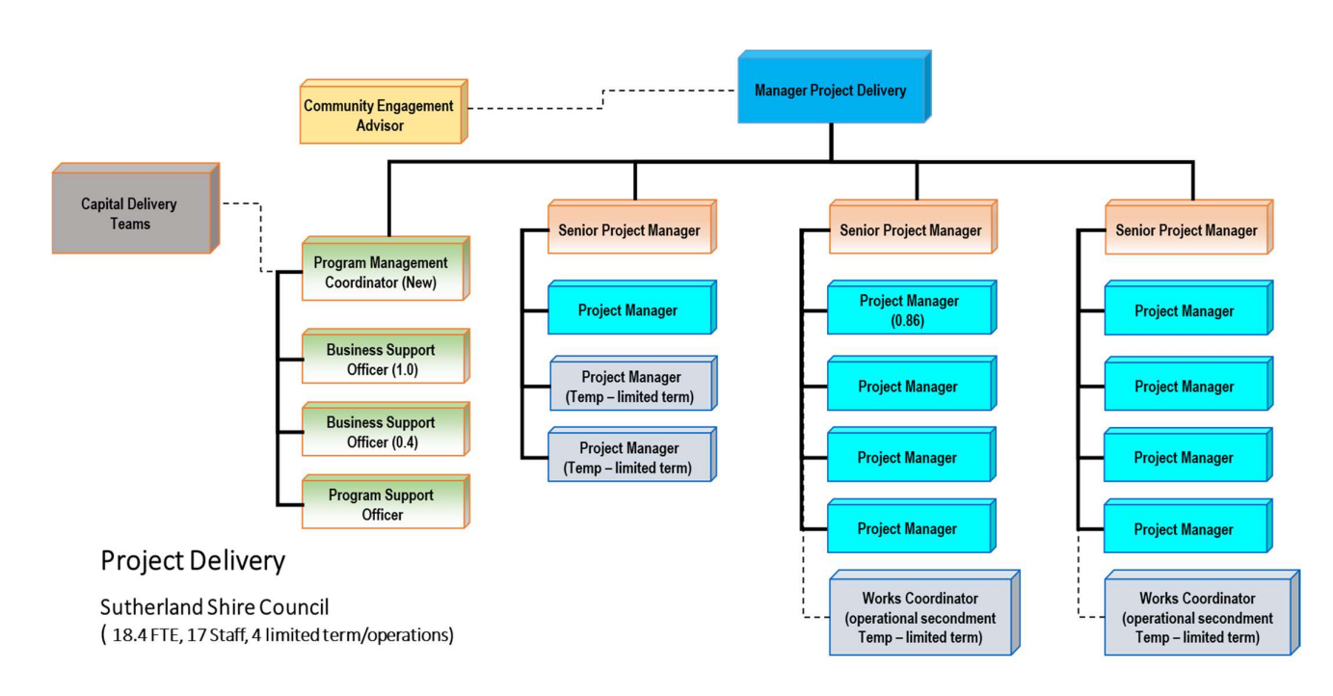

SPECIFIC CONDITIONS OF EMPLOYMENT

Terms of Salaried Staff Enterprise Agreement, as may be varied from time to time.
35-hour week, 19 day month.

Occasional requirement to attend meetings out of hours (e.g. Community Consultation, Council Committees, Chamber of Commerce Meetings) on projects. Accrual of Time-in-lieu or overtime payment available for additional hours worked subject to agreement of the employee.

