POSITION DESCRIPTION
POLICY PROJECT COORDINATOR - TEMPORARY
Position Number: | PCG023
Directorate: | Internal Services
Team: | Governance and Risk
Supervisor: | Coordinator Governance and Risk
Classification: | Band: | 2 | Level: |  | 3 | Grade: | 9
Tenure: | Temporary 9 months |  |  | Hours of Work: 70 hours per fortnight
Primary Location: | Tumut/Tumbarumba

Purpose:
To manage and coordinate the development of policy initiatives to contribute to the delivery of policy implementation within timeframes across Snowy Valleys Council.

Scope:
Budget Responsibility | Staff Management Responsibility
$0 | Nil
Reporting Structure:
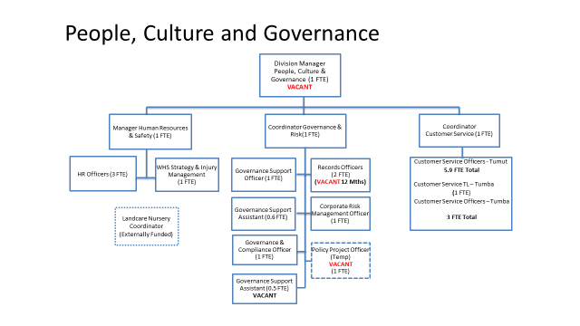
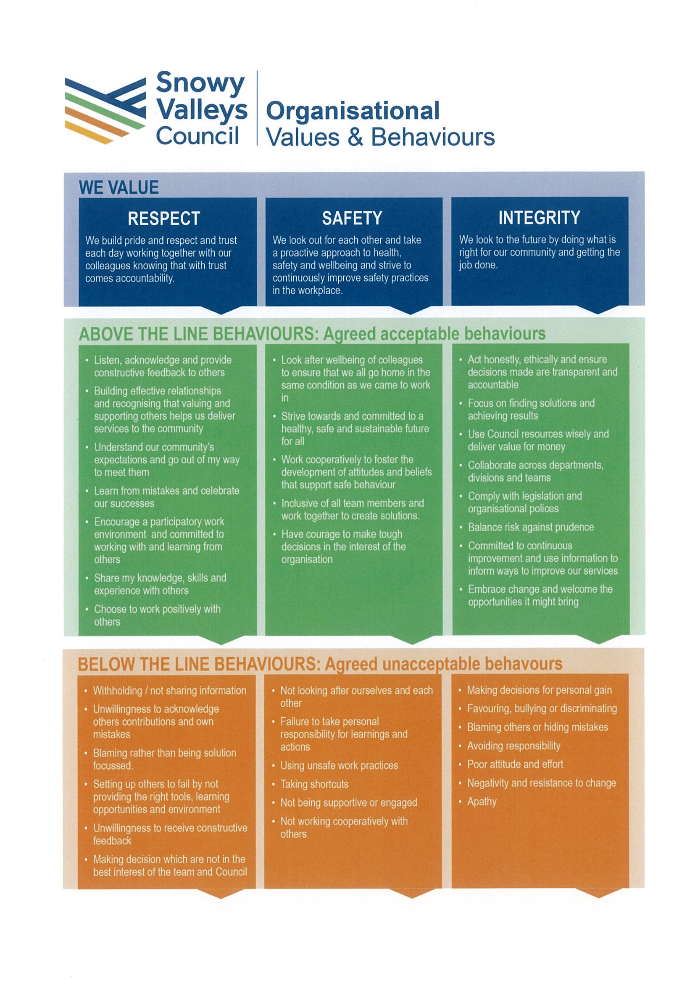
Key accountabilities:
- Research, analyse and review complex policy issues, identifying emerging issues, developing evidence based options, and recommended solutions to resolve problems and mitigate risks against;
- Provide expert policy advice and information to relevant stakeholders to facilitate the appropriate interpretation and implementation of policies;
- Build and maintain relationships with key stakeholders, facilitating their engagement in, and contribution to, the identification and development of policy solutions and to inform policy decision making;
- Monitor, evaluate and report on the development and/or implementation of policies to identify issues and ensure the achievement of established organisational outcomes;
- Mentor and coach Managers and Coordinators, ensuring compliance with governance and quality requirements (e.g. Policy and Procedure Framework), to successfully deliver policy priorities and initiatives
- Prepare correspondence, written reports, and briefs to the Executive Leadership Team that are informative and aligned with Council priorities
- Cooperate and comply with Council’s WH&S Policy and Program
- Demonstrate positive cultural behaviours and commit to applying Snowy Valleys Council’s values, policies and procedures at all times.
SELECTION CRITERIA:
ESSENTIAL
- Relevant tertiary qualifications in policy, business or project management and/or minimum of 5 (five) years’ experience in a similar role
- Demonstrated experience in researching, developing, writing and consulting to draft contemporary policy
- Demonstrated capability in providing strategic research and preparing high level reports, minutes, briefings and policy advice including the analysis and interpretation of emerging policy issues
- Demonstrated superior communication skills
- Proven track record of successful completion of project work
- Proven track record in providing high level advice and support to a senior leadership position in a large organisation including governance, effective communication, negotiation and presentation skills
- Sound understanding of the legislative, economic, social, technological and political environment in which local government operates
- Comprehensive understanding of the budget process, governance and reporting in local government
- Current driver licence

DESIRABLE
- Previous experience in Local Government

