POSITION DESCRIPTION

Building Surveyor

Position Number: | DE003
Directorate: | Director Strategy, Community & Development
Division: | Development & Environment
Supervisor: | Division Manager Development & Environment
Classification: | Band: | 3 | Level: |  | 2 | Grade: | 11
Tenure: | Permanent Full Time |  |  | Hours of Work: 70 hours per fortnight
Primary Location: | Tumut Office / Tumbarumba Office

Position Purpose
Provide development building assessment, certification and building inspection services to ensure effective management of the built and natural environments and compliance with legislative requirements.

Scope:

Budget Responsibility | Staff Management Responsibility
$0 | 0

Reporting Structure:

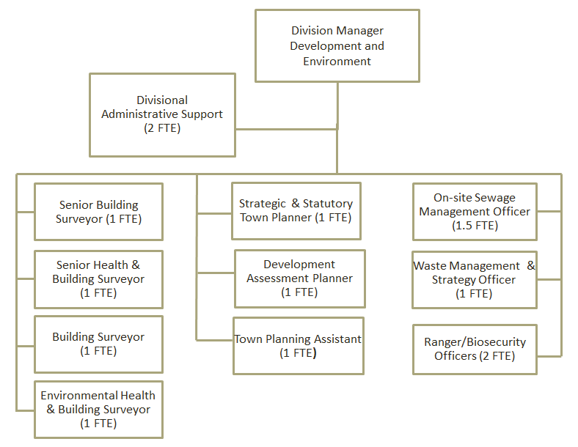

Key Result Areas:
- Accurately process, assess and determine applications for Development Applications, Certificates and Complying Development Certificates under the Environmental Planning and Assessment Act.
- Administer other related legislation, Australian Standards, Policies and Procedures relevant to the position.
- Carry out critical stage inspections of buildings under construction in accordance with the Environmental Planning and Assessment Act (within any BPB accreditation limitations) to ensure compliance with the relevant legislation, BCA Australian Standards, Council Policies and the approved plans and specifications.
- Carry out plumbing and drainage inspections to ensure compliance with the Plumbing and Drainage Act, relevant Australian Standards and the National Construction Code.
- Determine applications for Building Certificates in accordance with the Environmental Planning and Assessment Act.
- Provide accurate and timely advice to the public.
- Investigate complaints relating to building and development control in a timely manner.
- Attend the Local Court and the Land & Environment Court as necessary.
- Ability to operate as an effective Team Member.
- Assess and improve work practices and procedures on a continuous basis to achieve or exceed Snowy Valleys Council’s strategic goals.
- Demonstrate positive cultural behaviours and commit to applying Snowy Valleys Council’s values, policies and procedures at all times.

SELECTION CRITERIA

ESSENTIAL
- Tertiary qualifications in Building Surveying
- Three (3) years’ experience in Building Surveying
- Hold or able to obtain, a minimum of Category A2 accrediation under the Building Professionals Board (BPD) accreditation scheme
- Highly developed computer applications skills
- Demonstrated experience in carrying out critical stage inspections for all classes of buildings
- Working knowledge of:
- Environmental Planning & Assessment Act 1979 (EPA Act) and Regulations
- Environmental Planning Instruments (EPI’s) applicable to Snowy Valleys Council
- Local Government Act 1993
- Building Code of Australia (BCA) and appropriate standards
- Work Health and Safety Act and Regulations 2011
- Ability to provide quality customer service to internal and external customers
- Current C Class Driver licence.

DESIRABLE

- Previous experience in Local Government in the field of Building Surveying
- Training in and experience with Plumbing and Drainage Inspection
- Training in and experience with Town Planning and Development Control

‘Leading, engaging & supporting strong & vibrant communities’
Our Values
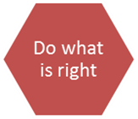 | Accountability, decision-making, equity and sustaining high ethical standards  - taking responsibility for our own behaviour, productivity and quality of work  - making the best contribution we can to achieve the community’s vision  - using resources wisely and delivering value for money  - learning about and working within Council policies  - being responsive and helpful to members of the community, and  - being ethical, respectful and treating everyone fairly.
Team spirit, organisational commitment and wellbeing at work
- supporting the effectiveness and success of our teams
- creating and maintaining a safe and healthy workplace
- speaking up if we experience or observe unfair, disrespectful, discriminatory or bullying behaviour
- meeting and resolving work challenges as a team
- a willingness to go the extra mile when needed, and
- treating colleagues as valued individuals.
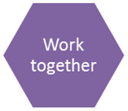 | Collaboration, teamwork and communication.  - building positive and professional relationships in the organisation and community  - being an active listener  - respecting each other’s skills and needs  - being willing to learn from each other  - finding out what is happening that might impact on the team  - being willing to lend a hand to a colleague, and  - sharing information that will enable the team to work effectively and be positive.
Achievement, motivation and learning.
- giving work our full attention and completing tasks on time and competently
- being solution focused
- taking responsibility for the development of our own knowledge and skills
- strengthening Council’s capacity and responsiveness by being flexible and adaptable in how we work with each other
- being open about, and learning from, our mistakes, and
- looking for the enjoyment in our work and recognising how this can unlock creativity and energise the team.
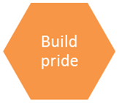 | Recognition, acknowledgement and valuing self, the team and the community.  - valuing others who are approachable and believe in our abilities and aspirations  - giving work our best shot  - seeking feedback about our performance and behaviour and using it to improve  - acknowledging the contributions and achievements of our colleagues  - always speaking positively about the Council and the decisions it makes  - valuing community service, and  - taking the time to reflect on how our work has delivered community benefit.
Being forward looking, working to anticipate and understand the needs of the community and focusing on organisational performance.
- taking a proactive approach to understanding the community’s needs and aspirations
- showing financial responsibility when performing Council work in acknowledgement of the importance of Council’s financial sustainability
- seeking long-term solutions rather than reactive band aid responses, and a focus on excellence.

