**Vision Australia**

Prospectus: Board Secretary

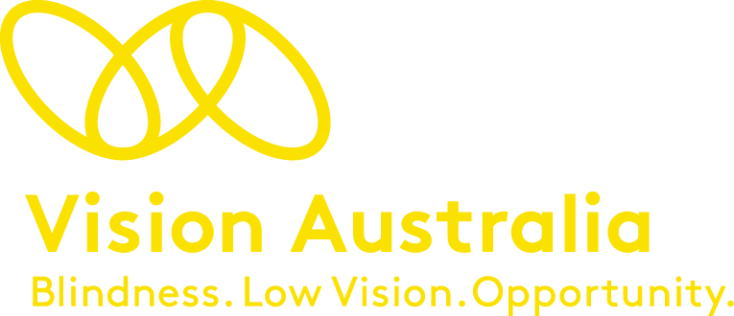various images of staff in the workplace



**Contents**

About Vision Australia  4

Position Description Board Secretary 6

Attachment One: Our Mission Our Story……………………….…………..…………………. 12



**About Vision Australia**

Vision Australia has grown and evolved since it began over 150 years ago. Today Vision Australia is a national provider of disability services that support people who are blind or have low vision to live the life they choose.

Our commitment is to place people who are blind or have low vision at the centre of everything we do. This approach is essential to the human rights of every individual we support and also to the future of our organisation.

Passionate, committed and highly skilled health professionals work with clients across a number of services including:

* Allied health services specialising in blindness and low vision across a range of disciplines such as Orthoptics, Optometry, Occupational Therapy, Physiotherapy and Orientation and Mobility.
* Community and recreation groups, events and activities, online forums and social media communities.
* 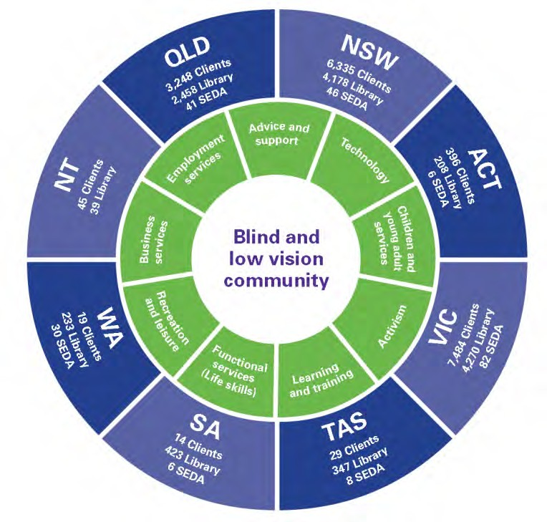Quality living groups and peer support programs that facilitate learning and shared experiences.
* Client and carer advocacy representation at an individual and systemic level
* Employment services including career development
* Technology services specialists with experience in supporting clients to use assistive technology
* Seeing Eye Dog training to international best practice standards.

Our front-line employees rely on the expertise of over 350 people in support roles who provide IT infrastructure, product development, marketing, fundraising, finance, digital and product development.

And whether it’s reading the news headlines on the Vision Australia radio, caring for Seeing Eye Dog puppies or preparing reading material for library members, we couldn’t achieve great outcomes for our clients without the support of over 3,500 active volunteers.

**Vision Australia’s commitment to its workforce**

Vision Australia recognises that our workforce (paid and volunteer) is our most valuable asset. It’s already a great place to work, and we continue to work together to make it even greater by:

* + Creating a positive work environment so our people can deliver great client outcomes
  + A focus on performance so our people can successfully contribute to the strategic objectives of the organisation
  + Investing in capability to ensure we meet the current and future needs of the business and the aspirations of our people.



**Board Secretary**

**Introduction**

Vision Australia is Australia’s leading provider of services to people who are blind or have low vision. Each year more than 27,000 people benefit from our comprehensive range of services delivered across more than fifty locations in all states and territories of Australia.

The organisation has an annual turnover of $100m derived through Government funding, philanthropy, a range of commercial interests and earnings on an investment portfolio of more than $200m (governed through the Vision Australia Trust).

We are an organisation that prides itself on our commitment to mission, our positive culture, and our strategy to make a meaningful difference to the lives of people who are blind or have low vision in the areas of Education, Employment, Independence and Social Inclusion. “Our Mission, Our Story” (Attachment One) provides insight into the foundations of Vision Australia.

Our organisation has been through a period of rapid change spanning the past four years as we respond to Government policy to introduce individualised funding streams (NDIS and My Aged Care). Changes have included rebranding, a complete redesign of our processes, a refresh of core information systems, and development of our culture through promotion of our values.

While our change journey is not complete, and never will be, we are transitioning to benefits realisation from Financial Year 2022 and beyond.

This benefits realisation is as much a cultural journey as it is a mechanical process. Like many similar organisations, we are on a path from charity to “for purpose business”. This is best expressed through our current “strategy tagline” of Head + Heart = Success.

**Purpose of Position**

The Board Secretary is responsible for effective management of the operation of the Vision Australia Limited (VAL) and Vision Australia Foundation (VAF) Boards and the three committees of the Boards and wholly owned subsidiaries of Vision Australia Limited.

The Board Secretary reports jointly to the Chair of Vision Australia and the Chief Executive.

**Context**

The VAL and VAF Boards, Committees, and subsidiary Boards meet regularly to govern the organisation's affairs. It is in the best interests of Vision Australia that we deploy the time volunteered by Directors and the efforts of management in the most effective way possible.

The role of the Board Secretary is to contribute their expertise, working with Board and Committee members and management to achieve the best possible governance outcomes for Vision Australia.

The Board Secretary's role is not that of the Company Secretary; however, there will be a close working relationship with the Company Secretary, a position held by our Chief Financial Officer.

**Principle Responsibilities**

1. In conjunction with the CEO, optimise the relationship between the Boards, Committees and management to ensure access to all relevant and material information.
2. Working closely with the Chairs of VAL and VAF, Committee Chairs, subsidiary company Chairs and the CEO, ensure the smooth operation of the Boards and Committees through:

* preparation of Board and Committee calendars setting out both meeting timing, locations and the program for the year;
* meeting planning, agenda preparation and logistics;
* orchestration of papers, in particular quality and consistency checking of material presented to Boards and Committees;
* taking minutes and preparing a register of Matters for Action for each Board and Committee, seeking verification of these minutes, and ensuring Chair signoff of Board minutes.

1. The Board Secretary will maintain:

* a repository of Board and Committee information, including Company Constitutions, Board and Committee Charters, Board Policies, past Board and Committee papers and minutes, contact information for Directors and Committee members, and any other relevant reference documentation;
* registers of directors' interests and the skills matrices for the VAL and VAF Board; and
* an information pack suitable for providing information to prospective or recently appointed directors, to include an overview of Vision Australia, constitutions, charters, the strategic plan, values, and other documentation of value.

**Key Performance Indicators**

1. We will measure the Board Secretary’s performance against the following criteria:
2. The delivery of Board information to directors one week before Board and Committee meetings (Unless otherwise agreed).
3. Quality and consistency of Board and Committee agenda and papers.
4. Quality and consistency of Board and Committee meeting minutes taken, with minutes distributed to the Chair for review no more than five days post-meeting.
5. The (blindness and low vision) accessibility of documents provided to the Board and Committees.
6. Adherence to Vision Australia values.

**Essential Job Competencies**

1. Governance and Strategy
2. Demonstrable expertise in governance, Board operations, and general management in organisations of comparable scale and complexity to Vision Australia.
3. Leadership
4. Demonstrates strong leadership, particularly the ability to influence those outside direct management responsibility or sphere of influence.
5. Ability to work as a member of a team at all levels within an organisation.
6. Personal Effectiveness
7. Able to maintain absolute confidentiality in all matters relating to Vision Australia.
8. Outstanding verbal and written communication skills, particularly the preparation of complex reports suitable for Board decision-making.
9. Excellent skills in the use of Microsoft Office, Sharepoint, Zoom and Microsoft Teams.
10. Able to subscribe to and operate within the values of Vision Australia at all times.

**Professional Qualifications**

The successful candidate will hold a tertiary qualification in governance, company secretary, or the law, augmented by a significant level of professional experience in the “for profit” or “for purpose” business sectors.

**Vision Australia Environment**

Vision Australia offers employees a high level of flexibility. While this role involves inter-state travel and fixed obligations relating to Board and Committee days, there is also flexibility regarding the days worked and work setting (flexibility around working from home). Vision Australia ICT facilitates working from anywhere there is an INTERNET connection.

Many Vision Australia employees work with Seeing Eye Dogs, and all employees are likely to have contact with working dogs.

Employment is subject to the Organisation receiving a National Police Record Check, Working with Children Check (in all States requiring this check for directors and officers), and NDIS Worker Check.



**Vision Australia Leadership Structure**

**Board of Directors**

**Chief Executive** – Ron Hooton (reports to Board of Directors)

**Board Secretary** – in recruitment (reports to Board Chair and CEO jointly)

**Executive Assistant** – Kate Davies (reports to the CEO)

**Chief People Officer** – Simone Blumberg (reports to CEO)

**Chief Financial Officer** – Justine Heath (reports to CEO)

**GM Fundraising, Marketing & Communications** – Ian Finlayson (reports to CEO)

**GM Commercial Services**– Michael Linke (reports to CEO)

**GM Client Services** – Karen Knight (reports to CEO)

**Chief Information Officer** – Damien McCormack (reports to CEO)

**GM National Programs and Client Insights**– Graeme Craig (reports to CEO)

**Director Performance** **& Change** – Mike van Dyk (reports to CEO)

**Our mission. Our story**

This is our story. It’s the story of who we are, where we are going and how we will get there.

Above all it’s a story of change. Change that we’ve embraced throughout our 150 year history and will continue to embrace as we move into an exciting future.

A future where our clients have the opportunity like never before to live the life they choose.

Vision Australia’s mission is to support people who are blind or have low vision to live the life they choose.

**Together we’re on a path of transformation.**

**Our clients are at the centre of everything we do.**

We listen to our clients and build our services around their needs and aspirations.

Our staff have flexibility and do what they need to support clients and help them achieve positive and measurable outcomes.

**We advocate for social change so that people who are blind or low vision can live the life they choose.**

* We actively strive to change the community’s perceptions about the capability of people who are blind or have low vision.
* We strive for equity and inclusion in all areas of economic and community life that our sighted peers often take for granted.

**We will take a business-like approach to delivering on our purpose.**

* We are responsible in how we use all our resources.
* We will increase our impact by growing the number of clients we serve.

**Deliver the services our clients, their families and supporters need**

* We seek to make a measurable difference in the areas of education, employment, independence and social inclusion.
* Our workforce is expert in providing support for people who are blind or have low vision.

**People love to work at Vision Australia**

Our paid and volunteer workforce gain personal satisfaction from seeing clients achieve their goals.

We provide the professional development and tools our staff need to deliver excellent services.

**Guided by the needs of our clients**

Our future lies in a lifetime of support that has a measurable positive impact in four key areas important to our clients.

Each of these areas is inseparably linked – our clients can achieve great outcomes with our help.

**Education**

Access to lifelong learning for people who are blind or have low vision so they can strive for the same or better educational outcomes as their sighted peers.

**Independence**

People who are blind or have low vision have choices about how they live their lives. They face no barriers to being full and independent participants within their communities.

**Social Inclusion**

Advocating for people who are blind or have low vision so they can choose to have meaningful and active participation in society.

**Employment**

People who are blind or have low vision independently seek and gain employment and develop their careers, participating equally with their sighted peers in the workplace.

**Made real by the actions of our people**

Our teams live by Vision Australia’s values:

**Person Centred**

We recognise and build on clients’ strengths, with clients in control and at the centre of everything we do.

**Collaborative**

Everyone works together with our clients, their families and the community to deliver a measurable and positive difference to people who are blind or have low vision.

**Agile**

We rapidly adapt to individual client needs and to our changing environment.

**Accountable**

We deliver on our promises and hold ourselves responsible for what we do and don’t do.

**Commercially focussed**

We maintain high standards of financial accountability and performance in a competitive environment.

**Summed up in a promise to our clients**

At Vision Australia, we recognise that everyone with low or no vision has an individual story and a unique set of goals and ambitions, so we’ll never take a one-size-fits-all approach with you – our client.

We approach each and every step of your journey with an open mind, flexibility and a legacy of specialist knowledge and understanding.

We create and design services with you and for you. Created so you can get the education and work you want, and protect your rights as a citizen. You have the right to enjoy a sense of purpose, and experience all that life has to offer.

As an economically responsible organisation, we have the commercial acumen required to secure our future, so we can continue to provide you, and those close to you with the services you want; functional services, technology, advocacy and family support at every stage of your life.

Our relationship covers your entire journey and we’ll guide you along the way. From your big milestones to the small moments, we’re with you to offer and provide the right tools, experience and services that support you to live the life you seek. A life led by choices, where you’re in control.

As we move into this new era, with clients the focus of every decision we make, we’re ensuring that your future is one filled with opportunity. We’ll link what you need today with your goals of tomorrow, and actively keep these ambitions front and centre.

You have the right to lead the life you want, and we’re here to help you get there – every step of the way.

**‘Link’ helps us tell our story**

‘Link’, our identifying symbol, represents the connection we have to our clients, our workforce, donors, volunteers and the community.

Link tells the story of how we put our clients at the centre of everything we do. How we work with our clients to deliver services, and work collaboratively with other organisations to help clients with complex needs.

It’s how we bring together our paid and voluntary workforce, with the generosity of our donors, in a way that enriches the services we offer.

Link comes to life in so many ways for an organisation like ours that seeks to make a measurable difference to the lives of people who are blind or have low vision.