Role: Personal Care Attendant (PCA)
Task Description  - Personal Care Attendants (PCA) provide support and assistance to residents. Focus is on providing assistance for ADL’s.  - At the start and end of each shift, PCA staff check their trolley and restock as needed for shift. This includes replenishing of linen, towels and gloves and at the end of shift, emptying bin.  - Shower assistance: may be 1-3 staff assist, based on resident needs. PCA assist transfer in/out of bed/chair, to shower.  - May complete face washing, shaving, application of deodorant, application of various creams etc. in bathroom or at bedside.  - Change bed linen.  - Provide assistance with continence needs: changing pads, assisting residents to toilet, checking and emptying of catheters.  - Assist residents to dress and undress.  - Assisting with feeds in rooms, taking tray to resident and physically assisting or monitoring feeding. May also mix supplements and take to resident room or table.  - Complete various transfers throughout shift which may include use of slide sheets, standing machine, ceiling hoist, and hands on assistance during step transfer and ambulation with aids.  - If medication endorsed PCA, may complete medication round.  - PCA staff assist in dining area to disperse meals, make coffee, order food from kitchen staff.  - PCA staff expected to react to resident calls and emergency medical incidents alongside other care staff.  - Complete medical documentation.  Modification Options  - Stairs may be avoided by using lifts and ramps.  - Co-worker assistance may be sought for heavier tasks |  |  |  |  |  | Body Map  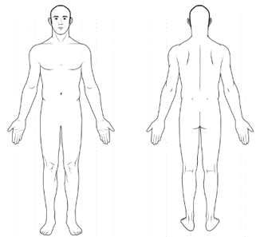
 |  |  |  |  |  | Demands Category
 |  |  |  |  |  | Physical Demand |  | Emotional Demand
 |  |  |  |  |  | Cognitive Demand |  | Role Demand

Photos
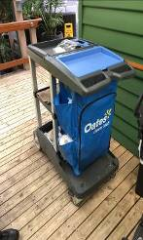 |  |  |  |  |  |  | 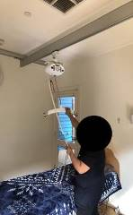
PCA Trolley | Medical file storage area |  |  |  |  |  | Ceiling hoist
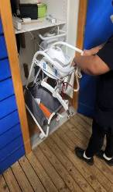 |  |  |  |  |  |  | 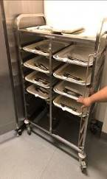
Hoist machine trolley in cupboard | Assisting in meals area |  |  |  |  |  | Meal trays
Job Activity |  | Frequency |  |  | Comments
 |  | O  <33% | F  33-66% | C  >66%

Physical Demands
Neck movement: |  |  |  |  | During resident interactions and assisting with ADLS.
Trunk movement: |  |  |  |  | Transfers, showering, continence tasks, changing linen.
Shoulder movement: above shoulder height
Shoulder movement: below shoulder height |  |  |  |  | Transfers, showering, continence tasks, changing linen.
Elbow movement: |  |  |  |  | During transfers, showering, continence tasks.
Hand movement: |  |  |  |  | During transfers, showering, continence tasks.
Foot movement: |  |  |  |  | Walk through facility, applying or releasing breaks.
Standing: |  |  |  |  | Bedside cleans, assist with feeds, dressing, showering.
Sitting: |  |  |  |  | Feeding residents, observing feeds, documentation
Walking: |  |  |  |  | Required to walk around facility.
Squatting / kneeling: |  |  |  |  | Transfers, showers, dressing, linen change, continence
Lifting:
Average weight: <5kg |  |  |  |  | May include linen, toiletries, clothing, continence aids, food items, food trays, gait aids.
Maximum weight: 10-15kg |  |  |  |  | Relative weight of residents when providing assistance.
Climbing / stairs: |  |  |  |  | Can avoid use of stairs by using lifts and ramps.
Push / pull: |  |  |  |  | Includes PCA trolley, linen trolleys, food trolleys, bins.
Sensory: |  |  |  |  | To hear, touch and view residents to provide best care

Psychological Demands
Reading comprehension |  |  |  |  | Read and comprehend medical documentation
Oral comprehension |  |  |  |  | Understand oral information from staff and residents
Oral expression |  |  |  |  | Must be able to verbally provide medical information from other care staff, and speak to residents to provide safe and effective care.
Writing |  |  |  |  | Must be able to write medical documentation
Numerical reasoning |  |  |  |  | To understand timings of medication and care
Critical thinking |  |  |  |  | Required to problem solve when residents issues arise
Attention to detail |  |  |  |  | When assessing, interacting and providing care to residents, ensure errors avoided, provision of safe care
Judgment and decision making |  |  |  |  | Required to problem solve when resident issues arise
Active listening |  |  |  |  | Listen to residents, colleagues
Memory |  |  |  |  | To recall actions taken throughout shift
Concentration |  |  |  |  | To ensure safe and effective care provision.

Emotional Demands
Social perceptiveness |  |  |  |  | Read social cues from residents and staff.
Stress tolerance |  |  |  |  | Environment may be high stress.
Persuasion |  |  |  |  | Must be able to withstand and work with persuasion.
Dealing with customers |  |  |  |  | Must be able to deal with residents and their families.
Resolving conflicts & negotiating with others |  |  |  |  | May assist with resolving conflict with residents.
Deal with unpleasant or angry people |  |  |  |  | May be required to deal with disgruntled residents.
Work with work group or team |  |  |  |  | Must be able to work effectively alongside other staff.

Role Demands
Adaptability and flexibility |  |  |  |  | Responding to changing resident requests
Time pressure |  |  |  |  | Work under time pressure, ensure tasks completed.
Time management |  |  |  |  | Be able to manage time and prioritize tasks.
Coordinate and lead others |  |  |  |  | If/when working alongside co-worker to provide care
Impact of decisions on co-workers or  company results |  |  |  |  | Care provided to residents impacts overall facility outcomes and success.

Key Definitions
Term | Definitions
Physical Demands
Sedentary Work | Manual handling involving < 5kg occasionally or < 1kg frequently to lift, carry, push, pull or otherwise move objects. Sedentary work involves sitting most of the time, but may involve walking or standing for brief period of time. Jobs are Sedentary if walking and standing are required only occasionally and all other Sedentary criteria are met. Sedentary work may involve repetitive action (i.e. typing).
Light Work | Manual handling < 10kg of force occasionally, or < 5kg of force frequently, or a negligible amount of force constantly to move objects. Physical demand requirements are in excess of those for Sedentary work. Even though the weight lifted may be only a negligible amount, a job should be rated as Light Work:  When it requires walking or standing to a significant degree: or  When it requires sitting most of the time but entails pushing or pulling of arm or leg controls  When the job requires working at a production rate pace entailing the constant pushing or pulling of materials even though the weight of those materials is negligible
Medium Work | Manual handling 10kg to 25kg occasionally, or 5kg to 10kg frequently, or up to 5kg constantly to move objects. Physical demand requirements are in excess of those for Light Work.
Heavy Work | Manual handling 25 to 50kg occasionally, or 10 to 25kg frequently, or 5 to 10kg constantly to move objects. Physical demand requirements are in excess of those required for medium work.
Psychological Demands
Lowest | Cognitive:  < 3 cognitive demands in the frequent or constant on the frequency rating and / or < 5 occasional ratings | Emotional:  < 3 emotional demands in the frequent or constant on the frequency rating | Role:  < 2 role demands in the frequent or constant on the frequency rating
Light | Cognitive:  Between 3 & 5 cognitive demands in the frequent or constant on the frequency rating and / or between 6-7 occasional ratings | Emotional:  Between 3 & 4 emotional demands in the frequent or constant on the frequency rating | Role:  2 role demands in the frequent or constant on the frequency rating
Medium | Cognitive:  Between 6 & 8 cognitive demands in the frequent or constant on the frequency rating and / or 8-10 occasional ratings | Emotional:  Between 5 & 6 emotional demands in the frequent or constant on the frequency rating | Role:  3-4 role demands in the frequent or constant on the frequency rating
High | Cognitive:  >8 cognitive demands in the frequent or constant on the frequency rating and / or 11 plus occasional ratings | Emotional:  > 6 emotional demands in the frequent or constant on the frequency rating | Role:  5 role demands in the frequent or constant on the frequency rating

