Business Unit: Operations
Reporting to Position Manager: Team Leader Regional Project Delivery

Position Purpose
Provide engineering expertise to ensure optimal whole of life solutions are effectively identified, developed and implemented in response to identified project needs. The Project Engineer is responsible for checking design and technical delivery applying WaterNSW project delivery frameworks and tools, and to put safety first.

Key Accountabilities
- Safety: ensure all activities are undertaken with the safety of everyone as the number one priority and always role model safe behaviour.
- Values: behave and make decisions in accordance with the WaterNSW Values at all times.
- Lead development and implementation of technical/engineering solutions on behalf of the project manager. Includes provision of timely accurate and complete technical support, advice reporting and recommendations to the project manager to minimise risk, environmental impact and ensure overall project objectives are met.
Position
Description

Project Engineer

- Manage identification of solution options and selection of preferred or recommended options to meet project needs, including assessment of associated capital and operational costs and ensuring that key stakeholders are involved in decision-making.
- Ensure project specification documentation is clear and comprehensive to enable consultants and contractors to effectively respond to requests for tender and to minimise number and nature of requests for information (RFIs).
- Interface with design consultants during development of options, concept and detailed designs and REFs or EIAs where relevant.
- Oversee the project design process ensuring all relevant engineering specifications and standards are met, and appropriate inspection and test planning is in place. Lead design review meetings including HAZOP (Hazards and Operability Analysis) and CHAIR (Construction Hazard Assessment Implication Review). Ensure design optimisation and value engineering processes are undertaken and that recommendations are made and adopted where appropriate.
- Regularly monitor work undertaken to ensure it complies with agreed scope and meets agreed requirements, including factory validation during production of technical components. Manage all requests for design or other engineering changes to ensure that they are reasonable, meet original project aims and are within defined scope.
- Develop and then implement commissioning, testing and handover plans for all relevant projects, modify these in accordance with any approved change to ensure agreed solution is effectively implemented and that operators have been trained in use where there is a change in operating practices.
- Ensure drawings, operating and maintenance manuals and other relevant artefacts are produced in timely manner and meet specifications or other requirements of the business.
- Ensure that delivered solutions are operating satisfactorily and that defects identified during the defect period are addressed in a timely manner.
- Provide technical support and recommend actions across all project phases to ensure that engineering designs meet operational requirements and engineering standards. Respond to technical RFIs from external parties and ensure appropriate mechanisms are in place for factory testing, where relevant.
Commented [BY1]:
@Daryl Gilchrist

did you mean
'whole of life' solutions here?

Commented [DG2R1]:
yes

Key Challenges
- Getting alignment and commitment of number of different, predominantly internal stakeholders to meet project objectives without direct line management authority to do so.
- Managing engineering aspects to deliver cost and risk appropriate solutions to meet customer needs.
- Acceptance of approved solutions by operators and internal stakeholders that may be resistant to change.
- Managing competing priorities of time and cost pressures against the pressure to develop effective and reliable whole of life solutions.

Significant Internal Relationships
Stakeholder | Purpose of Relationship
Project Manager, Construction Manager,  Project Controller, Project Officer | Project Engineer works within a Project Team to describe the interplay of technical issues, to represent the key technical requirements and
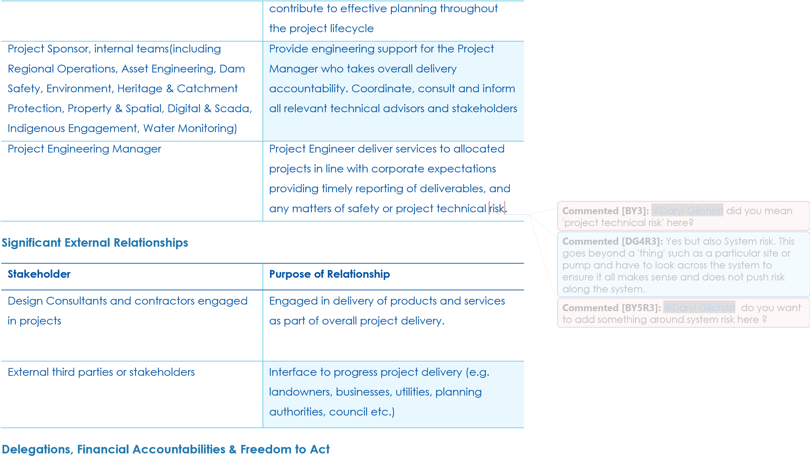
As defined in the WaterNSW Financial Delegations as varied from time to time.
People

Level

Coaching & Developing
others

B

•

Supports individual development in line with career
aspirations

and business requirements

•

Challenges others to achieve their full potential

•

Actively listens to others

•

Supports others to establish meaningful goals

•

Asks questions to create
awareness and encourage
self
-
directed problem solving

Commented [BY6]:
Copied and pasted from the
Competency framework as I noticed
discrepancies in wording with the framework and
what was in here. The wording shouldn't be
changed from what is in the Competency
Framework. Also, t
he person in the role must satisfy
or be competent in all dot points, if they don't
need one of them, they must drop down to the
lower level.
@Daryl Gilchrist

FYI

WaterNSW Leadership & Performance Competencies
Communicating with  Influence | B | • | Tailors communication to suit the audience and uses a range of influencing techniques to build support
 |  | • | Supports messages with relevant examples, demonstrations and stories
 |  | • | Communicates issues clearly with different audiences
 |  | • | Handles challenging questions confidently and constructively
Business

Level

Safety & Risk Management

B

•

Takes immediate and appropriate action to minimise
risk and maximise opportunities

•

Implements and monitors policies, procedures and
programs.

•

Role models safety behaviour

•

Considers safety and risk in all business decisions

Analysis & Problem Solving

B

•

Defines the extent and cause of the problem through
observation and
investigation

•

Knows when and how to source and use additional
information to effectively diagnose the problem and
determine suitable solutions.

•

Considers all possible solutions and
seeks input from
subject matter experts where appropriate

•

Takes necessary action to implement the identified
solution

Commented [BY7]:
@Daryl Gilchrist

The only higher
competency in the Lead PE role is for this
competency, 'Analysis & Problem Solving'. Should
that be the case? Or are there some other
competencies that need to 'drop down' to a lower
level as compared to a Lead PE?

Customer | Level
Collaboration & Engagement with Stakeholders &  Customers | B | •  • | Builds and maintains relationships with individuals from other work groups to accomplish shared goals Adapts approach to meet the needs of a broad range of customers and stakeholders

Continuous Improvement | B | • | Analyses current processes and practices to identify opportunities for improvement
 |  | • | Identifies patterns in data and information and implements improvements based on this analysis
 |  | • | Has knowledge of and able to apply appropriate continuous improvement tools to achieve the best outcome
 |  | • | Undertakes improvement projects within own team or business area to improve outcomes by utilising innovative thinking

Technical Competencies
Competency | Level
Nil

Mandatory Candidate Requirements
Qualifications:
- Bachelor degree or higher tertiary institution in civil, mechanical or electrical engineering, or demonstrated equivalent relevant experience.
- Current NSW Drivers Licence
Knowledge:
- Knowledge of assets relevant to WaterNSW core asset base such as dams, water regulating structures, bridges roads, canals, embankments, buildings and cranes etc.
- Knowledge of regulatory requirements and standards including WHS as they relate to the design and delivery of engineering aspects of range of capital projects
- Ability to interpret, assess and review engineering designs, drawings and construction or other work methodologies to ensure compliance with standards and to meet required objectives.

Experience:
- Demonstrated experience in managing the engineering and design aspects of multiple multidisciplinary infrastructure projects
- Experience working collaboratively and making decisions with stakeholders to review, analyse, negotiate and implement technical solutions
- Demonstrated experience in determining appropriate solutions to technical challenges through evaluation of options
- Experience in development of technical specifications including interpretation of regulatory and other standards in developing those specifications.
- Demonstrated experience in coordinating and facilitating meetings/workshops to determine appropriate solutions to technical challenges through evaluation of options

Favourable Candidate Requirements
- Post Graduate qualifications in project management or equivalent with experience in managing various forms of commercial arrangements to drive ‘value for money’ engineering outcomes.
Commented [BY8]:
@Daryl Gilchrist

deleted as it is
no longer a company requirement.

Commented [DG9R8]:
OK

- 5+ years' experience with engineering design responsibility, and site validation responsibilities.
- Demonstrated experience in successfully delivering Engineering projects with design coordination and stakeholder engagement.

Pre-Employment Checks Required
- Identification
- Qualifications
- Drivers Licence
- Pre-employment Medical (Field)
- Police Check

